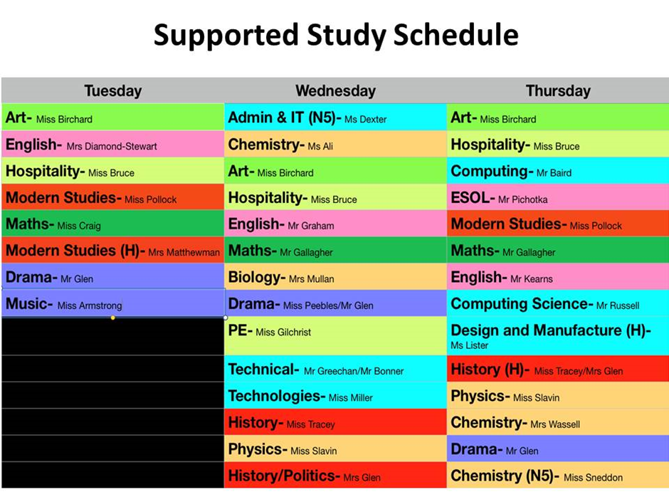

At St. Mungo’s Academy, staff provide an extensive range of supported study to help support young people in preparation for SQA exams. After prelims there is an excellent opportunity to put in place actions that will bring success in time for the SQA exams to start. Below is a copy of our weekly **drop-in session** timetable:

**DROP-IN SESSIONS:**

Drop-in sessions are designed to be **lead by young people**. The expectation is that young people arrive to these sessions prepared with questions they have based on what they have worked on in class or from the revision they have been undertaking at home.

**MASTERCLASSES:**

Masterclasses will be provided weekly by staff and, unlike the drop-in sessions, will have a specific focus set by the teacher. Information on Masterclasses will be given out weekly to young people and will be available to view on Twitter @StMungosAcademy .

Supported Study @ St. Mungo’s

**Remember!**