1.5 Science Forces Online Lesson 1: Streamlining
Task 1
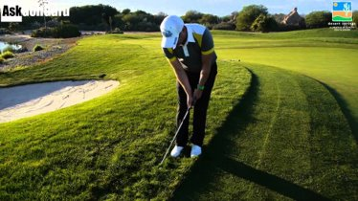
- Look at the pictures below and decide if the friction is useful or not:
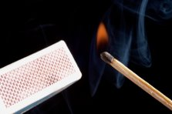
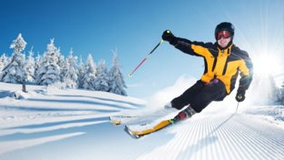

________________ ___________

________________ _____________

- Look at the picture of the Formula 1 car below, what forces may be acting upon the car?
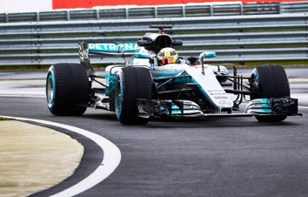

___________________________________________________________________________

- Air resistance and friction are some of the forces acting upon the car. What are the advantages and disadvantages of these forces?
Advantages: ________________________________________________________________ ______________________________________________________________________________________________________________________________________________________

Disadvantages: ______________________________________________________________ ______________________________________________________________________________________________________________________________________________________

- Watch the videos labelled cycling and dolphin in the ‘Class Documents’ section of the Team.
How did the dolphin and the cyclist reduce the affect of drag (air/water resistance)?
____________________________________________________________________________________________________________________________________________________________________________________________________________________________________________________________________________________________________________

- Look at the picture of the Formula 1 car again, what steps have been taken to reduce drag on the car?
______________________________________________________________________________________________________________________________________________________

When an object is streamlined, corners and rough edges are removed. Making the object smoother and curvier reduces the friction and allows the air/water to more easily flow around it.

- Surface friction can be reduced by smoothing surfaces or by reducing surface contact area. Hovercraft and curling stones are a good example of this in action.
Challenge:
Ask an adult if you have the following items:
- An old CD/DVD,
- Blue-tack,
- A sports cap from a bottle,
- A balloon.
If you have these items, try the challenge below. Record your results on your phone and email them to me and I will upload to your file in the team.

