Lesson 3 - An Introduction to the Periodic Table

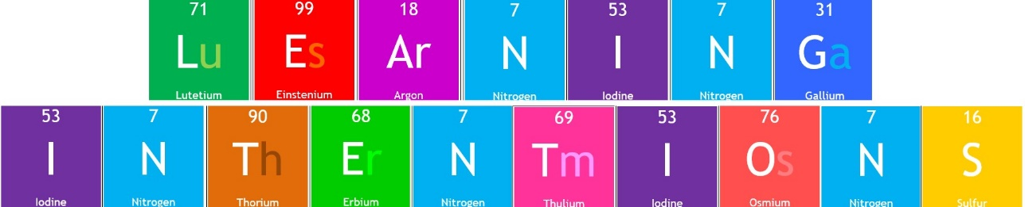
  - I can explain that the elements in the Periodic Table are organised using their atomic number
  - I can state that each element has its own unique atomic symbol

The Periodic Table is where we can find all the elements that make up all life and all materials.

Definition: Element

An element is a __________________ that contains only ___________ type of ________________.

Element Names and Symbols

Each of the elements has a name and also a quick way of identifying the element – its symbol. These also allow scientists from different countries who speak different languages to co-operate in scientific research using the same symbols

Writing an Elements Symbol

Rule 1: The first letter of a symbol is always a capital letter

Rule 2: The second letter of a symbol is always a lower-case letter

Activity 3.2: Element Soup

Using your Periodic Table, correctly match each element name to its correct symbol.

Element Name | Atomic Symbol
 | Mg
 | H
 | Co
 | S
 | K
 | Ra
 | Xe
 | Mn
 | P
 | Sn
 | Au
 | C
 | Cl

Activity 3.3: Elements Named After Countries

Using your Periodic Table, look for four elements that are named after countries and fill your results in the table below.

Element Name | Atomic Symbol | Country
 | Fr
 | Po
 |  | Germany
 |  | America

Activity 3.4: Elements Named After Famous People

Using your Periodic Table, look for four elements that are named after famous people and fill your results in the table below.

Element Name | Atomic Symbol | Person
 | Md
 |  | Marie/Pierre Curie
 | Es
 |  | Alfred Nobel

Activity 3.5: Elements Named After Planets

Using your Periodic Table, look for four elements that are named after planets and fill your results in the table below.

Element Name | Atomic Symbol | Planet
 |  | Pluto
 | Hg
 | Np
 |  | Uranus

Activity 3.6: Odd Symbols
Not all elements have symbols that obviously belong to them.
Some are named after other languages and some have interesting stories behind the name.

Use your Periodic Table to complete the table below and find the corresponding element name and symbol.

Element Name | Symbol
Iron
 | K
Sodium
 | Cu
Gold
 | Ag

Activity 3.7: Element Emojis

Emoji symbols will be shown to represent different elements.
Use the sounds of the emojis to try and work out the full name of the element.
Write your answers in the space bellow:

Homework Task

For homework your task is to research the element strontium.

You can display your research as a poster, newspaper article, comic book, essay or spider diagram.

You must include:
- When was strontium discovered?
- Where was strontium discovered?
- Who discovered strontium?
- How did they discover strontium?
- At least 3 interesting facts about strontium

