

**Every child is included and supported: Getting it right in St Mungo’s Academy, the Nurturing School**

**Policy Guidelines 2023-24**

Table of Contents

Introduction 3

Section 1 - Aims 4

Section 2 – Dignity of All: Rights, Inclusion and Nurture 5

Section 3 - Roles and responsibilities of all staff 8

What is an inclusive learning environment? 8

Support through our House Structure 10

Section 4 - Universal support for children and young people 11

What is Getting it right for every child? (GIRFEC 11

What is SHANARRI? 12

Section 5 – Staged intervention, the Wellbeing Assessment and Plan (WAP) and planning for targeted support 14

Process for submitting and responding to Requests for Assistance 15

The Wellbeing Assessment and Plan (WAP) 16

Identification and assessment 17

Section 6 – Quality Assurance 18

Appendix 1 – Roles and responsibilities of all staff 19

Appendix 2 – Level 1 Teaching and Learning Strategies 20

Appendix 3 – Request for Assistance Referral **Error! Bookmark not defined.**

Appendix 4 – Round Robin 21

References 27

## Introduction

We are all made in the image and likeness of God. Thus, the Community of St Mungo’s Academy recognises the central place of Jesus Christ in our work and in our relationships. We endeavour every day to provide opportunities to encounter Jesus in all that we do and say.

The mission of the Catholic school is to develop as a community of faith and learning, providing the highest quality of education, and offering formation through the promotion of Gospel values, through celebration and worship, and through service to the common good. Our school values of Faith, Hope and Love embody this mission and we endeavour to live them out in the daily life of the school. The goal of Catholic Education is to enable all learners to achieve their fullest potential.

**‘Preparing them for life, informing their minds and informing their characters so that they contribute with others, and above all with God, to the transformation of the world’ - ‘**This is our Faith’ (Article 6 Rights of the Child)

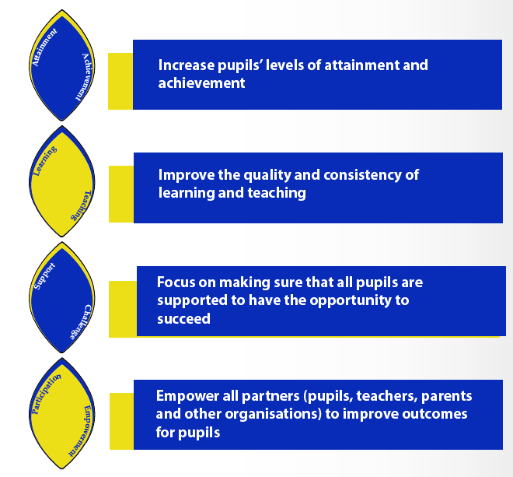

In line with *The Children and Young People Act*, this policy applies to all children and young people in St Mungo’s Academy. Our policy is shaped by:

* the Charter for Catholic Schools in Scotland
* our ongoing development of the curriculum and of learning and teaching;
* our strategic commitment to promoting inclusion, positive relationships and to nurturing approaches; and
* our key focus on participation and consultation with all stakeholders.

Each has led to the development of our School Improvement Plan 2018 – 2023, which has four key aims, as illustrated.

# Section 1 - Aims

St Mungo’s aim as an inclusive school is to ensure all young people are supported through both universal and targeted support in order to thrive in both their learning and wider achievement. We reflect the requirements of legislation and ensure that these are being met through all staff having a full understanding of GIRFEC policy. Our policy and practice, which places the child at the centre, is underpinned by the following aspects.



# Section 2 – Dignity of All: Rights, Inclusion and Nurture

As a school that is committed to Catholic Social Teaching, the promotion of human dignity is a key feature of our values, vision and aims. We seek to realise this commitment through the following key strands:

1. Recognising and Realising Children’s Rights

Catholic social teaching believes that human beings, created in the image and likeness of God (Genesis 1:26-27), have by their very existence inherent dignity, value, worth, and distinction. This belief in universal human dignity is expressed and supported through our work to support the United Nations Convention on the Rights of the Child (UNCRC) as a UNICEF Rights Respecting School. As such, the four key principles of the Convention support our commitment to continuous improvement for equity and excellence in our endeavours to provide an inclusive education (Article 28) which develops the personality, talents and abilities of our young people to the fullest (Article 29):

* Non-discrimination (Article 2) – we are committed to the inclusion of all young people to achieve their potential, regardless of any characteristic or need;
* Best interest of the child (Article 3) – the adults in our school are committed to what is in our young people’s best interests;
* Optimal development (Article 6) – we are driven by the challenge of ‘bringing out the best’ for all our young people;
* Respect for the views of the child (Article 12) – we are fully committed to listening and responding to our young people as empowered young leaders.

1. Inclusive practice

*"The prevention, elimination or regulation of discrimination between persons on grounds of sex or marital status, on racial grounds, or on grounds of disability, age, sexual orientation, language or social origin, or of other personal attributes, including beliefs or opinions, such as religious beliefs or political opinions."*

*Equality Act (2010)*

Our commitment to the universal dignity of all our stakeholders through rights-based learning and practice is the foundation of our promotion of equity, equality and excellence for all our young people. However, in respect of our response to the Equality Duty, while the rich diversity of our school is one of its key strengths, it must always be a factor that we consider when promoting the rights of every child to ensure appropriate educational provision and development. The principle of ‘non-discrimination’, or inclusion, is a key feature of St Mungo’s Academy where we aspire to ensure that**:**

* All our children and young people will grow and learn in an environment where they are safe and healthy, active, nurtured and achieving, respected, responsible and included. They will be valued as individuals and their needs will be understood and met;
* Children and young people with identified additional support needs will receive appropriate support which is based on robust, collaborative assessment of their needs and responds to national guidance on supporting all young people;
* Together, staff, families and young people themselves will be fully involved in planning appropriate pathways for those few children and young people who require a very high level of additional support;

1. 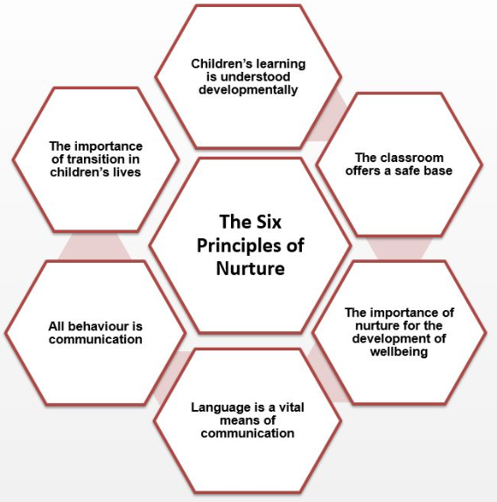Getting it Right for Every Child – Wellbeing through Nurture

Our response to GIRFEC can be understood within the context of our ambition to be ‘a nurturing school’. A nurturing school is one in which all young people feel that they belong, are listened to, and that they and their families are valued. The ethos of a nurturing school is supportive and all staff are clear about their roles and responsibilities.

**The underlying aim is to ensure we are Getting it right for every child by understanding the six key principles of nurture.**

1. Mental Health and Wellbeing of our Young People

Our school plays a unique and key role in supporting children’s mental health and wellbeing, which is underpinned by Getting It Right for Every Child (GIRFEC). This approach supports children and young people so that they can grow up feeling loved, safe and respected and can realise their full potential. We aim to remove the stigma of mental health issues that many young people experience and recognise that the school alone cannot and should not meet all the wellbeing needs of children and young people. Parents, carers, families and a range of partners in schools and the wider community play a role in meeting those needs. Our practice is guided by the Scottish Government *Whole School Approach Framework for Schools to Support Children and Young People’s Mental Health and Wellbeing, 2021.* [*https://www.gov.scot/publications/whole-school-approach-mental-health-wellbeing/documents/*](https://www.gov.scot/publications/whole-school-approach-mental-health-wellbeing/documents/)

We base our approaches on eight principles:

* Leadership and management of the school;
* Creating an ethos and environment that promotes positive and respectful relationships and values diversity;
* An effective curriculum and learning and teaching which promotes resilience and supports positive mental, emotional, social and physical wellbeing;
* Enabling young people’s voices and participation to influence decisions;
* Supporting staff professional learning and development in order to ensure their own and other’s wellbeing;
* Identifying need and monitoring impact of interventions;
* Working with parents, carers and the wider community to support wellbeing of all;
* Targeted support and appropriate pathways to the right support.

# Section 3 - Roles and responsibilities of all staff

The holistic wellbeing of all young people is the responsibility of every member of staff in St Mungo’s Academy. Inclusion begins in the classroom where all staff are expected to support the key principles of GIRFEC policy and demonstrate this in practice.

All our staff should also demonstrate their professional values and personal commitment as outlined in the GTCS Professional Standards. Professional values are at the core of the Professional Standards. The educational experiences of all our learners are shaped by the values and attitudes of all those who work to educate them. Underpinning this are the values of social justice, integrity, trust, respect and professional commitment. In St Mungo’s Academy these values are embodied in our school values of **Faith, Hope and Love**, and reflect our foundations as a Catholic Community of Faith.

## What is an inclusive learning environment?

The ethos of the school as reflected in our vision, values and aims creates the climate and relationships within the learning environment that are the basis of universal support. An inclusive learning environment is one in which all children and young people experience learning which meets their individual needs and supports them as they develop the four capacities of Curriculum for Excellence: successful learners, confident individuals, responsible citizens and effective contributors. Health and Wellbeing is a central theme in Curriculum for Excellence, central to developing these four capacities. As such, health and wellbeing is the responsibility of all staff.

**All staff in St. Mungo’s Academy have a responsibility for the welfare of our young people.  (See appendix 1 for roles and responsibilities of all staff in St. Mungo’s Academy)**

In addition to this our key adult programme provides universal support for all young people through the practitioner who knows the child well and has a holistic overview of their progress. Through regular dialogue with the child about their learning, the key adult has a major role to play in the provision of such universal support and ensuring we are Getting it right for every child. **(See Key Adult Handbook for outline of role)**

## Support through our House Structure

Initial support for pupils is provided by class tutors in the first 10 minutes of each day. The ‘**tutor teacher’** is an essential first point of contact for young people and also their **Key Adult**, with time allocated throughout the year to discuss progress and any concerns

**Parents/carers** are essential stakeholders in their child’s education. Full discussion is held with parents/carers and outcomes are planned and agreed in partnership, determining what level of support or intervention is required for each young person.

Each House has a **Principal Teacher of Pastoral Care (PTPC)** responsible for the leading staff teams to ensure the health and wellbeing of all young people in that House. The PTPC is the first point of contact for parents and provides a vital link between home and school as the pastoral care teacher has an ‘all-round’ picture of a pupil’s progress and general health and well-being.

The **Pupil Support Team** will review pupils’ progress following each target update episode and will engage all other staff (classroom and Principal Teachers/Faculty Heads, support staff) where appropriate, to agree interventions for pupils. All staff in St Mungo’s have a responsibility for the health and wellbeing of our young people. All staff are involved in the **Staged Intervention** **process** (Section 6) of assessment, analysis, planning and review of supports for our pupils.

Each House also has a lead **Depute Head Teacher (DHT)** with overall responsibility for ensuring the health and wellbeing of young people in their House. The House DHT meets regularly with the House PTPC to support young people and will also meet with parents when necessary.

# Section 4 - Universal support for children and young people

This policy applies to all children and young people for whose education St Mungo’s Academy is responsible. In line with the National Practice model, St Mungo’s Academy places high priority on using information from Primary transition and ongoing evaluation of children and young people in order to support staff in taking action to ensure that these children are able to achieve their full potential. The National Practice Model is a dynamic and evolving process of assessment, analysis, action and review, and a way to identify outcomes and solutions for individual children or young people. It allows practitioners to meet the Getting it right for every child core values and principles in an appropriate, proportionate and timely way. Schools have a responsibility for identifying and assessing pupils who do not seem to be making progress in learning and for taking action to support their learning and wellbeing. Such a responsibility starts in the classroom with the class teacher who is supported by promoted staff.

## What is Getting it right for every child? (GIRFEC

* It is a consistent way for people to work with all children and young people.
* The approach helps practitioners to focus on what makes a positive difference for children and young people – and how they can act to deliver these improvements.
* The Getting it right for every child approach ensures that anyone providing support puts the child or young person – and their family – at the centre.
* Getting it right for every child is important for everyone who works with children and young people – as well as many people who work with adults who look after children.
* Practitioners need to work together to support families and, when appropriate, take early action at the first signs of any concern about wellbeing – rather than only getting involved when a situation has already reached crisis point.
* This means working across organisational boundaries and putting children and their families at the heart of decision making – and giving all our children and young people the best possible start in life.

## What is SHANARRI?

* SHANARRI is an acronym developed by the Scottish Government to describe well-being indicators to not only assist practitioners understand the child in the context of their *wider world* but to assist children and young people to understand how and why they will get the help they need when they need it. It is described for them in this way.
* **SAFE -** *This means that you have the right to be protected from abuse, neglect and harm at home, at school and in your community.*
* **HEALTHY -** *This means you get the help to keep healthy and to make choices which will give you the best possible physical and mental health.*
* **ACHIEVING -** *This means you will get the support and guidance to learn, develop skills, and build confidence and self-esteem.*
* **NURTURED -** *This means that whenever possible you should live and grow up in a caring family setting even if not with your own family.*
* **ACTIVE -** *This means that you will have real opportunities for leisure activities, play activities and sport.*
* **RESPECTED & RESPONSIBLE -** *This means you will be listened to, involved in decisions that affect you, supported and advised regarding your rights and able to play an active and responsible part in your school and community.*
* **INCLUDED -** *This means overcoming those things which make it difficult for you to get involved and helping you to enjoy the same opportunities as others.*

How GIRFEC and the National Practice Model impacts on our practice is explained below.

|  |  |  |
| --- | --- | --- |
| All staff should consider the wellbeing indicators when observing and recording concerns about young people. This is done through our Request for Assistance referral system and a wellbeing assessment using wellbeing cards **(Appendix 4).** When considering the needs of young people, all staff should consider the five key GIRFEC questions:   1. What is getting in the way of this child’s or young person’s wellbeing?; 2. Do I have all the information I need to help this child and young person?; 3. What can I do now to help this child and young person?; 4. What can my agency do to help this child or young person?; and 5. What additional help, if any, may be needed from others? | The My World Triangle is used at every stage to think about the whole world of the child or young person. This requires all staff to identify strengths or wellbeing concerns and share information that may affect a young person’s development. Using the My World Triangle allows practitioners to consider systematically:   1. how the young person is growing and developing 2. what the young person needs from the people who look after him or her 3. the impact of the young person's wider world of family, friends and community   The Resilience matrix considers the basic needs of each young person and all staff should aim to create these:   * A safe base * Self-esteem * Self-efficacy | When the young person's needs are clear, they can be summarised using the Wellbeing Indicators to develop a plan for action. Wellbeing indicators can be used to identify priorities, describe what needs to change to improve the young person's wellbeing and identify the expected outcomes.  It is the responsibility of all adults working with a young person to contribute to planning, action and review.  In the classroom it is essential that a young person’s plan is considered when preparing for teaching and learning. |

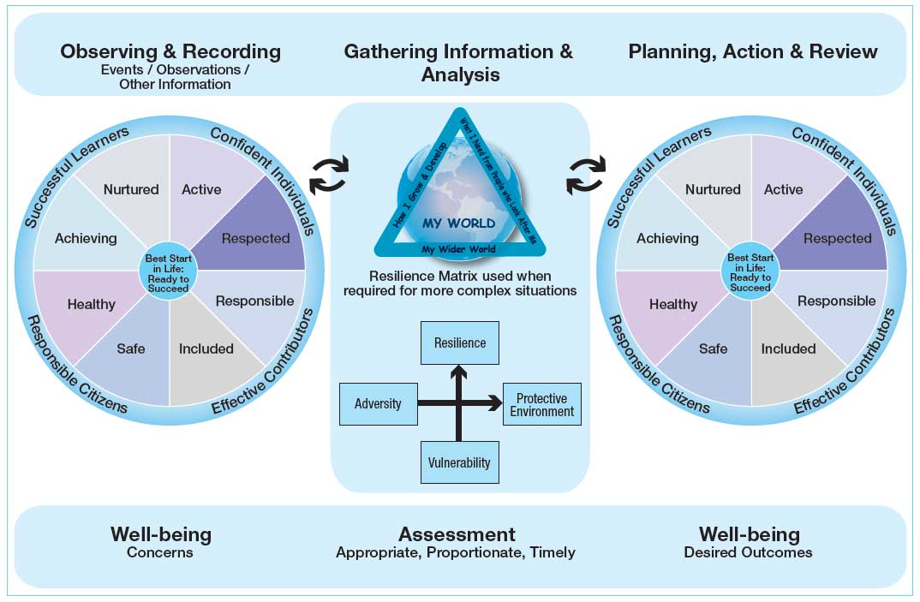

# Section 5 – Staged intervention, the Wellbeing Assessment and Plan (WAP) and planning for targeted support

A young person’s need for additional support is addressed as shown in the diagram below through a cycle of identification, assessment, planning, providing support, and then reviewing the outcomes, in accordance with the National Practice Model. In St Mungo’s Academy, the staged intervention framework guides all staff in meeting support needs. **The** **Staged Intervention process begins in the classroom and every member of staff must understand and respond appropriately to their responsibilities at each stage of intervention.**

**Stage 4:** A young person requiring support at Stage 4 has needs which can be met only by education staff, including Psychological Services, working closely with staff from other services and appropriate agencies.This may result in the creation and implementation of a Coordinated Support Plan (CSP) if significant additional support is required for an extended period due to one or more complex factors.

**Stage 3 Resources external to school but within Education services**

**Stage 2 Resources within school**

**Stage 1 Resources within the classroom**

**Stage 4 Multi-agency involvement**

**Stage 3:** Young people require levels of intervention at Stage 3 when their additional support needs cannot be fully met by staff in St Mungo’s Academy. At Stage 3, the school seeks support from other educational services such as the Psychological Service or the EAL Service. Other professionals from Social Work or Health may be asked to assess and give advice.

Request for Assistance Chronology

**Stages 1 & 2:** The needs of young people requiring additional support at Stage 1 are met within classrooms. **Class teachers** should provide support through some adjustment to the environment, curriculum, learning, teaching and assessment. **These level 1 teaching strategies are outlined in appendix 2.** The class teacher identifies that a child or young person requires support over a sustained period at a level beyond that which he or she can provide within the classroom. This should be highlighted through a ‘Request for Assistance’ referral **(Appendix 3).** It is a requirement that a clear chronology of interventions is recorded to support further planning. For some, plans are shared with all staff teaching a young person and must be known to and implemented by all staff working with a young person.

**Principal Teachers** should ensure that all staff are engaged in the SI process and know the young people in their care. They should conduct regular reviews with class teachers and monitor the progress of all young people, but particularly those who move beyond stage 1 or who have a plan. Principal Teachers should support staff in assessing the young person’s needs and agree the appropriate intervention to meet those needs. Principal Teachers are the key link between classroom teachers and Pastoral Care when supporting staged intervention.

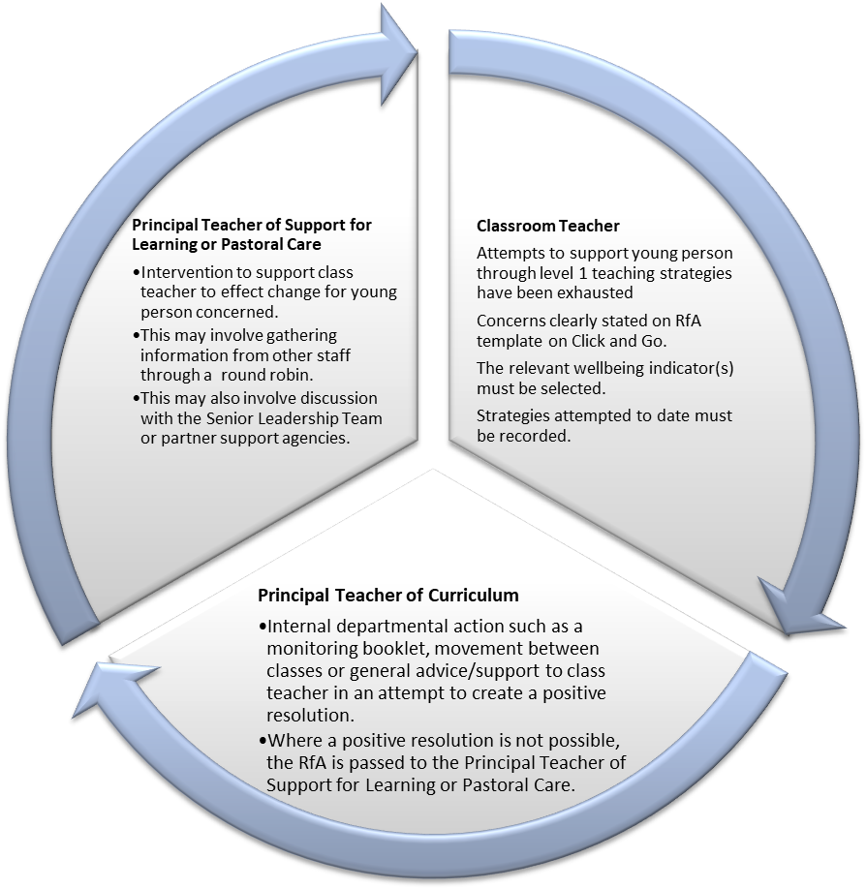

Requests for Assistance are an ongoing cycle of interventions and supports to effect positive change for the young person concerned.

It should be an ongoing chronology of all wellbeing concerns and the actions taken to address these. Staff should maintain these as a record to inform future planning.

If the RfA interventions work the RfA cycle stops but staff should continue to observe the young person and record any further concerns.

If the RfA interventions do not work, all staff concerned should work collegiately to explore further supports or interventions that may effect positive change.

## Process for submitting and responding to Requests for Assistance

## The Wellbeing Assessment and Plan (WAP)

The Wellbeing Assessment and Plan (WAP) should provide a holistic overview of the child’s wellbeing and is a means to plan for and record, the wellbeing needs and how the assessment of need has been reached. The National Practice Model provides a shared framework for all agencies who have a role in supporting, promoting and safeguarding the wellbeing of children and young people. The Wellbeing Indicators and My World Triangle are integrated within the Wellbeing Assessment and Plan. The Resilience Matrix supports the practitioner in analysing the collated information and determining the appropriate supports for the child or young person.

Assessment, planning and reporting are essential components in identifying and meeting the needs of all children and young people and particularly those who require additional support. Much assessment, planning and reporting is undertaken as part of learning and teaching and through discussion. Some form of written record, however brief, is necessary to guide the work of staff and serve as a baseline to demonstrate the effectiveness of the approaches taken.

The Wellbeing Assessment and Plan (WAP) is designed to fit with good practice in establishments. It is ultimately the responsibility of the head teacher/ head of establishment to ensure that the agreed stages of intervention are recorded against the wellbeing indicators for all children and young people requiring additional support. (In operational terms however the WAP may be completed by the PT Pastoral Care or PT Support for Learning.)

A child or young person’s need for additional support is addressed through a cycle of identification, assessment, planning, providing support, and then reviewing the outcomes. In St Mungo’s Academy, the staged intervention framework and the National Practice Model guides practitioners in meeting support needs.

|  |  |  |  |
| --- | --- | --- | --- |
| **Features of good practice in St Mungo’s Academy** | | | |
| **Identifying** | **Assessing** | **Planning and providing support** | **Reviewing** |
| Listening to and recording the views of parents/carers, children and young people.  Collaborating with partners.  Ongoing monitoring.  Inclusion Group response to concerns.  Sharing wellbeing concerns. | Using appropriate language.  Ensuring assessment approach meets the needs of the individual child.  Gathering views of a range of partners.  Discussing approaches and their outcomes.  Listening to and recording the views of parents/carers, children and young people. | Plans based clearly on outcomes and assessment.  Planned and co-ordinated support.  Appropriate classroom practice.  Listening to and recording the views of parents/carers, children and young people. | Regular formal and informal monitoring through planned self-evaluation.  Careful recording of outcomes.  Outcomes used to inform next steps and future planning.  Listening to and recording the views of parents/carers, children and young people. |

## Identification and assessment

# Section 6 – Quality Assurance

In order to achieve the aims of this policy St. Mungo’s Academy commits to rigorous quality assurance and self-evaluation, embedded in our normal cycle of review. This approach is outlined in How good is our school 4 (HGIOS4) and How good is OUR school (HGIOURS) which aims to support learner participation in self-evaluation and school improvement.

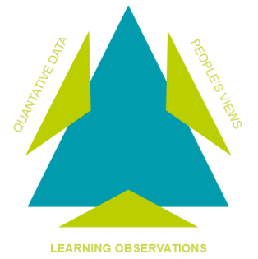

Through robust self-evaluation using quality indicators of success and challenge questions, we will gather a range of evidence on an annual basis to determine our success in ensuring that Every child is included and supported in St. Mungo’s Academy.

Senior Leaders will ensure that all every department through Principal Teachers uses this policy to review and evaluate inclusive practice. Our partner agencies will be expected to assess their own contribution to our nurturing and inclusive ethos.

This triangulation of evidence will inform our improvement planning for the next session, and will involve staff, pupils, parents and all stakeholders throughout the process. We commit to sharing the outcome in our annual standards and quality report.

# Appendix 1 – Roles and responsibilities of all staff

|  |  |  |  |  |  |  |
| --- | --- | --- | --- | --- | --- | --- |
|  | **Class/Tutor Teacher** | **Principal Teacher** | **PT Pastoral Care/SfL** | **Senior Leadership Team** | **Support for Learning Workers** | **Support Staff** |
| Create an inclusive and welcoming environment | **X** | **X** | **X** | **X** | **X** | **X** |
| Plan learning so that all young people are included | **X** | **X** | **X** | **X** |  |  |
| Ensure they have a full understanding of GCC Inclusion policy | **X** | **X** | **X** | **X** | **X** | **X** |
| Evaluate their own professional development | **X** | **X** | **X** | **X** |  |  |
| Work collaboratively with colleagues | **X** | **X** | **X** | **X** | **X** | **X** |
| Contribute to decisions about staged intervention, assessment and planning | **X** | **X** | **X** | **X** | **X** |  |
| Listen to and value the views of young people | **X** | **X** | **X** | **X** | **X** | **X** |
| Monitor and record attendance | **X** | **X** | **X** | **X** |  |  |
| Monitor and record latecoming | **X** | **X** | **X** | **X** |  |  |
| Monitor uniform | **X** | **X** | **X** | **X** | **X** |  |
| Keep children’s wellbeing at the heart of all decisions | **X** | **X** | **X** | **X** | **X** |  |
| Modelling behaviour that promotes an inclusive ethos | **X** | **X** | **X** | **X** | **X** | **X** |
| Work with parents to support all young people |  |  | **X** | **X** |  |  |

# Appendix 2 – Level 1 Teaching and Learning Strategies

[](http://www.st-mungosacademy.glasgow.sch.uk/)

**Level 1 Strategies**

**Adaptations to accommodate pupil learning styles**

Seated close to teacher

Use of individual/ single desk

Seated near board

Other seating arrangement/ seating plan

Organisation checklist

Teacher support with organisation

**Teaching and Learning**

Photocopied notes provided in advance

Use of highlighter

Extra time to complete tasks

Extra time to process information

Differentiated teaching materials

Differentiated tasks and activities

Access to ICT

Use of times-tables square

Use of wordbanks

Use of multi-media and AV resources

1:1 repetition of instructions and key points

1:1 re-enforcement to aid comprehension

1:1 homework check

Out of School hours club (such as supported study)

Interactive lessons

Easily accessible resources (e.g. less read/ writing demands)

Visual cues such as flashcards, appropriate graphics

Appropriate use of praise, encouragement and rewards

Different coloured paper and overlays

Provision for lost time due to medical appointments etc.

Individual learning targets

**Social and Emotional**

Co-operative Learning

Positive communication

Informal discussion with pupil

Opportunities for pupil to feel valued

Restorative practices

Doodle sheet

Time out

Seated beside appropriate peer for emotional support

Individual learning targets

Individual behaviour targets

Peer or Buddy support

Provision of resources e.g. pen, pencil, spare kit etc.

Allowances made to accommodate home circumstances

Quiet corner

# Appendix 3a: Request for Assistance Document

[](http://www.st-mungosacademy.glasgow.sch.uk/)

**Pupil Wellbeing and Assessment**

**2016/17**

Request for Assistance Referral

**Name: Year: House Group:**

**When referring RfA on seemis, please copy and paste the table only.**

**Please follow the guidelines in the RfA policy.**

|  |  |
| --- | --- |
| **RFA - Wellbeing Concern:** |  |
|  |  |
| **1.What is getting in the way of this young person’s wellbeing?** |  |
|  |  |
| **2. What have I done to help this young person?** |  |
|  |  |
| **INTERVENTION 1:** |  |
| **Teacher Name -** |  |
| **Date of intervention -** |  |
| **Description of intervention -** |  |
| **Impact -** |  |
|  |  |
| **INTERVENTION 2:** |  |
| **Teacher Name -** |  |
| **Date of intervention -** |  |
| **Description of intervention -** |  |
| **Impact -** |  |
| ***(Duplicate for each intervention)*** |  |
|  |  |
| **3. What can our school do to help this young person?** |  |
|  |  |
| **4. What additional help do you think others could provide e.g. parents, partner agencies?** |  |

# Appendix 3b: Request for Assistance Exemplar

[](http://www.st-mungosacademy.glasgow.sch.uk/)**Pupil Wellbeing and Assessment**

**2016/17**

Request for Assistance Referral

**Name: Pupil A Year: S1 House Group: St Andrew**

**When referring RfA on seemis, please copy and paste the table only.**

**Please follow the guidelines in the RfA policy.**

|  |  |
| --- | --- |
| **RFA - Wellbeing Concern:** | ACHIEVING. |
|  |  |
| **1.What is getting in the way of this young person’s wellbeing?** | 70% attendance. Below track in learning. Not catching up with work when absent. No homework being completed. |
|  |  |
| **2. What have I done to help this young person?** |  |
|  |  |
| **INTERVENTION 1:** |  |
| **Teacher Name -** | Teacher A. |
| **Date of intervention -** | 9.9.23 |
| **Description of intervention -** | 1-2-1 meeting. Demonstration on how to access TEAMS for class resources, homework, revision and wider achievement resources. |
| **Impact -** | Next homework returned. But then no homework following this. |
|  |  |
| **INTERVENTION 2:** |  |
| **Teacher Name -** | Teacher A. |
| **Date of intervention -** | 1.10.23 |
| **Description of intervention -** | 1-2-1 meeting. I believe that there may be financial issues at home and no access to wifi. Pupil also stated there is no quiet place to complete homework and needs to spend time looking after Gran. Offered space at lunchtime and after school to complete homework and study. |
| **Impact -** | Pupil has attended 1 lunchtime to complete homework but is still behind in course work and not passing. |
| ***Duplicate template for further interventions.*** |  |
|  |  |
| **3. What can our school do to help this young person?** | PC meeting to discuss possible barriers to studying and completing homework at home. Referral to school Inclusion Group. |
|  |  |
| **4. What additional help do you think others could provide e.g. parents, partner agencies?** | Phonecall/meeting with parent/carer. If Young Carer, consider supports from Young Carers org. |

# Appendix 3c: Request for Assistance on Seemis

Step 1 – Create a new referral for pupil on Seemis.

Step 2 – Select ‘other’ category:

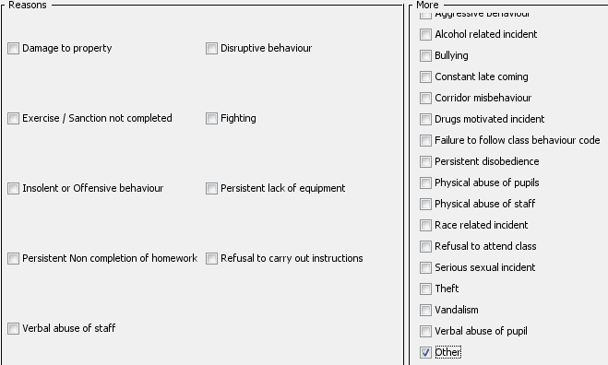

Step 3 – Copy and paste the **TABLE ONLY** from the RFA word document you completed in Appendix 3b.

Step 4 – RFA will appear as below:

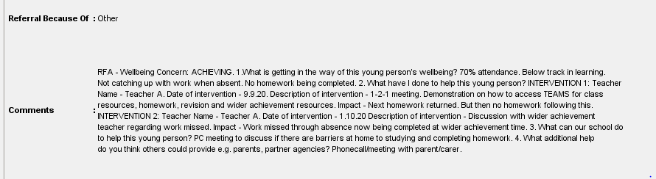

Step 5 – PT will respond with suggested strategies or pass RFA to PTPC for further advice/action.

# [St Mungo’s Academy](http://www.st-mungosacademy.glasgow.sch.uk/)Appendix 4 – Round Robin

**Pupil Wellbeing and Assessment Planning**

Round Robin

|  |  |  |  |  |  |
| --- | --- | --- | --- | --- | --- |
| **Pupil Name:** |  | **Class:** |  | **Staged Intervention Level:** |  |

|  |  |  |  |
| --- | --- | --- | --- |
| **Subject:** |  | **Teacher:** |  |
| **THE SECTION(S) MOST RELEVANT TO THE CONCERNS ABOUT A PUPIL SHOULD BE COMPLETED BELOW. (See notes over page).** | | | |

|  |  |  |  |  |  |
| --- | --- | --- | --- | --- | --- |
|  | **Description** | **AREA OF STRENGTH** | | **AREA OF RISK/CONCERN** | |
| (ü/O) | **DETAILS** | (ü/O) | **DETAILS** |
| **SAFE** | Knowing how to stay safe and making informed choices. |  |  |  |  |
| **HEALTHY** | Having the highest attainable standards of physical and mental health, access to suitable health care and support to make healthy choices and in order to access their learning fully. |  |  |  |  |
| **ACHIEVING** | Being supported and guided in their learning and in the development of their skills, confidence and self-esteem. |  |  |  |  |
| **NURTURED** | Having a sense of belonging and involvement in school and community. |  |  |  |  |
| **ACTIVE** | Having opportunities to take part in activities which contribute to healthy growth and development. |  |  |  |  |
| **RESPECTED** | Having the opportunity, along with parents/carers, to be heard. |  |  |  |  |
| **RESPONSIBLE** | Having opportunities and encouragement to play active and responsible roles in their schools and communities where necessary. |  |  |  |  |
| **INCLUDED** | Having help to overcome social, educational, physical and economic inequalities and being accepted as part of the community in which they live and learn. |  |  |  |  |

Please see advice and general examples to help with completion.

|  |  |
| --- | --- |
| **Complete by:** |  |
| **Return to:** |  |

[](http://www.st-mungosacademy.glasgow.sch.uk/)**Pupil Wellbeing and Assessment Planning**

**2016/17**

Round Robin Advice and General Examples

|  |  |
| --- | --- |
| **SAFE** | **Knowing how to stay safe and making informed choices** |
| For example:   * Makes safe choices in activities which do not put self/others at risk |
| **HEALTHY** | **Having the highest attainable standards of physical and mental health, access to suitable health care and support to make healthy choices and in order to access their learning fully** |
| For example:   * no concerns regarding health and wellbeing/specific concerns over health and wellbeing * pattern of latecoming, disorganisation and presentation (appropriately dressed for weather/tired etc), low mood |
| **ACHIEVING** | **Being supported and guided in their learning and in the development of their skills, confidence and self esteem** |
| For example:   * Details of progress, homework, assessments (summative/formative), CfE Levels, SQA levels and attainment * Is able to access the curriculum/cope with classwork * Work needs differentiation |
| **NURTURED** | **Having a sense of belonging and involvement in school and community** |
| For example:   * Appears keen to be involved in activities * Appears happy and settled in class/school |
| **ACTIVE** | **Having opportunities to take part in activities which contribute to healthy growth and development** |
| For example:   * Is involved in lessons/physical activity |
| **RESPECTED** | **Having the opportunity, along with carers, to be heard** |
| For example:   * Contributes well to discussion/learning/activities * Makes no effort to/shows no interest in learning |
| **RESPONSIBLE** | **Having opportunities and encouragement to play active and responsible roles in their schools and communities where necessary** |
| For example:   * Participation in departmental activities linked to the curriculum; outwith curriculum; takes ownership of resources; level of enthusiasm for learning; demonstrates accountability for self, others and resources * Attends class on time, behaves well |
| **INCLUDED** | **Having help to overcome social, educational, physical and economic inequalities and being accepted as part of the community in which they live and learn** |
| For example:   * Takes up opportunities to be involved in activities in the classroom * Is settled and has friends/does not appear isolated * Is not disadvantaged in any way because of perceived or real inequalities |

# References

*Every child is included and supported in St Mungo’s reflects* Glasgow City Council Education Services’ policy on inclusion. The Policy is targeted at all staff and takes account of:

* Glasgow’s developing vision for the inclusive support of all children and young people;
* *The Children and Young People (Scotland) Act 201*4 which outlines the national approach to ensuring improved outcomes for children and young people;
* *The Equality Act 2010;*
* *The Additional Support for Learning (Scotland) Act* of 2004 and its amendments of 2009;
* *Standards in Scotland’s Schools etc. Act 2000* which emphasises a presumption of mainstream education for all children and young people;
* The Scottish Government *Whole School Approach Framework for Schools to Support Children and Young People’s Mental Health and Wellbeing, 2021;*
* Consultation with stakeholders during 2009-2010 and, through a Core Consultation Group and a series of parents’ conferences, continued during 2013-2014;
* Management Circular 5a Positive Approach to the Promotion of Positive Attendance in Glasgow Schools; and
* Management Circular 5b Children missing from education.