St Mungo’s Academy
Child Protection and Safeguarding Policy and Procedures

Contents

INTRODUCTION 2
WHAT DO WE MEAN BY CHILD PROTECTION AND SAFEGUARDING? 3
WHEN WOULD A YOUNG PERSON BE AT RISK? 4
WHAT TO LOOK FOR? 5
PROCEDURES FOR ALL STAFF 6
DO’S AND DON’T’S 7
LEADERSHIP ROLES AND RESPONSIBILITIES 8
CHILD PROTECTION COORDINATOR 8
PRINCIPAL TEACHERS OF PUPIL SUPPORT 9
FURTHER INFORMATION 10

INTRODUCTION

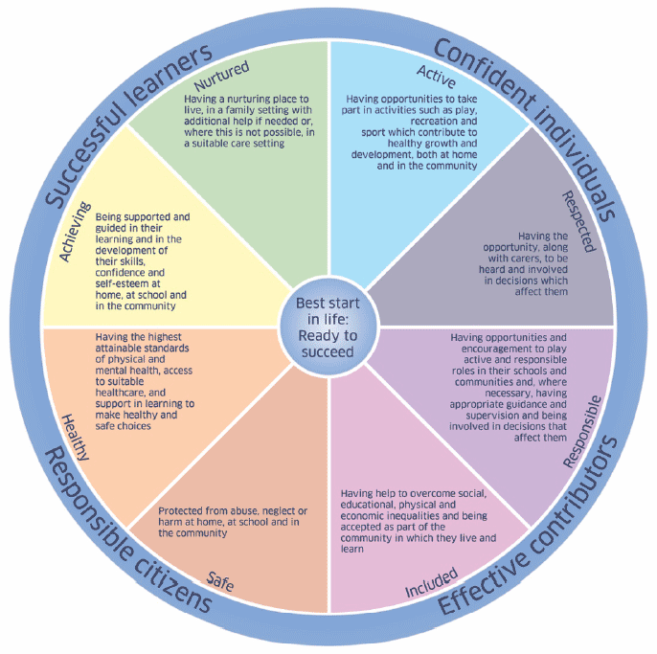
At St Mungo’s Academy we aim to ensure all young people are supported through both universal and targeted support in order to thrive in both their learning and wider achievement. We reflect the requirements of legislation and ensure that these are being met through all staff having a full understanding of GIRFEC policy. Our policy and practice, which places the child at the centre, acknowledge that all staff have a responsibility to recognise and actively consider potential risks to a young person.
All staff have a crucial role in the support and protection of young people as well as the development of their wellbeing and know that they are expected to identify and consider the young person’s needs, share information and concerns with other agencies in order to improve outcomes for the young person. We create and maintain a positive ethos and climate which actively promotes child welfare and a safe environment by:

- Ensuring as far as possible that the school environment is a positive, safe space for young people which is reflective of our values of Faith, Hope and Love;
- Ensuring that Children’s Rights as outlined by the UNCRC are respected and listened to, and we continue to uphold our responsibilities as a Gold Rights Respecting School;
- Providing a Key Adult for all young people in addition to their Pastoral Care teacher;
- Ensuring that programmes of health and personal safety are central to the curriculum;
- Ensuring that all staff and visitors are aware of child protection issues and procedures;
- Conducting open conversations inside and outside the classroom to help young people recognise potentially abusive behaviours, identify trusted adults who they can talk to and offer information about support services;
- Providing children and young people with opportunities to learn about sexual health and relationships through our Religious Education curriculum;
- Providing children and young people with opportunities to learn about drug and alcohol education, relationships, e-technology and bullying through our Personal, Social and Education (PSE) curriculum;
- Establishing and maintaining close working relationships and arrangements with all other agencies to make sure that professionals collaborate effectively in protecting children.

WHAT DO WE MEAN BY CHILD PROTECTION AND SAFEGUARDING?

CHILD PROTECTION
The processes involved in consideration, assessment and planning of required action, together with the actions themselves, where there are concerns that a child may be at risk of harm from abuse, neglect or exploitation.

SAFEGUARDING
This is a much wider concept than child protection and refers to promoting the welfare of children, young people and protected adults. It encompasses protecting from maltreatment, preventing impairment of their health or development, ensuring that they are growing up in circumstances consistent with the provision of safe and effective care, and taking action to enable all children, young people and protected adults to have the best outcomes. Child protection is part of this definition and refers to activities undertaken to prevent children suffering, or likely to suffer, significant harm.
Every child, young person and protected adult, at all times, has a right to feel safe and protected from any situation or practice which may result in harm.
Child Protection and Safeguarding Policy, Education Scotland (2021)
We have a distinctive approach to safeguarding in Scotland linked to Getting It Right for Every Child (GIRFEC) which promotes action to improve the wellbeing of every child and young person. Safeguarding is a golden thread that runs through the curriculum. The aim is to support the development of learners’ knowledge, skills and resilience to keep themselves safe and protected, and to develop an understanding of the world so that they can respond to a range of issues and potential risky situations arising throughout their lives. As such, it permeates many features of the education experience including leadership, values, vision, the curriculum, learning and teaching, positive relationships, building learner resilience and suchlike.

WHEN WOULD A YOUNG PERSON BE AT RISK?

Any young person could be at risk from several types of abusive behaviour:
- Physical abuse – causing physical harm to a child or young person through hitting, shaking, burning, scalding, drowning or suffocating. This can also happen when a parent or carer feigns symptoms or deliberately causes ill-health.

- Sexual abuse – any act involving sexual gratification of another person whether or not it is claimed the child consented. This can involve forcing or enticing a child to take part in sexual activities, including penetrative and non-penetrative acts. It can also involve non-contact activities such as looking at or producing pornography, watching sexual activities, using sexual language or encouraging sexualised behaviour.
The sexual abuse of children by other children is a specific safeguarding issue in education.
- Emotional Abuse – this is the persistent emotional neglect or ill treatment that has severe and persistent adverse effects on a child’s emotional development. It may involve conveying to a child that they are worthless or unloved, inadequate or valued only insofar as they meet the needs of another person. It may involve the imposition of age or developmentally-inappropriate expectations on a child. It may involve causing children to feel frightened or in danger, or exploiting or corrupting children. Some level of emotional abuse is present in all types of ill-treatment of a child; it can also occur independently of other forms of abuse.

- Neglect - Neglect is the persistent failure to meet a child’s basic physical and/or psychological needs, likely to result in the serious impairment of the child’s health or development. It may involve a parent or carer failing to provide adequate food, shelter and clothing, failing to protect a child from physical harm or danger, or to ensure access to appropriate medical care or treatment. It may also include neglect of, or failure to respond to, a child’s basic emotional needs. Neglect may also result in the child being diagnosed as suffering from non-organic failure to thrive where they have significantly failed to reach healthy weight and growth or development milestones, and where physical and genetic reasons have been medically eliminated.

In its extreme form, children can be at serious risk from the effects of malnutrition, lack of nurturing and stimulation. This can lead to serious long-term consequences such as greater susceptibility to serious childhood illnesses and reduction in potential stature.

WHAT TO LOOK FOR?

There are many reasons you may have a concern over a young person and most often several unimportant seeming issues combine to build a picture. These may include:
- Unexplained bruising
- Appearing afraid, quiet or withdrawn
- Appearing afraid to go home
- Appearing hungry, tired or unkempt
- being left unattended or unsupervised
- having too much responsibility fopr their age
- misusing drugs or alcohol

SPECIFIC GROUNDS FOR CONCERN
If you have a specific concern you must notify Mr Mark Ruddy (Depute Head Teacher and Child Protection Coordinator) or the Head Teacher on the grounds of:
- a specific incident or disclosure
- information from a third party
- adult behaviour that may place the child at risk
- Young person behaviour that may place themselves or others at risk
- A culmination of minor concerns over time

PROCEDURES FOR ALL STAFF
"Everyone has a responsibility to protect young people and protected adults.
Child Protection and Safeguarding Policy, Education Scotland (2021)

It is everyone’s responsibility to pass on concerns to protect children in our care. This includes permanent members of staff, supply teachers, students, visiting specialist or Partnership workers.

IF YOU HAVE A CONCERN
- Be calm, don’t panic.
- Act on your concern. Don’t ignore.
- Complete Management Circular 57 (MC57) Appendix 3 and hand to the Child Protection Coordinator. Electronic copies are saved in: St Mungo’s Staff Team > General > Files > Child Protection.
- The completed form must be handed to the Child Protection Coordinator (never left on desk or in tray).
- At St Mungo’s Academy the Child Protection Coordinator is Mr Mark Ruddy (Depute Head Teacher) or, in his absence, the Head Teacher.
- No matter how small, tell the Child Protection Coordinator your concern, it might be part of a bigger picture.
- Never go home without passing on your concerns to the Child Protection Coordinator
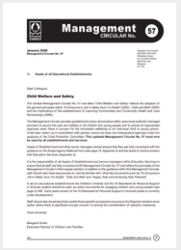
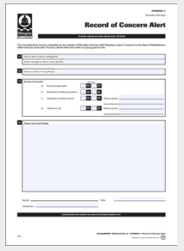

DO’S AND DON’T’S

DO:
- Stay calm
- Listen to the child
- Keep any questions to a minimum
- Reassure the child that they are right to have told you
- Tell the child what you're going to do next
- Record in the child's own words what has been said
- Act promptly and immediately report to Mr Mark Ruddy (Depute Head Teacher)

DON’T:
- Ask unnecessary questions. You can clarify what the child is telling you, but do not probe, or push the child to say more than they want to
- Make any false promises
- Express shock or anger at what is being said to you
- Interpret what the child is saying to you, just record and report
- Delay listening to the child or passing on your concerns
- Carry out an investigation into the allegation

LEADERSHIP ROLES AND RESPONSIBILITIES

CHILD PROTECTION COORDINATOR

The Child Protection Coordinator has lead responsibility for child protection and safeguarding, including:
- Staff induction;
- Ensuring that all staff are aware of the school’s child protection procedures and any amendments to them;
- Overseeing the planning of any curricular provision designed to give children the knowledge and skills to keep themselves safe;
- Understanding the specific needs of children in need, those with special educational needs and young carers;
- Keeping detailed, accurate, secure written records of concerns and referrals;
- Referring notifications of concern the statutory agencies;
- Supporting staff who raised the concern;
- Liaising with other agencies, e.g. Police, Social Work (Children and Family Services), Health, the Children’s Reporter in matters relating to Child Protection;
- Listening and responding to general concerns raised by staff, pupils and parents/carers in relation to Child Protection;
- Delegating responsibilities to the most appropriate person;
- Review the school’s procedures annually;
- Audit child protection at regular intervals;
- Liaising with Glasgow City Council Child Protection Development Officer;
"Above all, the welfare of children, young people and protected adults is the paramount consideration and we must all work together to ensure they are protected."
Child Protection and Safeguarding Policy, Education Scotland (2021)

PRINCIPAL TEACHERS OF PUPIL SUPPORT

Principal Teachers of Pupil Support advocate on behalf of the young person and will be involved throughout the process, including:
- Working with the young person and their family to ensure they are fully supported.
- Working with the Campus Police Officer.
- Referral to external agencies e.g. Action for Children, CAMHS, Barnardo’s.
- Meeting with external agency staff such as Social Worker, Educational Psychologist, Youth Worker.
- Maintaining accurate records including Pastoral Notes.
- Updating Meeting Learners' Needs documentation.
- Notifying staff of relevant and sensitive information.
- Following STAGED Intervention Procedures.
- Carry out risk assessment in relevant cases.
- Working with the Inclusion Team and families to support attendance

FURTHER INFORMATION

This policy and all supporting documents are available in the St Mungo’s Academy Staff Team.

LOCAL AND NATIONAL POLICIES
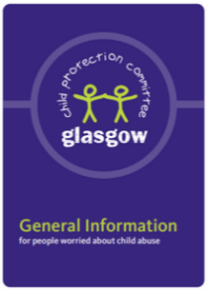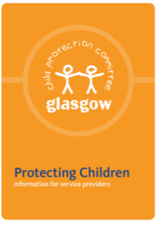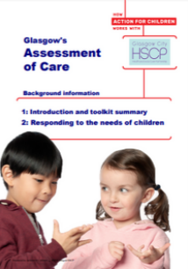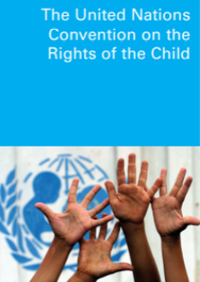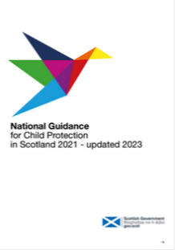
Scottish Government - Child Protection
Scottish Government - Getting it right for every child
Glasgow City Council - Child Protection
Children and Young People (Scotland) Act 2014

