How to run 1 mile
1
Go to the track and walk the mile. Work on getting an even, quick pace and breathing evenly. Gradually quicken your walking pace. Do not train every day. Your muscles need to recover, so take Saturday and Sunday off.
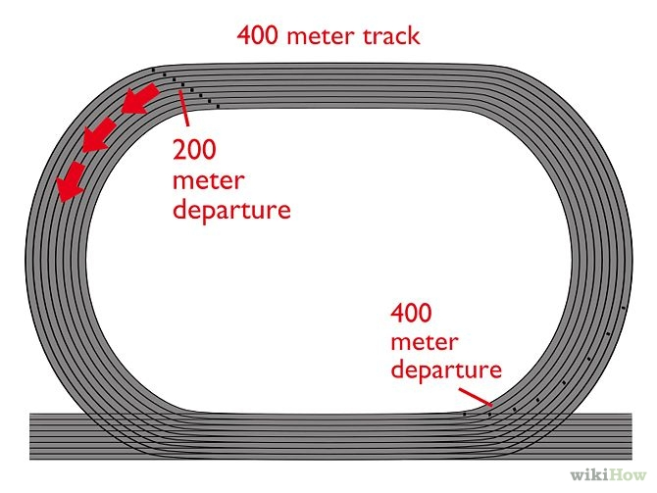
•Train for only a moderate amount of time each day. A mile of quick walking takes 15 minutes. When you multiply that by 2, you go two miles in 30 minutes. To start out, go for 15 minutes. Then, increase to 30 minutes if you want to
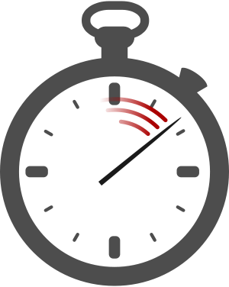
2
Don't worry about your grades suffering. It is only 15 - 30 minutes a day. That amount of time won't affect your studies. In fact, the extra exercise may improve your grades over time.

3
Do not run in snow. You can slip on ice. In snow or ice, it's safer to run indoors.

4
Notice how much you've improved already. Now that you've mastered walking a mile, your time should be around 14 minutes. You may even beat your class mates or a competitor. Keep your improvement in mind to raise your spirits as you take the next steps.
5
Gently jog your first lap. On a standard track, a lap is a quarter mile, and lap 1 is the easiest since you have a lot of energy. •If jogging an entire quarter mile is still challenging, alternate jogging with walking, then gradually increase how much of the quarter mile you jog.
6
Master jogging your first lap. It may take a couple weeks, your time for the mile should be 12 minutes, if you jog lap 1.

7
Master jogging the fourth lap, too. Think of it as "just one more lap" and use that for encouragement. Aim for a mile time around 10:30 minutes.

8
Now try jogging the second lap too. Lap 2 is a fair lap, no mental support, no physical support. Aim for around 9:00 minutes for the complete mile.

9
Master jogging the third lap. Lap 3 is the hardest. You are over half-way finished and feel like you still have a long way to go. This makes it hard, mentally. Once you finish this and can jog all 4 laps, your time should be around 8 minutes.
10
Look how much you have improved. By now you will probably be coming in ahead of a few people, and more than half of your P.E class. Most teenagers run a mile in about 9 minutes.
Now write down your time __________
Now give yourself a target time __________

Further Improving your time
1
Try adding some sit-ups to your routine. Notice the improvement. That is how much stronger you are.
2
Jog as hard as you can, and notice that you will be tired easily. It is twice as hard.
3
Master fast jogging the first lap. You will eventually shave about 30 seconds from each lap. Plan on improving a lap per month. You should have a 7:25 mile.
4
Master fast jogging the fourth lap. If all goes well, you will soon have a 7 minute mile.

