‘How to’ measure Standing Long Jump
1.
Always complete a warm up before you begin jumping. A warm up is important to increase your heart rate and reduce the risk of getting injured. 10 minutes jogging/exercising.
2.
Do some stretching exercises to make sure your muscles are flexible and this will help you to jump further. 3 important muscle groups found in your legs are your quadriceps at the top/front, the hamstrings at the top/back and the calf muscles at the bottom/back of your legs.
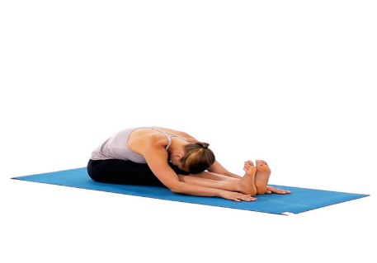
Quadricep Stretch Hamstring Stretch Calf Stretch

3.
Use a tape measure set up on the floor at the side.
Get someone to watch and measure for you.

4.
Put your toes behind the starting line.
Bend your knees and swing your arms.
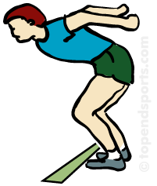
5.
Jump up and forward, as far as you can.
Try and land steady so the distance can be measured accurately, to the back of your feet.
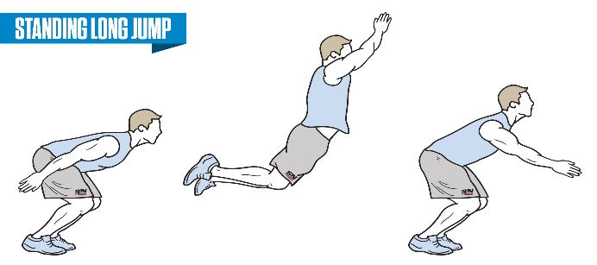
6.
Don’t step back. If you step back or fall back you measure to the furthest back where you touch the ground.
7.
Your score is the best of the three attempts.
8.
Now write down your best score.
History of Standing Long Jump
9. The standing long jump, also known as the standing broad jump, was an Olympic event until 1912.

10.Ray Ewry set the first world record for the standing long jump at 3.47 m on September 3, 1904.
The current world record is held by Byron Jones, who recorded a jump of 3.73 m on February 23, 2015.

11. Today, Norway is the only country where the standing long jump is a national championship event. The Norwegian Championships in Standing Jumps (long jump and high jump) has been held in Stange every winter since 1995.

Further Improving your distance
12.
Stretching: do some stretching exercises for the three important leg muscle groups. 10 minutes each day would help keep your muscles flexible.
13.
Strength: do some exercises to build up strength in your leg muscles, like step ups, star jumps, vertical bounce or just walking/running up steps.

