St Mungo’s Academy
Mathematics Department

REVISION NOTES
National 5 Maths
Enabling you to be engaged in
BRINGING OUT YOUR BEST



Contents
Unit 1 : Expressions and Formulae:
Unit 1 Outcome 1: ......................................................................3
Applying numerical skills to simplify surds/ expressions using the laws of indices
1.1.1 Working with surds 3
1.1.2 Simplifying expressions using the laws of indices (A: using indices B: Scientific Notation ) 4
Unit 1 Outcome 2: ......................................................................8
Applying algebraic skills to manipulate expressions
1.2.1 Expansion of brackets 8
1.2.2 Factorising an algebraic expression 9
1.2.3 Completing the square in a quadratic expression with unitary x² co-efficient 13
Unit 1 Outcome 3: ......................................................................14
Applying algebraic skills to algebraic fractions
1.3.1 Reducing an algebraic fraction to its simplest form 14
1.3.2 Applying one of the four operations to algebraic fractions 14
Unit 1 Outcome 4: ......................................................................17
Applying geometric skills linked to the use of formulae
1.4.1 Determine the gradient of a straight line given two points 17
1.4.2 Calculating the length of arc or the area of a sector of a circle 19
1.4.3 Calculating the volume of a standard solid 21
1.4.4. (Rounding to a given number of significant figures) 23
Unit 1 Outcome 5: ......................................................................24
Reasoning skills
1.5.1 Interpreting a situation where mathematics can be used and identifying a strategy 24
1.5.2 Explaining a solution and/or relating it to context 24

Unit 2 : Relationships
Unit 2 Outcome 1: ......................................................................25
Applying algebraic skills to linear equations
2.1.1 Determining the equation of a straight line given the gradient 25
2.1.2 Working with linear equations and inequations. 29
2.1.3 Working with simultaneous equations. 30
2.1.4 Changing the subject of a formula. 33
Unit 2 Outcome 2 : ......................................................................34
Applying algebraic skills to graphs of quadratic relationships
2.2.1 Recognise and determine the equation of a quadratic function from its graph 34
2.2.2. Sketching a quadratic function 36
2.2.3 Identifying features of a quadratic function 37
Unit 2 Outcome 3 : ......................................................................38
Applying algebraic skills to quadratic equations
2.3.1 Working with quadratic equations 38
Unit 2 Outcome 4 : ......................................................................42
Applying geometric skills to lengths, angles and similarity
2.4.1 Applying Pythagoras (A: In circles B: Converse C: 3D) 42
2.4.2 Applying the properties of shapes to determine an angle involving at least two steps 47
2.4.3 Using similarity 49
Unit 2 Outcome 5: ......................................................................51
Applying trigonometric skills to graphs and identities
2.5.1 Working with graphs of trigonometric functions 51
2.5.2 Working with trigonometric relationships in degrees 54

Unit 2 Outcome 6: ......................................................................57
Reasoning skills
2.6.1 Interpreting a situation where mathematics can be used and identifying a strategy 57
2.6.1 Explaining a solution and/or relating it to context 57
Unit 3 Outcome 1 ....................................................................58
Applying trigonometric skills to triangles which do not have a right angle
3.1.1 Calculating the area of a triangle using trigonometry 58
3.1.2 Using the sine and cosine rules to find a side or angle 59
3.1.3 Using bearings with trigonometry 62
Unit 3 Outcome 2: ......................................................................63
Applying geometric skills to vectors
3.2.1 Working with 2D vectors 63
3.2.2 Working with 3D coordinates 64
3.2.3 Using vector components 65
Unit 3 Outcome 3: ......................................................................67
Applying numerical skills to fractions and percentages
3.3.1 Working with percentages 67
3.3.2 Working with fractions 71

Unit 3 Outcome 4: ......................................................................73

Applying statistical skills to analysing data
3.4.1 Comparing data sets using statistics 73
3.4.2 Forming a linear model from a given set of data 81
Unit 3 Outcome 5: ......................................................................82

Reasoning skills
3.5.1 Interpreting a situation where mathematics can be used and identifying a strategy 82
3.5.2 Explaining a solution and/or relating it to context 82

Index of Key Words.................................................................83

Acknowledgement .................................................................. 84

Unit 1

Unit 1 : Expressions and Formulae:
Unit 1 Outcome 1:
Applying numerical skills to simplify surds/ expressions using the laws of indices
1.1.1 Working with surds
A:Simplification

Definition: a surd is a square root (or cube root etc.) which does not have an exact
answer. e.g. $\sqrt{2}$ = 1.414213562... , so 2 is a surd. However $\sqrt{9}$ = 3 and $\sqrt[3]{\text{64}}$ = 4 ,
so $\sqrt{9}$and $\sqrt[3]{\text{64}}$are not surds because they have an exact answer. To simplify a surd,
you need to look for square numbers that are factors of the original number.

Example 1
Express $\sqrt{\text{75}}$ and $\sqrt{\text{98}}$ in their simplest form.

Solution:
$$\sqrt{\text{75}}=\sqrt{\text{25}} x \sqrt{3}$$
$=5 \sqrt{3}$

$$\sqrt{\text{98}}=\sqrt{2} x \sqrt{\text{49}}$$
$=7 \sqrt{2}$
You can only add or take away surds when the number underneath the surd sign is the
same.
e.g. Simplify $\sqrt{5}$ +$\sqrt{3}$ is NOT $\sqrt{8}$ . Instead the simplest answer is$\sqrt{5}$ + $\sqrt{3}$
(i.e. no change), because no simplifying is possible.

Example 2 (Harder)
Write as a surd in its simplest form: $\sqrt{\text{63}}$ + $\sqrt{7}$ - $\sqrt{\text{28}}$

Solution
$\sqrt{\text{63}}$ + $\sqrt{7}$ - $\sqrt{\text{28}}$
=$\sqrt{9}\sqrt{7}$ + $\sqrt{7}$ - $\sqrt{4}\sqrt{7}$ Step One – simply all three surds
=$3\sqrt{7}$ + $\sqrt{7}$ - $2\sqrt{7}$ Step Two – add and take away
=$2\sqrt{7}$

B:Rationalising denominators

Example 3
Express $\frac{4}{\sqrt{5}}$ with a rational denominator
Solution

$\frac{4}{\sqrt{5}}$x $\frac{\sqrt{5}}{\sqrt{5}}$= $\frac{4\sqrt{5}}{5}$

1.1.2 Simplifying expressions using the laws of indices

A: Multiplication and division using positive and negative indices including fractions

Basic Rule 1: anything to the power 0 is equal to 1:
e.g. $9^{0}{\text{ =1 32}}^{0}{\text{ =1 548}}^{0}\text{= 1}$
Basic Rule 2: anything to the power 1 is equal to itself:
e.g. $9^{1}{\text{ = 9 32}}^{1}{\text{ =32 548}}^{1}\text{ = 548}$

Key Rule 1: when you multiplying two expressions involving powers, you add the
numbers in the power: a^{m} x a^{n} = a^{m+n}
e.g. x² x x⁵ = x⁷ and y⁻³ x y⁷ = y⁻³⁺⁷ = y⁴
Key Rule 2: when you divide two expressions involving powers, you take away the
numbers in the power: = $a^{m}÷{\text{ a}}^{n}{\text{ = a}}^{\text{m-n}}$

e.g. $x^{\text{10}} ÷{\text{ x}}^{6}{\text{ = x}}^{4}$ and $\frac{p^{7}}{p^{2}} ÷{\text{ = p}}^{5}$

Key Rule 3: when you have one power to the power of another, you multiply the numbers
in the power: (a^{m})^{n} = a^{mn}
e.g. (x³ )⁴= x¹² and (f⁵ )⁻² = f⁻¹⁰

Negative Powers
A negative power is all to do with dividing. In general a^{-m} =$\frac{1}{a^{m}}$
e.g. $3^{−2}=\frac{1}{3^{2}}=\frac{1}{9}$ $a^{−4}=\frac{1}{a^{4}}$ ${\text{5x}}^{−2}=\text{5 } x \frac{1}{x^{2}}=\frac{5}{x^{2}}$

Example 1
Rewrite 3 x ⁻⁴ using positive powers
Solution
$$\frac{3}{x^{4}}$$
Fractions in Powers
A fraction as a power is to do with a root (square root, cube root etc.) of some form.
$\begin{aligned}x^{\frac{2}{5}} \\ \sqrt[5]{x^{2}} \\ \left(\sqrt[5]{x^{2}}\right)\end{aligned}$In general, $a^{\frac{m}{n}}=\sqrt[n]{a^{m}}=\sqrt[n]{a^{m}}$
$\begin{aligned}{\text{64}}^{\frac{1}{3}} \\ \sqrt[3]{{\text{64}}^{1}} \\ 4^{1}=4\end{aligned}$$\begin{aligned}9^{\frac{3}{2}} \\ \sqrt{9^{3}} \\ 3^{3}=\text{27}\end{aligned}$e.g.

Exam Style Questions Involving Indices
You need to be able to handle questions using a mixture of these rules.
Example 2
Simplify ${\text{25}}^{−\frac{1}{2}}$
Solution
${\text{25}}^{−^{\frac{1}{2}}}=\frac{1}{{\text{25}}^{\frac{1}{2}}}=\frac{1}{\sqrt{\text{25}}}=\frac{1}{5}$

Example 3
Simplify 3x²(x⁻²+2x⁵)
Solution 3x²(x⁻²+2x⁵)
=3x²⁺⁻²+6x²⁺⁵
=3x⁰+6x⁷
=3(1) +6x⁷
=3 + 6x⁷

B: Calculations using scientific notation
Definition : Standard form (also known as Scientific notation) is a quicker way of
showing really large or really small numbers.
Definition : a number written normally is said to be “in normal form”.

A really small number (one that begins ‘zero point…’ e.g. 0.02 or 0.00015) will have
a negative number in the power when written in standard form

Example 4
Normal Form | Standard Form
92 000 000 | 9.2 × 10⁷
0.000456 | 4.56 × 10⁻⁴
305 000 | 3.05 × 10⁵

I:Changing Numbers from Standard Form into Normal Form
The basic rule for changing numbers back into normal form (or “writing a number in
full”) is to move the digits the number of places shown by the power.
If the power is positive, move the digits to the left, if it negative, move to the right.

Example 5
Change 6.3×10⁵ into normal form

Solution
Start with the number 6.3. Move the digits 5 places to the left.
Answer: 630 000

Example 6
Write 2.15×10⁻³ in full

Solution
Start with the number 2.15. Move the digits 3 places to the right.
Answer: 0.00215 (Note -3 power and 3 zeros at the start)

II: Changing Numbers from Normal Form into Standard Form
The number before the times sign has to be between 1 and 10. An easy way of
making this number is to put a point after the first digit:
· e.g. for 235000, we use 2.35 (and not 235)
· e.g. for 70543, we use 7.0543
· e.g. for 0.00027, we use 2.7

Example 7
Change 85000 into standard form

Solution
Step one – putting a decimal point after the first digit gives us 8.5. So our
number is 8.5×10?
Step two – count how many times you have to move the digits to go
from 8.5 to 85000. The answer is 4.
Answer: 8.5×10⁴

Example 8
Write 0.0027 in standard form

Solution
Step one – putting a decimal point after the first digit gives us 2.7. So our
number is 2.7×10?
Step two – count how many times you have to move the digits to go
from 2.7 to 0.0027. The answer is 3. However we are going backwards to do
this as the number is less than zero, so the power has to be negative (i.e. it is
–3)
Answer: 2.7×10⁻³

Example 9
Write 4008500 in standard form

Solution
Step one – putting a decimal point after the first digit gives us 4.0085. So our
number is 4.0085×10?
Step two – count how many times you have to move the digits to go
from 4.0085 to 4008500. The answer is 6.
Answer: 4.0085×10⁶

Example 10
Calculate 280 x 4 × 10⁶ and answer in standard form

Solution
280 x 4 000 000 = 1 120 000 000
= 1.12 x 10⁹
In Paper 2 this is easier if you use scientific mode on your calculator.
THIS IS YET ANOTHER REASON FOR HAVING YOUR OWN SCIENTIFIC CALCULATOR. YOU GET TO KNOW HOW IT WORKS AND BECOME CONFIDENT.

Unit 1
Unit 1 Outcome 2:
Applying algebraic skills to manipulate expressions
1.2.1 Expansion of brackets

- a(bx+c) + d(ex+f)
- ax(bx+c)
- (ax+b)(cx+d)
- (ax+b)(cx²+dx+f)
To multiply out double brackets, you have to multiply every term in the first bracket
by every term in the second bracket. You always need to simplify your answers:
be very careful with negative signs.

Example 1
Expand and simplify 4(3x-2) + 3(2x+3)

Solution
4(3x-2) + 3(2x+3)
= 12x -8 +6x +9
= 18x + 1

Example 2
Expand and simplify 4x(2x-3)

Solution
4x(2x-3) = 8x² -12x
Example 3 (Basic)
(x-7)(x-9)=x²-9x-7x + 63

= x²- 16x + 63
(2x+3)(x-4)=2x²-8x+3x -12

= 2x²- 5x - 12

Example 4 (Squaring brackets)
(x + 3)² is NOT x² + 9 . Instead you have to rewrite (x + 3)² as (x + 3)(x + 3)

(x+3)²=(x+3)(x+3)
=x²+ 3x + 3x + 9
= x²+ 6x + 9

Example 5 (Exam style questions with three terms in one bracket)
In these examples, the basic method is still the same, however you will have to do
more multiplications. These questions will usually involve a term in x³.
(x+4)(3x²-2x+ 5)= 3x³-2x²+ 5x +12x² -8x + 20
= 3x³ + 10x² -3 x + 20
Notice that 2 terms times 3 terms gives 6 terms initially.

1.2.2 Factorising an algebraic expression
This is the inverse process to expanding brackets. We put brackets in.

- Common factor
- Difference of squares p²x²- q²
- Common factor with difference of squares
- Trinomials with unitary x² coefficient
- Trinomials with non-unitary x² coefficient

A: Common Factor (from National 4)
Example 1
Factorise 5x - 15
Solution
5x – 15 = 5(x - 3)
B: Difference of two Squares
It is called Difference of Two Squares. You can spot it because:
· There are only two terms
· They are being taken away (a difference)
·
The method:
Step 1 – write down two brackets
Step 2 – put a + sign in one bracket and a – sign in the other. (it does not matter which way around they go).
Step 3 – identify what goes at the start and end of each bracket.

Both terms are squares (letters (x², a²,...), square numbers (25, 81,...) or both)
Example 2
Factorise a² – b²
Solution
Step 1 – ( ) ( ) Step 2 – ( + ) ( – )
Step 3 – to make a² you do a ×a, so a goes at the start of each bracket. To
make b² you do b ×b, so b goes at the end of each bracket.
Answer: (a + b)(a - b )

Example 3
Factorise 4x² - 25
Solution
Step 1 – ( ) ( ) Step 2 – ( + ) ( – )
Step 3 – to make 4x² you do 2x × 2x, so 2x goes at the start of each bracket. To
make 25 you do 5 × 5, so 5 goes at the end of each bracket.
Answer: (2x + 5)(2x - 5)

Example 4
Factorise 2x² – 32
Solution
2 and 32 are not square numbers, so we cannot use this method (yet).
However we can take out a common factor of 2, to give 2(x² - 16) . We can
use this method on x² - 16 , so we can complete the factorisation.
Answer: 2(x + 4)(x - 4)

C: Factorising Quadratic Expressions
A quadratic expression is one that contains a term in x². Examples include
x² + 4x + 3 , x² - 4x - 5 or 3x² + 7x - 6 . These factorise into two brackets.
Key fact:
· The numbers in the brackets multiply to give the number at the end – e.g.:
· For x²+ 4x + 3 , the two numbers in the bracket will multiply to give 3.
· For 3x² + 7x - 6 , the two numbers in the bracket will multiply to give –6.

Example 5 (easier – where it is just x² at the front)
Factorise x² - x - 12
Solution
Step 1 – make a list of all possible pairs of numbers
The two numbers in the bracket will multiply to give –12. So possibilities are:
(1,-12) (2.-6) (3, -4) (4,-3) (6,-2) and (12,-1)

Step 2 – To make x², you do x × x, so put x and x at the start of each bracket.
(x )(x )

Step 3 – experiment : try different pairs of numbers in the bracket as shown below. Multiply across the cross until you get x² - x - 12 .

Answer: (x +3)(x - 4)

Example 6 (harder – where there is a number before x²)
Factorise 3x² + 11x + 6
Solution
Step 1 – make a list of all possible pairs of numbers – order matters.
The two numbers in the bracket will multiply to give +6. So possibilities are:
(1,6) (2.3) (3,2) and (6,1) (technically we should also consider (–6, –1) ( –3, –2) etc. as these also multiply to give +6. However in this question we can ignore negative numbers as there are no negative signs in the question )
Step 2 – To make x², you do 3x × x, so put 3x and x at the start of each bracket.
(3x )(x )
Step 3 – experiment – try different pairs of numbers in the bracket. Multiply
the brackets out to see if you can get 3x² +11x + 6 .

Answer: (3x + 2)(x + 3)

1.2.3 Completing the square in a quadratic expression with unitary x² co-efficient

Example 1
QUICK WAY
(x²-6x) + 14
= (x-3)² + 14 -9
= (x-3)² + 5
p=3 and q=5

x ²– 6x + 14 is written in the form (x – p)² + q, what is the value of q?

Solution
(x – p)² + q = x² - 2px + p² + q

$\begin{aligned}{\text{ p}}^{2}+q=\text{14} \\ ⇒9+q = \text{14} \\ ⇒q=5\end{aligned}$Match up: $−\text{2px}=−6 ⇒p=3$ and

Example 2
x ²– 8x + 7 is written in the form (x – a)²+ b, what is the value of b?
QUICK WAY
(x²-8x) + 7
= (x-4)² + 7 - 16
= (x-4)² - 9
a=4 and b=-9

Solution
(x – a)²+ b = x² – 2ax + a² + b

Match up: $−\text{2ax}=−8 ⇒a=4$ and

Example 3
x ² + 10x - 7 is written in the form (x + p)² - q, what is the value of q?
QUICK WAY
(x² + 10x) - 7
= (x+5)² -7-25
= (x+5)² - 32
p=5 and q=32

Solution
(x + p)²+ q = x² + 2px + p² - q
$\begin{aligned}{\text{ p}}^{2}−q=−7 \\ ⇒\text{25}−q =−7 \\ ⇒q=\text{32}\end{aligned}$
Match up: $\text{2px}=\text{10 } ⇒p=5$ and

Elsewhere we see how this can help to find turning points and sketch quadratic graphs.

Unit 1
Unit 1 Outcome 3:
Applying algebraic skills to algebraic fractions
1.3.1 Reducing an algebraic fraction to its simplest form

You can simplify a fraction when there is a common factor (number or letter) on the
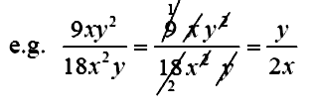
top and on the bottom.

In some examples, you may need to factorise before you can simplify.
Example 1
Simplify: $\frac{v^{2}\text{-1}}{\text{v-1}}$
Solution:

Example 2
$\frac{{\text{2a}}^{2}+\text{a-1}}{{\text{2a}}^{2}+\text{5a-3}}$Simplify:
$\frac{{\text{2a}}^{2}+\text{a-1}}{{\text{2a}}^{2}+\text{5a-3}}=\frac{(\text{2a}−1)(a+1)}{(\text{2a}−1)(a+3)}=\frac{(a+1)}{(a+3)}$
Solution:

1.3.2 Applying one of the four operations to algebraic fractions
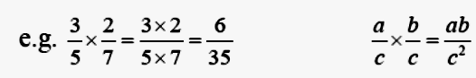
Multiplying Fractions
Multiplying fractions is the straightforward procedure – you multiply the tops and
multiply the bottoms.
It is easiest to cancel before you multiply.
You are allowed to cancel anything from the top row with anything from the bottom row.

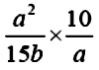
Example 1
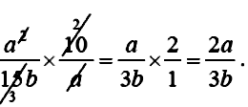
Simplify:
Solution
Cancelling gives:
Dividing Fractions
To divide two fractions, you turn the second fraction upside down, and change the
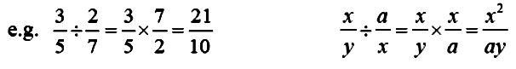
sum to be a multiply sum:

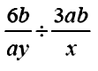
Example 2
Divide and simplify:
Solution
Flip the second fraction upside down and multiply:
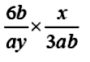
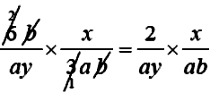
Cancel:

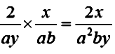
Multiply:

Adding and Subtracting Fractions
You can only add and subtract fractions when the denominators (the numbers on the
bottom) are the same. When they are not the same, we can change the fractions into
another fraction that is the same.

A quick method for doing this is:
· Step One – Multiply the two bottom numbers together to get the “new”
denominator, which will be the same for each fraction.
· Step Two – Multiply diagonally to get the “new” numerators (top numbers)
for each fraction
· Step Three – Add or take away the top line
Examples 3 (Basic)
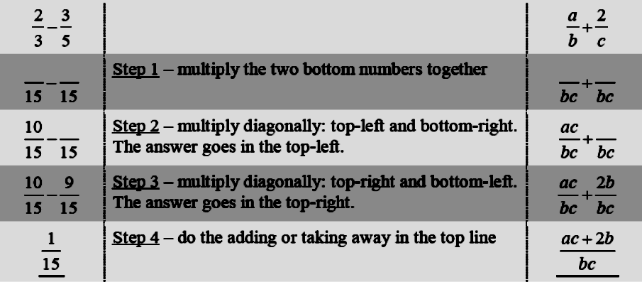

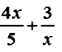
Example 4
Simplify:
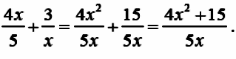
Solution:

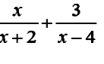
Example 5
Simplify:

Solution: When a fraction has more than one term on the top or bottom, you need to
introduce brackets. You then deal with a bracket as a single object.
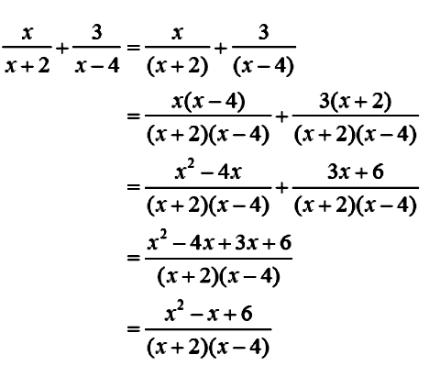

Note that x² – x + 6 does NOT factorise.

Unit 1
Unit 1 Outcome 4:
Applying geometric skills linked to the use of formulae
1.4.1 Determine the gradient of a straight line given two points
Definition : the gradient of a line is its steepness. It measures how much the line
goes up (or down) for every one square you move along. The basic definition of
gradient is gradient=$\frac{\text{up}}{\text{along}}=\frac{\text{vertical}}{\text{horizontal}}\text{.}$
A positive gradient means the line slopes upwards from left to right: a negative gradient means the line slopes downwards from left to right.
This formula is NOT given on the exam paper
Gradient between two points ( x₁ , y₁ ) and ( x₂ , y₂ ) : $m=\frac{y_{2}{\text{-y}}_{1}}{x_{2}{\text{-x}}_{1}}\text{.}$

Example 1 (two coordinate points)
Find the gradient between the points (–2,5) and (1,4)
Solution:
Step 1 – label the coordinates: (-2, 5) (1, 4)
x ₁,y ₁ x₂,y₂
Step 2 – put into the formula: $m=\frac{y_{2}{\text{-y}}_{1}}{x_{2}{\text{-x}}_{1}}$
$=\frac{\text{4-5}}{\text{1--2}}$
$=\frac{−1}{3}=−\frac{1}{3}$

Example 2 (from a diagram)
Find the gradient of this straight line

Solution:

Step 1 – pick any two coordinates on the line:
(0,- 2) (1,1)
Step 2 – label the coordinates:
(0, 2) (1, 1)
x ₁,y ₁ x₂,y₂
Step 3 – put into the formula: $m=\frac{y_{2}{\text{-y}}_{1}}{x_{2}{\text{-x}}_{1}}$
$=\frac{\text{1--2}}{\text{1-0}}$
$=\frac{3}{1}=3$

Answer: m = 3

1.4.2 Calculating the length of arc or the area of a sector of a circle
These formulae are NOT given on the exam paper
Arc length in a circle: Arc length = $\frac{\text{Angle}}{\text{360}}$ πd
Sector area of a circle: Sector Area = $\frac{\text{Angle}}{\text{360}}$πr²

The key idea in these questions is to identify the fraction of the circle that is in the
question. This depends on the angle at the centre of the circle. This fraction is
always $\frac{\text{Angle}}{\text{360}}$.
Example 1 (Arc Length)
Find the length of the arc in this sector of a circle
Solution
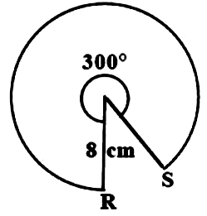
Radius is 8cm so diameter is 16cm.
Arc length=$\frac{\text{Angle}}{\text{360}}$ πd
=$\frac{\text{300}}{\text{360}}$ x π x 16
= 300 360 x π x 16
= 41.88790205...
= 41.9cm (1d.p.)
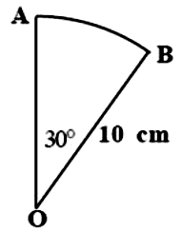

Example 2 (Sector area))
Calculate the area of sector AOB in this diagram.

Solution
Sector Area = $\frac{\text{Angle}}{\text{360}}$πr²
= $\frac{\text{30}}{\text{360}}$x π x 10²
= 30360 x π x 100
= 26.17993878...
= 26.2cm (1d.p.)

Angles and Circles
Definition : a tangent to a circle is a line that just touches the edge of the circle.
Definition : a chord in a circle is a straight line going from one side of the circle to another.
Questions about angles and circles are all to do with identifying the right angles,
And then using the rules of angles to find any remaining angles.
You can only write a right angle in a diagram if you know it is a right angle. There
are only three occasions when you can know an angle in a circle is a right angle:

1. A tangent always makes a right angle with the radius.
2. Triangles in semicircles are always right angled.
3. If a line in a circle diagram is a line of symmetry, it will cross any other line at
Right angles.
Once you have identified the right angles, you have to use the other rules of angles to
identify the other angles:
· Two angles on a straight line add up to make 180°.
· Opposite angles in X shapes are equal.
· The three angles in a triangle add up to make 180°.
· The four angles in a quadrilateral add up to make 360°.
· Angles in Z shapes (made by parallel lines) are equal.
· Isosceles triangles are symmetrical, meaning that the two angles in the base are equal.

You can identify isosceles triangles in circle diagrams because two of their sides are likely to be the radius (radii) of the circle.

1.4.3 Calculating the volume of a standard solid
Volume of a Cylinder
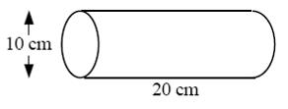
Example 1
Work out the volume of this cylinder.
Round your answer to 2 significant figures.

Solution
Diameter is 10cm so radius is 5cm
V = π r²h
= π x 5² x 20
= 1570.796327....
= 1600 cm³(to 2 sig fig)

Volume of a Cone
Example 2
Calculate the volume of this cone.
Round your answer to 3 significant figures.

Solution
Diameter is 30cm so radius is 15cm.
V = $\frac{1}{3}$π r²h
= π x 15² x 40 $3$
= 9424.777961....
= 9420cm (3 s.f.)

Volume of a Sphere
Definition : A hemisphere is half a sphere.

Example 3
Calculate the volume of this sphere.
Round your answer to 1 significant figure.

Solution
Radius is 8cm
V = $\frac{4}{3}$π r³
= 4 $3$x π x 8³
= 2144.660585....
= 2000cm³ (1 s.f.)

Example 4
Calculate the volume of this hemisphere.
Round your answer to 4 significant figures.
Solution
Diameter is 12cm so radius is 6cm
V = $\frac{4}{3}$π r³$2$
= 4 $3$x π x 6³$2$
= 452.3893421....
=452.4cm (4 s.f.)
Volume of a Prism
Definition : A prism is a 3d solid with a uniform cross-section.
In everyday language, this means that is the same shape all the way along.
Definition : The cross-section is the shape at either end (and in the middle) of a
prism.

Example 5
Find the volume of this prism

Solution:
Step 1: Work out the area of the crosssection
In this shape, the crosssection is a triangle.
The formula for the area of a triangle is $\frac{1}{2}$bh .
A triangle =$\frac{1}{2}$bh = 11 x 6 $2$= 33cm²

Step 2: Use the formula to find the volume
V= AL = 33 x 14 =462 cm³

1.4.4. (Rounding to a given number of significant figures)

Rounding to Significant Figures
Example 1
446.586 Rounded to 1 significant figure is 400
Rounded to 2 significant figures is 450
Rounded to 3 significant figures is 447
Rounded to 4 significant figures is 446.6
Note : Zeros sometimes have to be put in at the end to make the answer sensible.

Example 2
0.00567 Rounded to 1 significant figure is 0.006
Rounded to 2 significant figures is 0.0057

Note : Zeros at the start are NOT significant.

Unit 1
Unit 1 Outcome 5:
Reasoning skills
1.5.1 Interpreting a situation where mathematics can be used and identifying a strategy

Can be attached to a skill of Outcome 1 to require analysis of a situation.
Some questions are straight forward and you have been taught how to do these routinely. We call this knowledge. You have learned how do some new types of questions. Your knowledge toolkit has increased.

Mathematics also involves figuring out how to work out unfamiliar problems. We call this reasoning.
You have to work out how to apply your knowledge toolkit to the given problem. You will have been taught all the relevant knowledge but you have to work out what knowledge is appropriate/pertinent to the question.

This should be a mathematical or real-life context problem in which some analysis is required.
You should be required to choose an appropriate strategy and employ mathematics to the situation.

Examples of context: home economics, health and wellbeing, finance (inflation and interest rates), science (energy consumption in the home or car), technology (manufacturing), modern studies (population, statistics).

1.5.2 Explaining a solution and/or relating it to context
You are required to give meaning to the determined solution in everyday language.
This means that you must show working and explain how you arrive at the solution.

There are clues in the marks.

I mark means 1 argument in the answer.
2 marks means 2 arguments in the answer are looked for.
The more marks the arguments (lines of working) are looked for.

It is silly to write a single line and answer for a 5 mark question!
This completes
the revision
for Unit 1

Unit 2
Unit 2 : Relationships
Unit 2 Outcome 1:
Applying algebraic skills to linear equations
2.1.1 Determining the equation of a straight line given the gradient
- Use the formula y - b= m(x - a) or equivalent to find the equation of a straight line, given one point and the gradient of the line
- Use functional notation f(x)
- Identify gradient and y -intercept from y = mx + c
- Identify gradient and y-intercept from various forms of the equation of a straight line

The Equation of a Straight Line
Definition : the y intercept of a straight line is the number on the y axis
that the line passes through.
This formula is NOT given on the exam paper
Equation of a straight line: y = mx + c

Where m is the gradient of the line and c is the y intercept of the line.
In everyday language, this means that:
· the gradient is “the number before x”
· the y intercept is “the number on its own” (written as (0,c)

Example 1
Equation | Gradient | y intercept
y = 2x - 5 | 2 | -5
y = 8 - x | -1 | 8
y = 4 - 3 x | -3 | 4
y = 3 +$\frac{5}{2}$ x | $$\frac{5}{2}$$ | 3

The equation of the line must begin y = ... . If it does not, it must be rearranged:
Example 2
Equation | Rearranged Equation | Gradient | y intercept
3y = 6x - 9 | y = 2x - 3 | 2 | -3
x + y = 5 | y = - x + 5 | -1 | 5

Sketching a Straight Line from its equation
You need to know how to draw a line when given its equation. At Intermediate 1,
you used a table of values to draw a straight line. You can still do this. However
there is a quicker way that involves a knowledge of y = mx + c .

Example 3 (Basic)
Draw the line y = 2x - 5
Solution
Step 1 – the y intercept is –5, so the line goes through (0,–5). Plot this point.
Step 2 – the gradient is 2, so move 1 along and 2 up. Repeat this.
Step 3 – draw and label the line.

Example 4 (Negative Gradient)
Draw the line y = 4 - 3 x
Solution
Step 1 – the yintercept
is 4, so the line goes through (0,4). Plot this point.
Step 2 – the gradient is –3. This is negative so the line slopes downwards.
So from the first point, move 1 along and 3 down. Repeat this.
Step 3 – draw and label the line.

Example 5 (Fraction Gradient)
Draw the line y = $\frac{3}{4}$x + 1
Solution
Step 1 – the y intercept is 1, so the line goes through (0,1). Plot this point.
Step 2 – the gradient is$\frac{3}{4}$ .This means that you go 4 along and 3 up from
your first point. Repeat this.
Step 3 – draw and label the line.

Writing down the equation of a graph from a diagram
Example 6 (Basic)
Find the equation of the straight line in this diagram.
Solution
IMPORTANT – show your working to get all the
marks. Do not rush straight to step 3.
Step 1 – write down the y intercept: c = –2
Step 2 – work out the gradient.
Two points on the line are (0,–2) and (1,1).
$m=\frac{y_{2}{\text{-y}}_{1}}{x_{2}{\text{-x}}_{1}}$ $=\frac{\text{1--2}}{\text{1-0}}$ $=\frac{3}{1}=3$
(you may be able to spot this from the diagram)
Step 3 – put these values into y = mx + c
Answer: y = 3x – 2
Example 7 (Harder)
Find the equation of the straight line in this
diagram.
IMPORTANT – show your working to get all the
marks. Do not rush straight to step 3.
Solution
Step 1 – write down the y intercept.c = 1
Step 2 – work out the gradient.
Two points on the line are (0,1) and (3,3) and $m=\frac{y_{2}{\text{-y}}_{1}}{x_{2}{\text{-x}}_{1}}$ $=\frac{\text{3-1}}{\text{3-0}}$ $=\frac{2}{3}$
Step 3 – put these values into y = mx + c
Answer: y $=\frac{2}{3}$x +1

2.1.2 Working with linear equations and inequations.

Coefficients are a member of Z (Z is any integer ...-3,-2,-1. 0,1,2,3,... )
Solutions are a member of Q (Q is any fraction answer. Can be written as decimal)

Real-life limitations should be considered for inequations, eg maximum safe load for a concrete beam of given cross section area, maximum safe speed on a stretch of road etc

Example 1
Solve the inequality 5 – x > 2(x +1).

Solution

Example 2
Jane enters a two-part race.
(a) She cycles for 2 hours at a speed of (x + 8) kilometres per hour.
Write down an expression in x for the distance cycled.
(b) She then runs for 30 minutes at a speed of x kilometres per hour.
Write down an expression in x for the distance run.
(c) The total distance of the race is 46 kilometres.
Calculate Jane's running speed.

Solution
(a) D=ST
$⇒D =2(x+8)$$(b) D =\frac{1}{2}x$

$\begin{aligned}(c) 2(x+8)+\frac{1}{2}x=\text{46} \\ ⇒ 4(x+8)+x=\text{92} \\ ⇒ \text{4x}+\text{32}+x=\text{92} \\ ⇒ \text{5x}=\text{60} \\ ⇒ x=\text{12}\end{aligned}$
$⇒\text{running} \text{speed} \text{was} \text{12km/hr}$

2.1.3 Working with simultaneous equations.

Investigate real-life situations such as hiring a car, mobile phone charges, health and fitness.
Intersection of paths of moving objects described by equations.

Definition: a simultaneous equation is where you have more than one equation and
more than one unknown letter, and where you have to find values for the letters that
fit both equations.

Solving simultaneous equations algebraically
Example 1
3x – 2y = 11
2x + 5y = 1
15x – 10y = 55
4x + 10y = 2
19x = 57
x = 3
3x – 2y = 11
2(3) + 5y =1
5y =1-6
5y = - 5
y = - 1
Solve algebraically the system of equations

Solution
Step One – Decide which to ELIMINATE. Here y.
Multiply through each equation by
the number at the start of the letter in the other equation
e.g. in this example, we multiply the top equation by 5,
and the bottom equation by 2

Step Two – Add the two equations to eliminate the y terms

Step Three – solve the resulting equation:

Step Four – substitute this value for y back into one
of the original equations
(either one will do). We will use the top one
Answer: x = 3, y = - 1
Step Five – check your answer by substituting into the second equation.

Example 2
3 pencils and 2 books cost £10.30.
2 pencils and 3 books cost £15.20.
a) Write down a pair of equations to represent this situation
b) Solve these equations algebraically to find the cost of one book and one pencil.
3p + 2b = 1030
2p + 3b = 1520
9p + 6b = 3090
4p + 6b = 3040
SUBTRACT to get
5p = 50
p=10
Substitute in equation 1
3(10) + 2b = 1030
2b= 1000
b = 500

Solution
a) The equations are

b) Following the similar steps as in the last example:

Answer: b =500 and p =10
However you have to answer the question in a meaningful sentence to get the final
mark – i.e. a book is £5 and a pencil is 10p.

Solving simultaneous equations using a graph
This method is much easier, but much less likely to come up in an exam.
The solution to two simultaneous equations is the point where the graphs of each
equation cross each other. To find this, you need to be able to draw the graphs.

Example 3
Solve graphically the simultaneous equations:
y = 3x - 2
y = 6 - x

Solution
Step 1 – draw the two lines y =3x–2 and y =6–x
using the method from earlier.

Step 2 – write down the point where the two graphs cross

Answer: the graphs cross each other at the
point (2,4), so the answer is x = 2, y = 4

2.1.4 Changing the subject of a formula.
- Linear equation
- Equation involving a simple square or square root

Changing the subject of a formula is just like rearranging an equation: you move
things from one side to the other and do the opposite.
A useful tip for changing the subject questions is to switch the left-hand
side and the right-hand side before you begin moving things.
Example 1
Change the subject of the formula y = ab + d to “b ”
Solution
Step One – flip the left and right hand sides: ab + d = y
Step Two – rearrange to ab = y – d
then to b = $\frac{\text{y-d}}{a}$
Example 2
Change the subject of the formula A = π r² to r.
Solution
Step One – flip the left and right hand sides: π r² = A
$r^{2}=\frac{A}{π}$Step Two – rearrange to
$r=\sqrt{\frac{A}{π}}$
then to

Unit 2
Unit 2 Outcome 2 :
Applying algebraic skills to graphs of quadratic relationships
2.2.1 Recognise and determine the equation of a quadratic function from its graph

- y = kx²
- y = (x+p)² + q

Definition : a quadratic function is one that contains a squared term and no higher
powers. e.g. 3x² , x²- 4 and x² + 5x + 1 are all quadratic functions, but x⁵ and
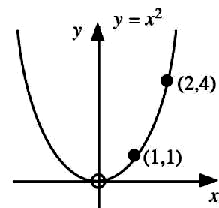
x² + x³ are not.
Graphs of Quadratic Functions
Definition : the graph of a quadratic function
is called a parabola.
The graph on the right is the basic graph of y = x² .
You should know its shape.
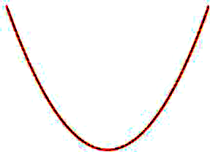
If x² is positive , then the graph is “happy”
(has a minimum turning point)
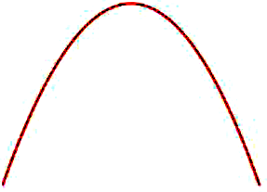
If x² is negative, then the graph is “unhappy” (has a maximum turning point)
Key facts:
· y = (x - a)² + b is a “happy” parabola. The minimum point of y = (x - a)²+ b is (a,b)
· y = -(x - a)² + b is an “unhappy” parabola. The maximum point of y = -(x - a)²+ b is (a,b)
· The axis of symmetry of y = (x - a)² + b has the equation x = a

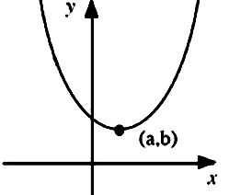
The graph of y = (x - a)² + b is still a parabola, but it looks like this

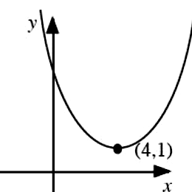
Example 1
What is the equation of this parabola?

Solution
The graph is “happy”, so it has an equation of the form y = (x - a)² + b
The minimum point is (4,1) so the equation is y = (x – 4)² + 1
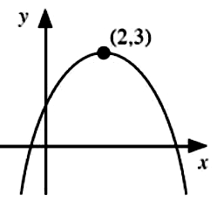
Example 2
What is the equation of this parabola?

Solution
The graph is “unhappy”, so it has an equation of the form y = -(x - a)² + b
The maximum point is (2,3) so the equation is y = -(x – 2)²+ 3 (or y = 3- (x – 2)² ).
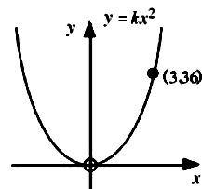
Example 3
The graph on the right has the equation
y = kx² . The graph passes through the point
( 3, 36 ). Find the value of k.
Solution
A point on the graph is (3 ,36 ). This means that
x = 3 and y = 36.
y = kx²
36 = k (3)²
9k =36
k = 4

2.2.2. Sketching a quadratic function

- y = (x-m)(x-n)
- y = (x+p)² + q

Example 1
Sketch the graph of y = x² - x -12 and state the nature and value of the turning point.
Solution
x
y
y = x² - x -12
=(x -4)(x+3)
Y=0 at x axis
(x -4)(x+3)=0 at x axis
x axis is crossed at (-3,0) and (4,0)
x=0 at y axis
y axis is crossed at y = 0² - 0 -12=-12. (0,-12)
Axis of symmetry at $x=\frac{−3+4}{2}=\frac{1}{2}$
x² is positive so we have a minimum TP
$\begin{aligned}y=\left(\frac{1}{2}−4\right)\left(\frac{1}{2}+3\right) \\ =\left(−3\frac{1}{2}\right)\left(3\frac{1}{2}\right)=−\frac{\text{49}}{4}=−\text{12}\frac{1}{4}\end{aligned}$Minimum

Minimum turning point = $\left(\frac{1}{2},−\text{12}\frac{1}{4}\right)$
x
y

Example 2
Sketch the graph of y = 16 – (x+2)² and state the nature and value of the turning point.

Solution
Negative x² means maximum TP.
Maximum at x = -2: y = 16 Min TP=(-2,16)
and axis of symmetry x = -2
x=0 at y axis
y axis is crossed at y = 16 – (0+2)² =16-4=12
Y=0 at x axis
0= 16 – (x+2)²
(x+2)² =16
x+2 = -4 or 4 so x = -6 or 2. (-6,0) and (2,0)

2.2.3 Identifying features of a quadratic function

Identify nature, coordinates of turning point and the equation of the axis of symmetry of a quadratic of the form: y = k(x+p)² + q where k= 1 or -1

Example 1
Identify nature, coordinates of turning point and the equation of the axis of symmetry of a quadratic of the form: y = (x+5)² - 25.
Solution
Positive x² means minimum TP
Occurs when x=-5 and gives y = -25.
The axis of symmetry is x = -5.

Example 2
Identify nature, coordinates of turning point and the equation of the axis of symmetry of a quadratic of the form: y = 36 - (x-3)².
Solution
Negative x² means maximum TP
Occurs when x=3 and gives y = 36.
The axis of symmetry is x=3.

Note: This is similar to the previous outcome but you are not asked to work out the roots or to sketch the graph.

Example 3
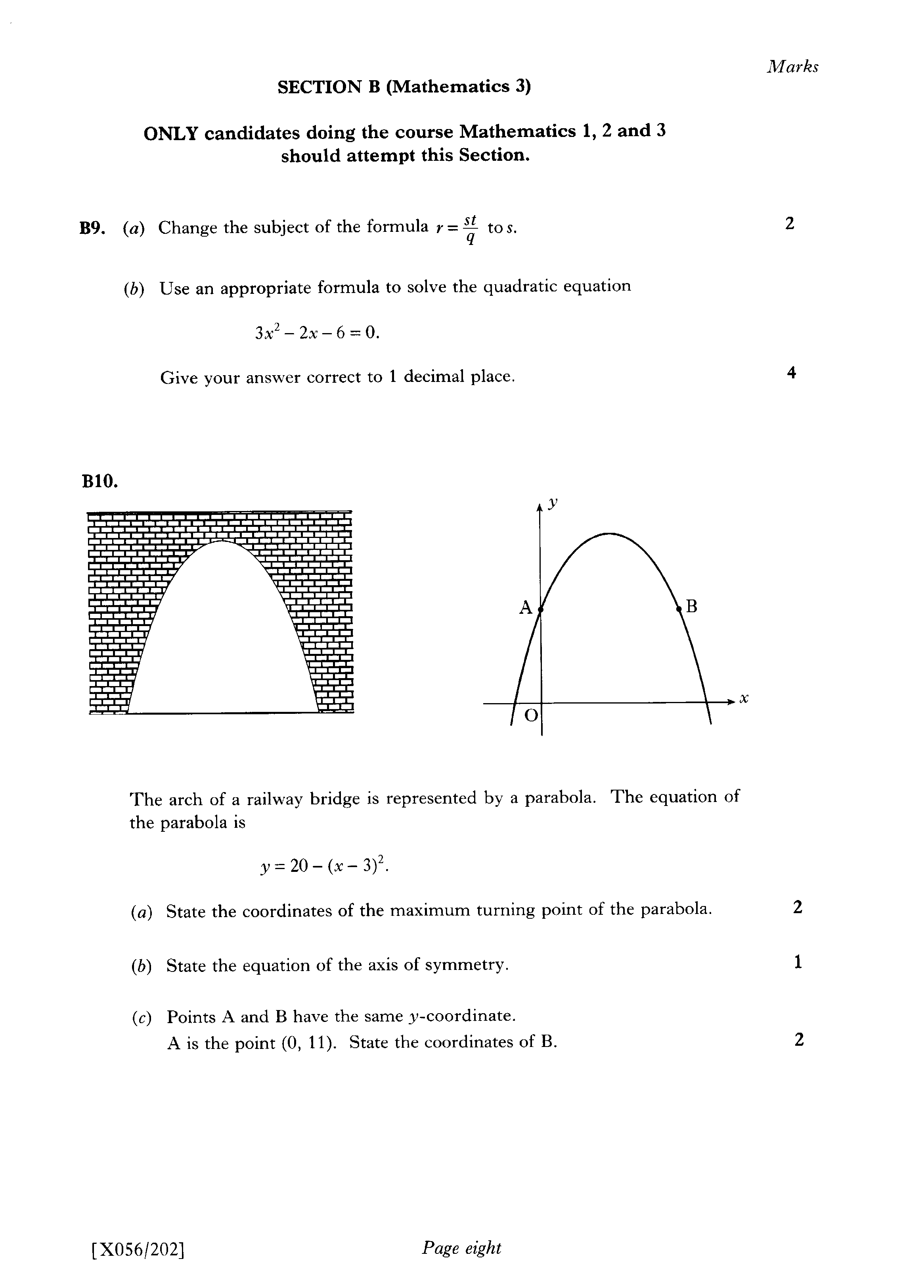

The equation of the parabola is y=20 –(x-3)².
(a) State the type and coordinates of the turning point. (b) State the equation of the axis of symmetry.
(c) Points A and B have the same y coordinate. Find the coordinates of B.
Solution
(a) Maximum turning point at (3,20)
(b) x = 3
(c) At A x =0 so y = 20 – (-3)² =11 A is (0,11)
Axis of symmetry is x = 3 so B is (6,11)

Unit 2

Unit 2 Outcome 3 :
Applying algebraic skills to quadratic equations
2.3.1 Working with quadratic equations

- Factorised
- Graphically
- Quadratic formula
- Discriminant
- Roots

Example 1
Use factorising to solve the equation 2x² - 6x = 0
Solution
Step 1 – check that the equation has ‘0’ on the right-hand side.
$\begin{aligned}{\text{2x}}^{2}\text{ - 6x = 0} \\ ⇒\text{2x}(\text{x-3})=0 \\ ⇒\text{2x}=\text{0 or }(\text{x-3})=0 \\ ⇒x=\text{0 or x}=3\end{aligned}$On this occasion, it does, so we move on.
Step 2 – factorise the expression (here common factor)
Step 3 – split up into two separate equations and solve
$\begin{aligned}y^{2}\text{ - 49 = 0} \\ ⇒(y+7)(\text{Y-7})=0 \\ ⇒(y+7)=\text{0 or }(\text{y-7})=0 \\ ⇒y=\text{-7 or y}=7\end{aligned}$Example 2 (Difference of Two Squares)
Use factorising to solve the equation y² - 49 = 0

Solution
Step 1 – check that the equation has ‘0’ on the right-hand side.
Step 2 – factorise the expression (here difference of 2 squares)
Step 3 – split up into two separate equations and solve

Example 3
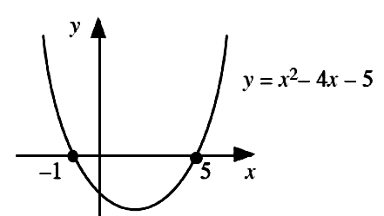
Using the graph shown, write down the
two solutions of the equation x²- 4x - 5 = 0

Solution
The two solutions are x = –1 and x = 5.
Example 4
Work out the two solutions of the equation x²- 4x - 5 = 0
Solution
x²- 4x - 5 = 0
(x+1)(x-5)=0
The roots are x = –1 and x = 5.
Note: This is the same equation as in Example 4 but the diagram is not given.
Example 5 (Number in front of x² )
Use factorising to solve the equation 2x² + 9x -5 = 0
Solution
Step 1 – check that the equation has ‘0’ on the right-hand side.
Step 2 – factorise the expression (here trinomial method)
1
1
5
-
5
−

(with practice the factors might be obvious)
Step 3 – split up into two separate equations and solve

Example 6 (Right hand side not zero )
Use factorising to solve the equation x² - 2x -10 = 5
Solution
$\begin{aligned}x^{2}−\text{2x - 10 = 5} \\ x^{2}−\text{2x - 15 = 0} \\ ⇒(x+3)(x−5)=0 \\ ⇒x=\text{-3 or x}=5\end{aligned}$Step 1 – check that the equation has ‘0’ on the right-hand side.
Re-arrange to get 0 on the right-hand side.
Step 2 – factorise the expression as before
Step 3 – split up into two separate equations and solve

The Quadratic Formula
This formula is given on the exam paper
The roots of ax² + bx + c = 0 are given by: $x=\frac{−b±\sqrt{b^{2}−\text{4ac}}}{\text{2a}}$

The quadratic formula can be used to solve any quadratic equation.
Important
You must rearrange the equation so that is has = 0 on the
right-hand side.
If you do not do this, you will risk losing all of the marks.
We usually use it when we can’t factorise the expression.

A clue to use the formula is where the questions tells you :
“give your answers correct to 2 decimal places” or similar.

Example 7
$\begin{aligned}x=\frac{−b±\sqrt{b^{2}−\text{4ac}}}{\text{2a}} \\ =\frac{−(2)±\sqrt{(2)^{2}−4(3)(\text{-6})}}{2(3)} \\ =\frac{−2±\sqrt{4−−\text{72}}}{6} \\ =\frac{−2+\sqrt{\text{76}}}{6} \text{or} \frac{−2−\sqrt{\text{76}}}{6} \\ =1\text{.}\text{12} \text{or} −1\text{.}\text{79}\end{aligned}$Solve the equation 3x²+ 2x - 6 = 0 , giving your answers correct to two decimal places.
Solution
Step 1 – check the equation has ‘=0’ on the right.
It does, so we can proceed.
Step 2 – write down what a, b and c are.
a = 3, b = 2, c = –6
Step 3 – substitute into the formula and solve
– being very careful when dealing with negative signs. Note the use of brackets.
If the number under the square root sign works out to be negative, then you will not
be able to complete the formula. This means either that:
· You have made a mistake with negative numbers and need to check your working
(realistically this is the most likely thing that would have happened in an exam)
· Or the equation has no solution (happens a lot in real life, but less likely in an exam)
Example 8
Solve the equation 2x²- 5x - 1 = 3 , giving your answers correct to two decimal places.
SolutionStep 1 – check the equation has ‘=0’ on the right.
It does not so re-arrange before, we can proceed.
NOW 2x²- 5x - 4 = 0
Step 2 – write down what a, b and c are.
a = 2, b = -5, c = –4 and proceed as before.
Use of Discriminant:

Unit 2

Unit 2 Outcome 4 :
Applying geometric skills to lengths, angles and similarity
2.4.1 Applying Pythagoras
- Using Pythagoras’ theorem in complex situations
- converse
- 3D

A: Pythagoras and SOH CAH TOA in triangles inside circles
There are only three occasions when you can know an angle in a circle is a rightangle:
· A tangent always makes a right angle with the radius.
· Triangles in semicircles are always right angled.
· If a line in a circle diagram is a line of symmetry, it will cross any other line
at rightangles (and will split that line in two equal parts).
If there is a rightangle inside a triangle in a diagram, then you can use Pythagoras or
trigonometry to work out other lengths or angles inside that triangle.
Example 1
PR is a tangent to a circle, centre Q.
Calculate angle PQR.
Solution
The fact that PR is a tangent means that the
angle at P is 90°. This means that PQR is a
rightangled triangle with the hypotenuse
8.5cm and the adjacent side 4cm.
S^{O}H C^{A}H T^{O}A

Cos PQR=$\frac{\text{ADJACENT}}{\text{HYPOTENUSE}}$ Cos PQR=
PQR = 61.9°

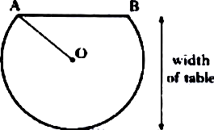
Example 2 (where a diagram is symmetrical)
A table top is in the shape of part of a circle.
The centre of the circle is O.
AB is a chord of the circle.
AB is 70cm.
The radius OA is 40cm.
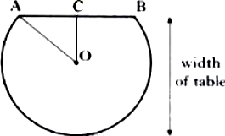
Find the width of the table.
35 cm
40 cm
Solution
Step one – draw a new line in the diagram to
make the diagram symmetrical.
In the diagram on the right, this is OC.
This means that triangle OCA is rightangled.
In this diagram, triangle AOC is right angled. AO is 40cm and AC is 35cm.
Using Pythagoras:
OC²= 40² -35²
=375
OC =
= 19.4cm (1d.p.)
The width of the table is
OC + the radius.
So in this diagram, the width is 19.4 + 40 = 59.4cm.

Step two – write in the length of the radius.
OA is 40cm.
Step three – use the fact that the new line
splits the other line in half.
In this diagram, AB is 70cm, so AC must be 35cm.
Step four – use Trigonometry or Pythagoras
to calculate another length (or angle) in the triangle.
Step five – check whether you have answered the whole question. In this question, they wanted the width of the table.

B: Converse of PYTHAGORAS
The converse of the Pythagorean Theorem helps you to find out if a triangle is right angled.
Basically, the converse states that whenever the sum of the squares of two sides equal to the square of the third side of the triangle, the triangle is a right triangle.
Example 3
Given the 3 sides of a triangle are 4, 5, 3 , is the triangle right?
Solution
Is 5² = 4² + 3² ?
5² = 25 and 4² + 3² = 16 + 9 = 25
Since 25 = 25, the triangle is a right triangle.
Example 4
Do the sides 6, 8, and 11 form a right triangle?


Solution
Is 11² = 6² + 8² ?
11² = 121 and 6² + 8² = 36 + 64 = 100
Since 121 100, the triangle is NOT a right triangle.
Example 5
A picture frame manufacturer claims that his
160 cm by 120 cm frame is rectangular.
He states that the diagonal is exactly 200 cm.
Is his claim true?

Solution
Is 200² = 160² + 120² ?
200² = 40 000 and 160² + 120² = 25 600 + 14 400 = 40 000
Since both are equal to 40 000 the triangle is a right triangle.
His claim is true.

C: 3D PYTHAGORAS
Consider PYTHAGORAS twice in the cuboid below.
Triangle 1 is half of the bottom face and c is the diagonal.
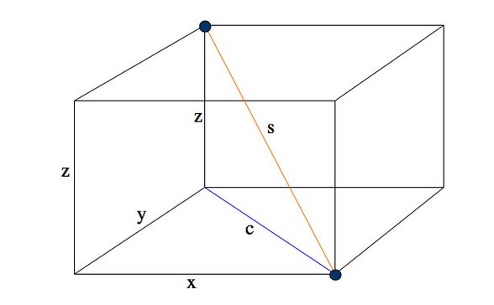
Triangle 2 includes s the space diagonal, c from before and z a vertical edge.

$\begin{aligned}s^{2}=c^{2}+z^{2} \\ ⇒s^{2}=x^{2}+y^{2}+z^{2} \\ ⇒s=\sqrt{x^{2}+y^{2}+z^{2}}\end{aligned}$
Triangle 1
Triangle 2
x
y
c
c
z
$$c^{2}=x^{2}+y^{2}$$
s

Example 6
Given the 3 sides of a cuboid are 2, 3, and 6.
Find the length of the space diagonal.
Solution
$\begin{aligned}s=\sqrt{2^{2}+3^{2}+6^{2}} \\ =\sqrt{4+9+\text{36}} \\ = \sqrt{\text{49}}=7\end{aligned}$

The space diagonal is 7 cm.
Note: This can be worked out in parts as shown before.
$\begin{aligned}s^{2}=\text{13}+6^{2} \\ ⇒s^{2}=\text{13}+\text{36} \\ ⇒s=\sqrt{\text{49}}=7\end{aligned}$$\begin{aligned}c^{2}=2^{2}+3^{2} \\ =\text{13}\end{aligned}$

The space diagonal is 7 cm.

Example 7
Given the slant side VA = 13 cm, AB =8cm
and BC =6 cm work out the vertical height VM.
Solution
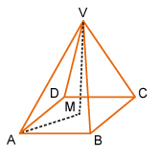
Not drawn to scale

2.4.2 Applying the properties of shapes to determine an angle involving at least two steps

- Quadrilaterals/triangles/polygons/ circles
- Relationship in a circle between the centre, chord and perpendicular bisector

Proportion can be asked as before but to find an angle.

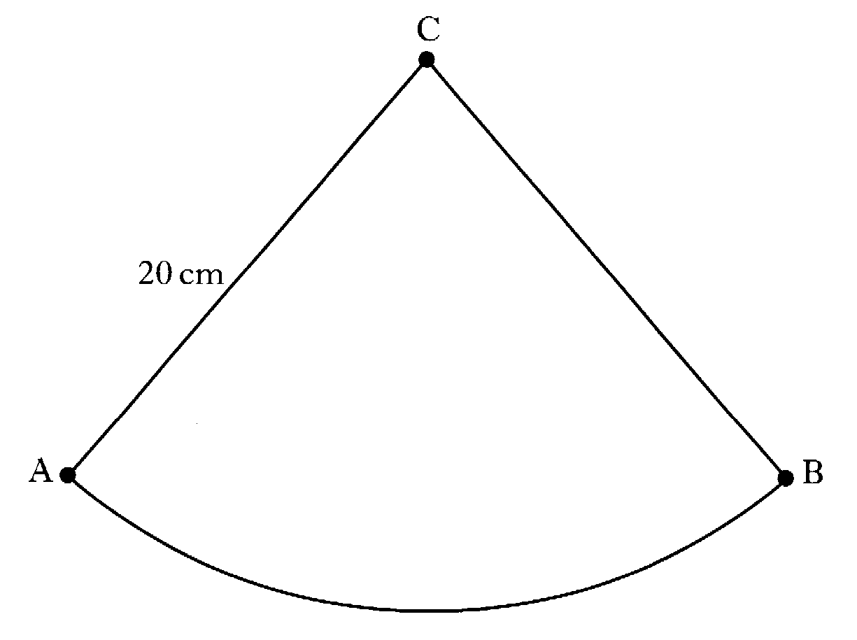
Example 1
The arc AB= 28.6 cm
and CA = 20 cm.
Find the angle ACB.

Solution
$$C=\text{πd}=3\text{.}\text{14} x \text{40} =\text{125}\text{.}\text{6cm}$$
$$\begin{aligned}\text{Angle ACB}=\frac{\text{28}\text{.}6}{\text{125}\text{.}6} x {\text{360}}^{o} \\ = {\text{82}}^{o}\end{aligned}$$

Angle properties can be incorporated into new situations.

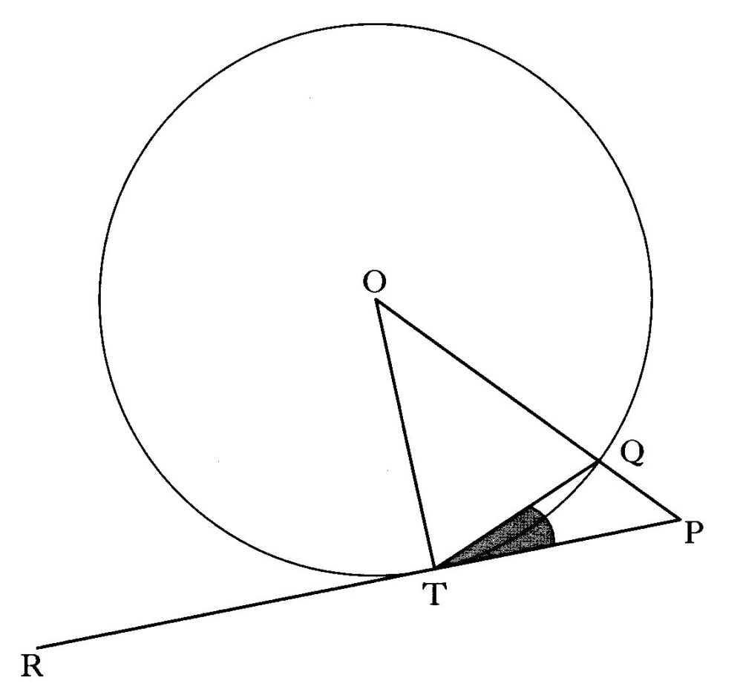
Example 2
RP is a tangent to the circle
and angle PTQ =24º.
Find the angle OPT.

Solution

$$\begin{aligned}∠{\text{OTP = 90}}^{o}(\text{tangent and radius}) \\ ∠{\text{OTQ = 90}}^{o}{\text{-24}}^{o}{\text{=66}}^{o} \\ ∠{\text{OQT = 66}}^{o}(\text{ISOSCELES ΔOQT}) \\ ∠{\text{TOQ= 180}}^{o}{\text{-66}}^{o}{\text{-66}}^{o}{\text{=48}}^{o}(\text{triangle sum}) \\ ∠{\text{OPT= 180}}^{o}{\text{-90}}^{o}{\text{-48}}^{o}{\text{=42}}^{o}(\text{triangle sum})\end{aligned}$$

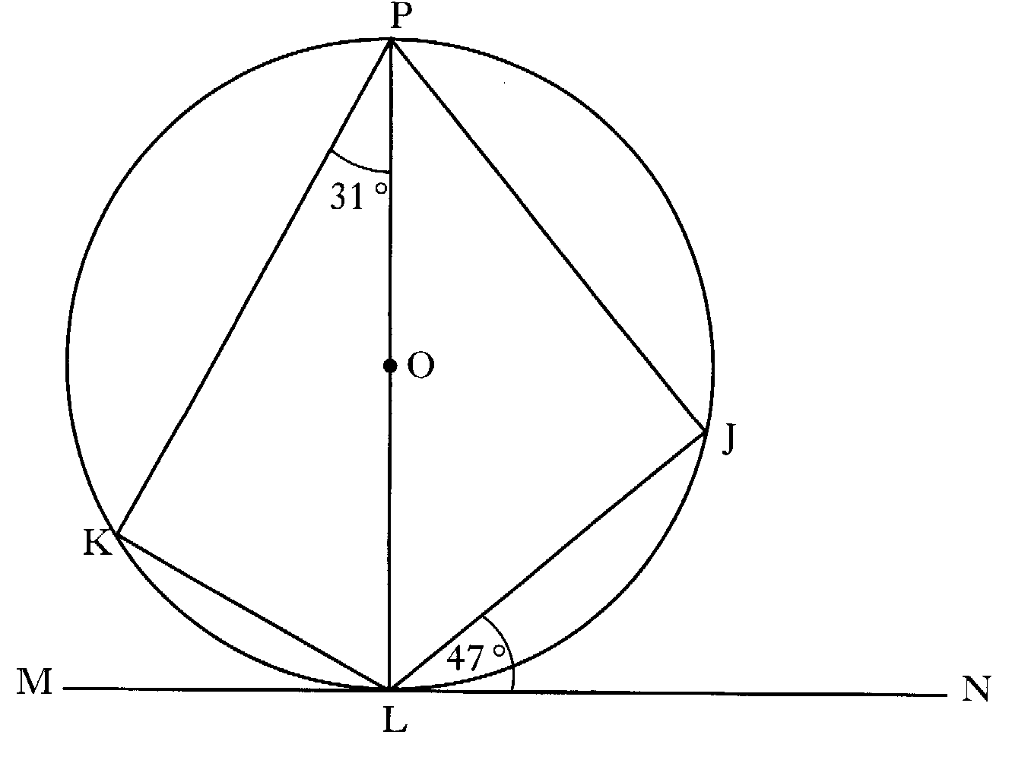
Example 3
MN is a tangent to the circle
Find the angle KLJ.

Solution

$$\begin{aligned}∠{\text{PKL = 90}}^{o}(\text{Angle in a semicircle}) \\ ∠{\text{KLP = 180}}^{o}{\text{-90}}^{o}{\text{-31}}^{o}{\text{=59}}^{o}(\text{triangle sum}) \\ ∠{\text{PLN = 90}}^{o}(\text{tangent and radius}) \\ ∠{\text{PLJ= 90}}^{o}{\text{-47}}^{o}{\text{=43}}^{o} \\ ∠\text{KLJ= }∠\text{KLP+}∠{\text{PLJ=59}}^{o}{\text{+43}}^{o}{\text{=102}}^{o}\end{aligned}$$

2.4.3 Using similarity

Interrelationship of scale — length, area and volume

- effect of linear scaling on areas and volumes
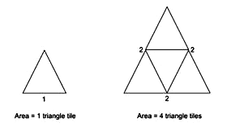
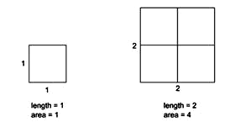

Both of the above situations show that as the length is doubled the area is multiplied by 4. This can be extended to volume to show that as the length is doubled the volume is multiplied by 8.

In general :
- Length multiplied by k e.g. length scale =3
- Area is multiplied by k² e.g. area scale = 9
- Volume is multiplied by k³ e.g. volume scale = 27

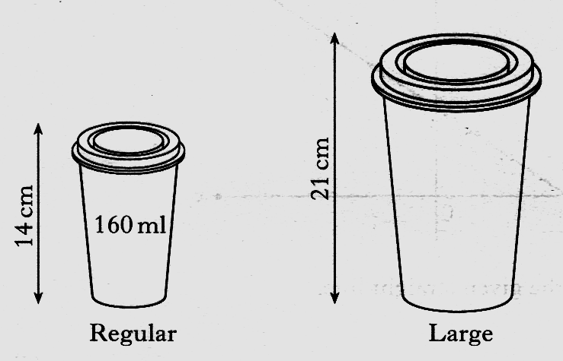
Example 1
Coffee is sold in regular cups and large cups. The two cups are mathematically similar in shape.
The regular cup is 14 centimetres high and holds 160 millilitres.
The large cup is 21 centimetres high.
Calculate how many millilitres the large cup holds.
$⇒k^{3}={\left(\frac{3}{2}\right)}^{3}=\frac{\text{27}}{8}$Solution
$k=\frac{\text{21}}{\text{14}}=\frac{3}{2}$

$⇒\text{large} \text{cup} \text{holds} \frac{\text{27}}{8} x \frac{ \text{160}}{1}=\text{540} \text{mls}$

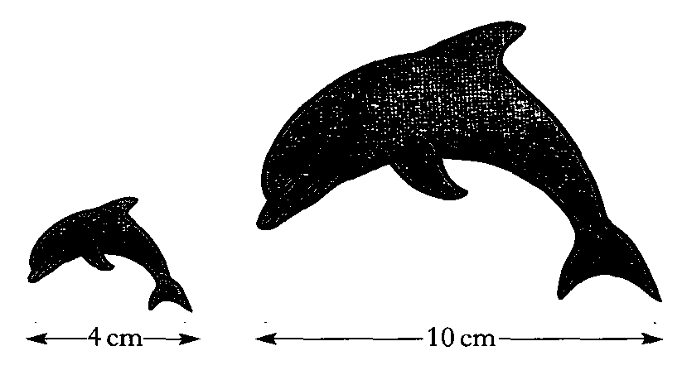
Example 2
Two fridge magnets are mathematically similar.
One magnet is 4 centimetres long and
the other is 10 centimetres long.
The area of the smaller magnet is
18 square centimetres.
Calculate the area of the larger magnet.

$⇒k^{2}={\left(\frac{5}{2}\right)}^{2}=\frac{\text{25}}{4}$Solution
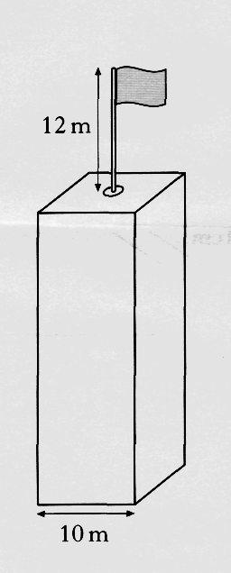
$k=\frac{\text{10}}{4}=\frac{5}{2}$$⇒\text{large} \text{magnet} \text{area} \frac{\text{25}}{4} x \frac{ \text{18}}{1}=\text{112}\text{.}5 {\text{cm}}^{2}$

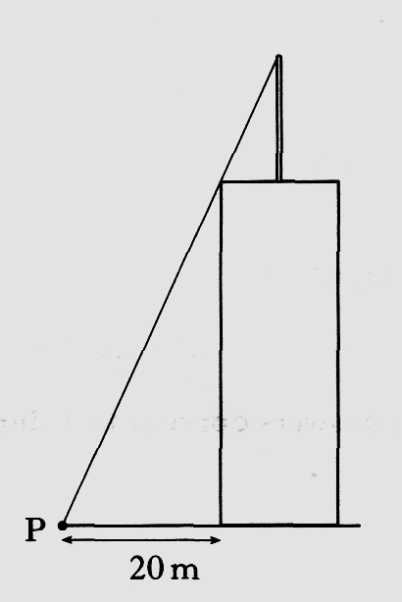
Example 3
A vertical flagpole 12 metres high
stands at the centre of the roof
of a tower.
The tower is cuboid shaped with
a square base of side 10 metres.
At a point P on the ground,
20 metres from the base of the
tower, the top of the flagpole is
just visible, as shown.
Calculate the height of the tower.

Solution
$\text{Let} \text{the} \text{tower} \text{height} \text{be} h\text{.}$$\text{The} \text{triangles} \text{are} \text{similar} (\text{EQUAL} \text{ANGLES})\text{.}$$⇒\frac{h}{\text{12}}=\frac{\text{20}}{5}$
$⇒\text{5h}=\text{240}$$⇒h=\frac{\text{240}}{5}=\text{48}$
$⇒\text{Tower} \text{height} \text{is} \text{48} m\text{.}$

Unit 2
Unit 2 Outcome 5:
Applying trigonometric skills to graphs and identities
2.5.1 Working with graphs of trigonometric functions

- Basic graphs
- Amplitude
- Vertical translation
- Multiple angle
- Phase angle

Graphs of sin, cos and tan
You are should know what the graphs of sin x, cos x and tan x look like between
0° and 360°:
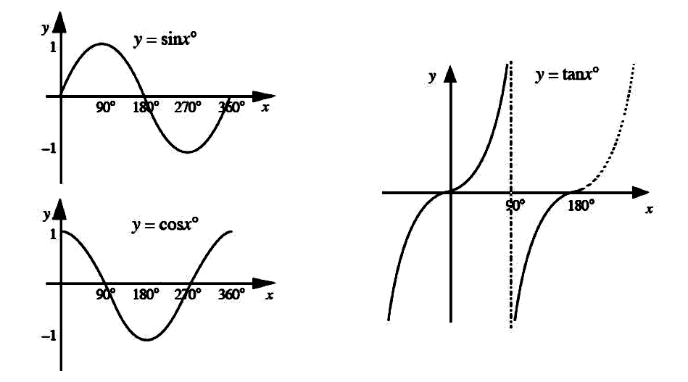

Definition : the period of a graph is how many degrees it takes the graph to do one
complete cycle. In the graphs above, sin x and cos x have a period of 360° and tan x
has a period of 180°.

Definition : the frequency of a sin or cos graph is how many times the graph repeats
itself in 360°. The frequency of a tan graph is how many times it repeats itself in
180°.
In the equation of a sin, cos or tan graph, the frequency is the number before x.

Definition : the amplitude is a way of describing the height of a sin or cos graph
e.g. the sine and cosine graphs above both have an amplitude of 1.
In the equation of a sin or cos graph, the amplitude is the number before sin or cos.
Example 1
Equation | Frequency | Amplitude
y = cos x | 1 | 1
y = 3sin 4 x | 4 | 3
y = 5cos 2 x | 2 | 5

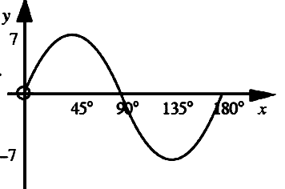
Example 2
The graph on the right has an equation of
the form y = a sin bx .
What are the values of a and b?
Solution
The maximum and minimum are 7 and –7, so the amplitude is 7 – i.e. a =7.
The graph repeats itself once between 0° and 180°. This means that it repeats
itself twice between 0° and 360°, so it has a frequency of 2, so b = 2.
Answer: the graph is y = 7sin 2 x

Example 3
The graph on the right has an equation
of the form y = a cos bx .
What are the values of a and b?
Solution
The maximum and minimum are 1.8 and –1.8, so the amplitude is 1.8.
This means that a = 1.8.
The graph repeats itself once between 0° and 90°. This means that it repeats
itself four times between 0° and 360°, so it has a frequency of 4, meaning b = 4.

Answer: the graph is y = 1.8cos 4 x

Definition : the phase angle is the amount a graph has been shifted to the right.
In the equation of a sin, cos or tan graph, the phase angle is the number taken away from x in the brackets.
Equation | Period | Amplitude | Phase Angle
y = 2cos(x - 45)° | 1 | 2 | 45°
y = sin(x -30)° | 1 | 1 | 30°
y = 4cos(2x -15) ° | 2 | 4 | 15°

Example 4
The graph on the below has an equation of the form
y = a sin(x - b )° .

What are the values of a and b?
Solution
The maximum and minimum are 2 and –2, so the amplitude is 2.
So this means that a = 2.
The graph has been shifted 30° to the right, so b = 30°.

Answer: the graph is y = 2sin(x - 30)°

2.5.2 Working with trigonometric relationships in degrees

Sine, cosine and tangent of angles 0°– 360°

A:Solving Trigonometric Equations (Equations with sin, cos and tan in)
You can recognise these questions because they will ask you to solve each equation
for 0 < x < 360 . (This just means x must between 0° and 360°.)
These questions will usually have TWO answers:
· Your calculator will give you the first using sin⁻¹, cos⁻¹ or tan⁻¹
· To get the other, you need either a CAST diagram or a sketch of the graph.
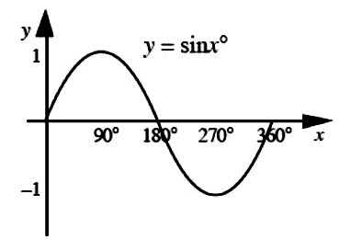

OR

Example 1 (Positive values of sin, cos and tan)
Solve the equation 5 sin x - 2 = 1 for 0 < x < 360 $\begin{aligned}\text{5 sin x - 2 = 1 } \\ \text{5 sin x = 3} \\ \text{sin} x = \frac{3}{5}=0\text{.}6 \\ \text{SHIFT SIN}⇒x_{1}=\text{36}\text{.}9^{o} \\ ⇒x_{2}={\text{180}}^{o}−\text{36}\text{.}9^{o}=\text{143}\text{.}1^{o}\end{aligned}$:
Solution:
Step One – rearrange the equation
Step Two – find the first solution using sin⁻¹
Step Three – find the second solution using
CAST This question involves sin.
180º-x
The number on the right is $\frac{3}{5}$ which is positive.
This means we tick the ALL and SIN quadrants.
Solution 2 is given by 180 – 36.9 = 143.1°.

$\begin{aligned}\text{3cos x }+\text{ 3 = 1 } \\ \text{3 cos x = -2} \\ \text{cos} x = −\frac{2}{3}=−0\text{.}\text{6666}\text{.}\text{.}\text{.}\text{.} \\ \text{SHIFT COS}⇒x_{1}=\text{131}\text{.}8^{o} \\ \text{131}\text{.}8^{o}={\text{180}}^{o}−\text{48}\text{.}2^{o} \\ ⇒x_{2}={\text{180}}^{o}+\text{48}\text{.}2^{o}=\text{228}\text{.}2^{o}\end{aligned}$Example 2 (Negative values of sin, cos and tan)
Solve the equation 3cos x + 3 = 1 for 0 < x < 360
Solution:
Step One – rearrange the equation
Step Two – find the first solution using cos⁻¹
Step Three – find the second solution using
CAST This question involves cos.
180º-x
180º+x
The number on the right is $−\frac{2}{3}$ which is negative.
This means we tick the SIN and TAN quadrants. This tells us “x” =48.2º
Solution 2 is given by 180º + 48.2º = 228.2°.
B: Trigonometric Identities
These formulae are NOT given on the exam paper
$\text{tan} x=\frac{\text{sin} x}{\text{cos} x}$ and $\text{sin} x + {\text{cos}}^{2}x =1$

We use trigonometric identities to simplify more complex expressions.
A question would normally ask you to “Prove that...” a fact about sin, cos or tan is true or to
“simplify” an expression involving sin, cos or tan.

There are not really any set rules for how to do these questions – instead you have to
use your mathematical ability to choose the correct rules of algebra to find the answer.
However the following tips are a good starting point:

Tip 1 – only ever “do stuff” to the more complicated expression (often the one on the
Left-hand side). Leave the simpler expression alone.

Tip 2 – you only get marks for knowing and using the two formulae in the box
above. So a good bit of advice is to look at the more complicated expression, and:
a) If you see ‘ tan x ’ on the left hand side, replace it with $\frac{\text{sin} x}{\text{cos} x}$
b) If you see ‘$\frac{\text{sin} x}{\text{cos} x}$’ on the left hand side, replace it with tan x
c) If you see ‘ 1 ’ on the left hand side, replace it with sin² x + cos² x
d) If you see ‘sin² x + cos² x ’ on the left hand side, replace it with 1
$\begin{aligned}\text{LHS}=\frac{1−{\text{cos}}^{2}x}{{\text{3sin}}^{2}x} \\ =\frac{({\text{sin}}^{2}x+{\text{cos}}^{2}x)−{\text{cos}}^{2}x}{{\text{3sin}}^{2}x} \\ = \frac{{\text{sin}}^{2}x}{ {\text{3sin}}^{2}x} \\ =\frac{1}{3}=\text{RHS}\end{aligned}$Example 3
Prove that $\frac{1−{\text{cos}}^{2}x}{{\text{3sin}}^{2}x}=\frac{1}{3}$.
Solution
Using Tip 1: The left-hand side is more
complicated, and the right-hand side is simpler.
This means that we will “do stuff” to the left-hand side
Using Tip 2: Using tip 2c above,
we replace ‘1’ with ${\text{sin}}^{2}x+{\text{cos}}^{2}x$and work out.

Example 4
Simplify ${\text{5sin}}^{2}x+{\text{5cos}}^{2}x$$\begin{aligned}{\text{5sin}}^{2}x+{\text{5cos}}^{2}x \\ 5({\text{sin}}^{2}x+{\text{cos}}^{2}x) \\ \text{ 5}(1) \\ 5\end{aligned}$.
Solution
Tip 1 isn’t relevant here as there is
only one expression.

Using Tip 2, none of those four expressions appear on the left-hand side exactly.
However if we spot there is a common factor of 5
and factorise it first, we can use tip 2d.

Unit 2
Unit 2 Outcome 6:
Reasoning skills
2.6.1 Interpreting a situation where mathematics can be used and identifying a strategy

Can be attached to a skill of Outcome 2 to require analysis of a situation.
Some questions are straight forward and you have been taught how to do these routinely. We call this knowledge. You have learned how do some new types of questions. Your knowledge toolkit has increased.

Mathematics also involves figuring out how to work out unfamiliar problems. We call this reasoning.
You have to work out how to apply your knowledge toolkit to the given problem. You will have been taught all the relevant knowledge but you have to work out what knowledge is appropriate/pertinent to the question.

This should be a mathematical or real-life context problem in which some analysis is required.
You should be required to choose an appropriate strategy and employ mathematics to the situation.

Examples of context: home economics, health and wellbeing, finance (inflation and interest rates), science (energy consumption in the home or car), technology (manufacturing), modern studies (population, statistics).

2.6.2 Explaining a solution and/or relating it to context

You are required to give meaning to the determined solution in everyday language.
This means that you must show working and explain how you arrive at the solution.

There are clues in the marks.

I mark means 1 argument in the answer.
2 marks means 2 arguments in the answer are looked for.
The more marks the arguments (lines of working) are looked for.

It is silly to write a single line and answer for a 5 mark question!

This completes
the revision
for Unit 2

Unit 3
Unit 3 Outcome 1
Applying trigonometric skills to triangles which do not have a right angle
3.1.1 Calculating the area of a triangle using trigonometry

This formula is given on the exam paper
Area of a Triangle: A = $\frac{1}{2}$ab sin C SAS

To find the area of any triangle you need the length of two sides (a and b – it does not
matter which one is which) and the size of the angle between them (C).

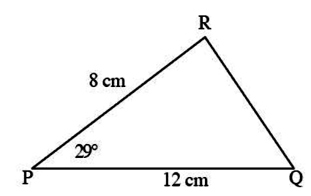
Example 1
Find the area of this triangle. Round your
answer to 3 significant figures.

Solution
A = $\frac{1}{2}$ab sin C a = 8, b = 12 and C = 29°
A= 8 x 12 x sin 29 º 2
= 23.27086177...
= 23.3cm (3s.f.)

3.1.2 Using the sine and cosine rules to find a side or angle

- Sine rule for side or angle
- Cosine rule for side
- Cosine rule for angle
This formula is given on the exam paper
Sine Rule: $\frac{a}{\text{sinA}}=\frac{b}{\text{sinB}}=\frac{c}{\text{sinC}}$ SSA or AAS

Where a, b and c are the lengths of the sides of the triangle, and A, B and C are the
angles in the triangle. Side a is opposite angle A etc.
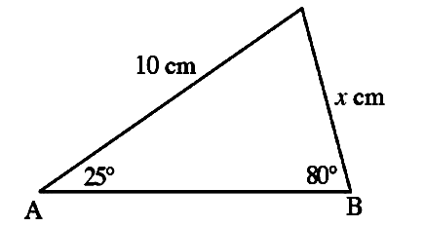
Important: to answer a question you do not use the formula as it is written.
C
You only need the first two bits: $\frac{a}{\text{sinA}}=\frac{b}{\text{sinB}}$
Example 1
Find the length x in this triangle.

Solution
x cm is opposite 25°, so a =x and A =25
10cm is opposite 80°, so b = 10 and B = 80
$$\frac{a}{\text{sinA}}=\frac{b}{\text{sinB}}$$
$$⇒\frac{x}{{\text{sin25}}^{o}}=\frac{\text{10}}{{\text{sin80}}^{o}}$$
$$⇒x=\frac{{\text{10sin25}}^{o}}{{\text{sin80}}^{o}}$$
= 4.291378296...
=4.29cm (2d.p.)

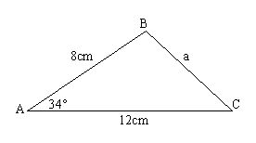
Example 2

Find the angle BCA to 1 decimal place.
12cm

Solution

12 cm is opposite 34°, so a =12 and A =34°
8 cm is opposite angle BCA, so c = 10 and C = ?
$$\frac{a}{\text{sinA}}=\frac{c}{\text{sinC}}$$
$$⇒\frac{\text{12}}{{\text{sin34}}^{o}}=\frac{8}{\text{sinC}}$$
$$⇒\text{Sin} C=\frac{{\text{8sin34}}^{o}}{\text{12}}$$
= Sin C = 0.372795269
=Angle BCA = 21.9º(1d.p.)
This formula is given on the exam paper
Cosine Rule: $a^{2}=b^{2}+c^{2}−\text{2bccosA}$ or $\text{cosA}=\frac{b^{2}+c^{2}{\text{-a}}^{2}}{2\text{bc}}$
SAS or SSS

where a is the length you are finding, b and c are the other two sides, and A is the
angle between the two sides b and c.
You use the first version of the formula to calculate a length, and the second version
to calculate an angle.

Finding a length using the cosine rule
You know the other two sides and the angle in between. It does not matter
which side is called b and which is called c. (You use info if given)

Example 3
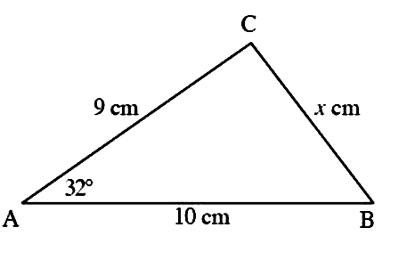
Find the length of x in this diagram

Solution
$$a^{2}=b^{2}+c^{2}−\text{2bccosA}$$
$$a^{2}=9^{2}+{10}^{2}−{\text{2 x 9 x 10 x cos32}}^{o}$$
= 28.35134269....
$$a=\sqrt{\text{28}\text{.}\text{35134269}\text{.}\text{.}\text{.}\text{.}}$$
= 5.324549789
= 5.32cm (2d.p.)

Finding an angle using the cosine rule
You must know the lengths of all three sides to be able to use this formula.
To find an angle, you use the second version of the formula.
In the formula $\text{cosA}=\frac{b^{2}+c^{2}{\text{-a}}^{2}}{2\text{bc}}$
a must be the side opposite the angle you are finding. It does not matter which way around b and c go.
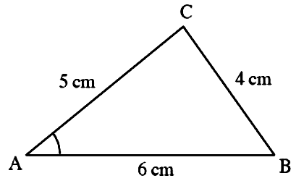
Example 4
Find the size of angle CAB in this diagram
Solution
The side opposite the angle we are finding
is 4cm, so a has to be 4.
Here b = 5 and c = 6.
$$\text{cosA}=\frac{b^{2}+c^{2}{\text{-a}}^{2}}{\text{2bc}}$$
$$\text{cosA}=\frac{5^{2}+6^{2}{\text{-4}}^{2}}{2 x 5 x 6}$$
$\text{cosA}=\frac{\text{45}}{\text{60}}=0\text{.}\text{75}$ (Use SHIFT Cos)
A = 41.40962211....
A = 41.4º (1d.p.)

3.1.3 Using bearings with trigonometry

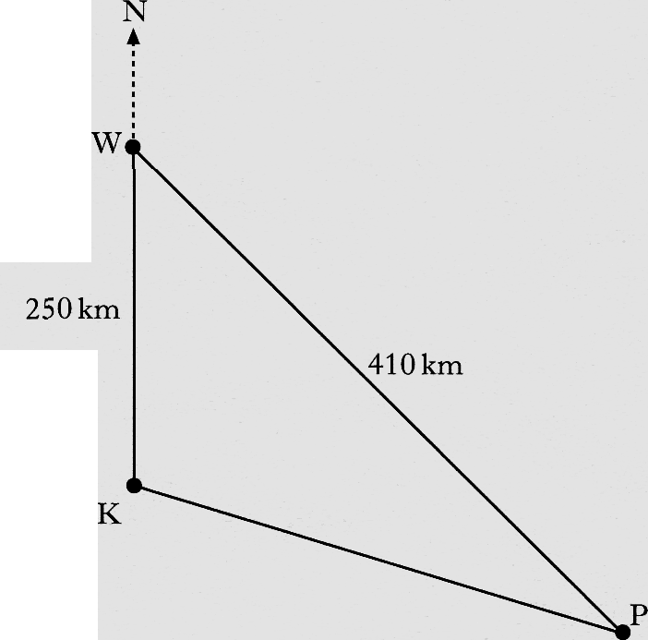
- To find a distance or direction

Example
Three radio masts, Kangaroo (K), Wallaby (W) and Possum (P) are situated in the Australian outback.
Kangaroo is 250 kilometres due south
of Wallaby.
Wallaby is 410 kilometres from Possum.
Possum is on a bearing of 130 ° from Kangaroo.
Calculate the bearing of Possum from Wallaby.
Do not use a scale drawing.

Solution

The bearing of Possum from Wallaby is 158°

Unit 3
Unit 3 Outcome 2:
Applying geometric skills to vectors
3.2.1 Working with 2D vectors

- Adding or subtracting two-dimensional vectors using directed line segments

A vector may be considered as a set of instructions for moving from one point to another. A line which has both magnitude and direction can represent this vector.The vector u can be represented in magnitude and direction by the directed line segment.The length of is proportional to the magnitude of u and the arrow shows the direction of u.

Example 1

or . It can be represented by

  - Vectors are added ‘nose to tail’. This is known as the Triangle Rule.
Example 2 Solution

v
u
v
3u + v

Draw the resultant of 3u + v
3u

  - To calculate 3u + v we can add the components (SEE 3.2.3)
Example 3

Example 4
  - To calculate 4u – 5v we subtract the components. Components mean that you are not restricted by drawing constraints.

3.2.2 Working with 3D coordinates

- Determining coordinates of a point from a diagram representing a 3D object
3 dimensional vectors can be represented on a set of 3 axes at right angles to each other (orthogonal), as shown in the diagram.
Note that the z axis is the vertical axis.
To get from A to B you would move:
4 units in the x-direction, (x-component)
3 units in the y-direction, (y-component)
2 units in the z-direction. (z-component)
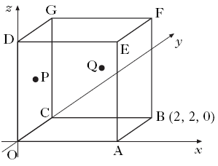
In component form: =
Example 1
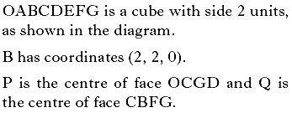
Write down the coordinates of:
G,F,P and Q and the components for

Solution

G=(0,2,2): F=(2,2,2): P=(0,1,1): Q= (1,2,1)

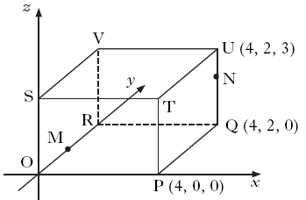
(SEE NEXT PAGE IF NOT SURE)
Example 2
P is the point (4,0,0), Q and R are marked on the diagram and M is the midpoint of OR.
Write down the coordinates of:
V,S,R and M and state the components for.

Solution
V=(0,2,3): S=(0,0,3): R=(0,2,0): M= (0,1,0)

(SEE NEXT PAGE IF NOT SURE)

3.2.3 Using vector components

- Adding or subtracting two- or three- dimensional vectors using components
- Magnitude of a vector
As before Vectors are added ‘nose to tail’
This is known as the Triangle Rule.
In practice we often use components
Example 1
Calculate 3a +2b where
Solution

Example 2
Calculate 2a – 5b where
Solution

Example 3
The forces acting on a body are represented by three vectors d, e and f as shown.

Find the resultant force.
Solution

Magnitude of a Vector in 2 and 3 dimensions:
We write the magnitude of u as .
The magnitude of a vector is the length of the directed line segment which represents it.
Use Pythagoras’ Theorem to calculate the length of the vector.

Example 4 Solution
Calculate the length of then
(also known as u here)
and so
P
Q
y
8
u
4
x

Example 5
Solution

Extension: Example 6
If A is (1, 3, 2) and B is (5, 6, 4). Find
Solution

or

Unit 3

Unit 3 Outcome 3:
Applying numerical skills to fractions and percentages
3.3.1 Working with percentages

- Use reverse percentages to calculate an original quantity
- Appreciation including compound interest
- Depreciation

Percentages
In National 5 percentage questions, you will always be asked to increase or
decrease an amount by a percentage – this will usually be either compound interest,
or appreciation or depreciation.
For every question, there is a longer way and a quicker way to do it.
Use the one you are happiest with.
Percentage | Longer way | Quicker way
3% increase | 0.03×.....  Then add answer on | [100% + 3% = 103%]  1.03 × .....
3% decrease | 0.03×.....  Then take answer away | [100% 3%= 97%]  0.97 × .....
2.4% increase | 0.024×.....  Then add answer on | [100% + 2.4% = 102.4%]  1.024 × .....
15% decrease | 0.15×.....  Then take answer away | [100% 15%= 85%]  0.85 × .....
4.5% decrease | 0.045×.....  Then take answer away | [100% 4.5%= 95.5%]  0.955 × .....

Example 1
After a 20% discount in the sale a TV was £240.
What was the price before the sale?
Solution
$\text{£240}÷0\text{.}8$0.8 x Price before = £240
Price before = = £300
Compound Interest
Compound interest is an example of appreciation (i.e. the amount in the account is always going up), so you always add the amount on each time.
Example 2
How much compound interest will you receive in 3 years on a balance of
£2500 in a savings account that pays 2.4% interest per annum?

Longer method Quicker method

Year 1: 0.024×2500 = £60 Year 1: 2500×1.024=2560
2500 + 60 = £2560
Year 2: 0.024×2560 = £61.44 Year 2: 2560×1.024=2621.44
2560 + 61.44 = £2621.44
Year 3: 0.024×2621.44 = £62.91 Year 3: 2621.44×1.024=2684.35
2621.44 + 62.91 = £2684.35 [you could also use even quicker method
2500×1.024³]

Interest: 2684.35 – 2560 = £184.35 Interest: 2684.35 – 2560 = £184.35

Appreciation and Depreciation
Definition: Appreciation means an increase in value.Definition:
Depreciation means a decrease in value.
Example 3
Peterhead has a population of 30 000 at the end of 2001. Its population
depreciates by 15% per year. What is its population at the end of 2003?
Round your answer to 3 significant figures.
Solution
Depreciation means decrease, so we will be taking away.
End of 2001 to end of 2003 is two years so need to repeat 2 times.
100% – 15% = 85%, so we use 0.85 in the quicker method.
Longer method Quicker method
Year 1: 0.15×30000 = 4500 Year 1: 0.85×30000=25500
30000 – 4500 = 25500
Year 2: 0.15×25500 = 3825 Year 2: 0.85×25500=21675
25500 – 3825 = 21675 [you could also use even quicker method 30000×0.85²]
Answer: 21700 (3s.f.) Answer: 21700 (3s.f.)
Example 4 where you have to find the percentage first
A house cost £240 000. One year later its value has appreciated to
£250800

a) Find the rate of appreciation
b) If the house continues to appreciate at this rate, what will its value
be after another 4 years to the nearest £100?

Solution
a) The increase is 250800–240000=£10 800
As a percentage of the original value (£240 000), this is
10800÷240000×100 = 4.5%
b) Using the quicker method:
Appreciation means increase. 100% + 4.5% = 104.5%, so use 1.045
Year 1: 1.045 × 250800 = 262086
Year 2: 1.045 × 262086 = 273879.87
Year 3: 1.045 × 273879.87 = 286204.46
Year 4: 1.045 × 286204.46 = 299083.67
[even quicker method: 250800 × 1.045⁴ ]
Answer:
After a further four years the house is worth £299 100 to the nearest £100.

3.3.2 Working with fractions

- Operations and combinations of operations on fractions including mixed numbers (Addition, subtraction, multiplication, division)

Rule for Addition of Fractions
$\frac{a}{c}+\frac{b}{c}=\frac{a+b}{c}$When adding fractions, you must make sure that the fractions being added have the same denominator. If they do not, find the LCD for the fractions and put each in its equivalent form. Then, simply add the numerators of the fractions.

Rule for Subtraction of Fractions
$\frac{a}{c}−\frac{b}{c}=\frac{a−b}{c}$When subtracting fractions, you must make sure that the fractions being subtracted have the same denominator. If they do not, find the LCD for the fractions and put each in its equivalent form. Then, simply subtract the numerators of the fractions.
Example 2
Work out $\frac{2}{3}−\frac{4}{7}$.
Solution
$\frac{2}{3}−\frac{4}{7}$=$\frac{\text{14}}{\text{21}}−\frac{\text{12}}{\text{21}}$=$\frac{2}{\text{21}}$

Example 1
Work out $\frac{1}{3}+\frac{1}{4}$.
Solution
$\frac{1}{3}+\frac{1}{4}$=$\frac{4}{\text{12}}+\frac{3}{\text{12}}$=$\frac{7}{\text{12}}$

Rule for Multiplication of Fractions
$\frac{a}{b}x\frac{c}{d}=\frac{\text{ac}}{\text{bd}}$When multiplying fractions, you simply multiply the numerators together and then multiply the denominators together. Simplify the result.

Rule for Division of Fractions
$\frac{q}{r}÷\frac{s}{t}=\frac{q}{r}x\frac{t}{s}=\frac{\text{qt}}{\text{rs}}$When you divide two fractions, you take the reciprocal of the second fraction, or bottom fraction, and multiply. (Taking the reciprocal of a fraction means to flip it over.)
Example 3
Example 4
Work out $\frac{2}{3}÷\frac{7}{\text{12}}$.
Solution
$\frac{2}{3}÷\frac{7}{\text{12}}$=$\frac{2}{3}x\frac{\text{12}}{7}$=$\frac{\text{24}}{\text{21}}$=$1\frac{3}{\text{21}}$=$1\frac{1}{7}$

Work out $\frac{2}{3}x\frac{9}{\text{10}}$.
Solution
$\frac{2}{3}x\frac{9}{\text{10}}$=$\frac{\text{18}}{\text{30}}=\frac{3}{5}$

Rule for Mixed Numbers: Addition and Subtraction
Example 5
Example 6
Work out $5\frac{2}{3}−2\frac{\text{11}}{\text{12}}$.
Solution
$5\frac{2}{3}−2\frac{\text{11}}{\text{12}}$=$3+\frac{8}{\text{12}}−\frac{\text{11}}{\text{12}}$$\begin{aligned}=3−\frac{3}{\text{12}}=2+\frac{\text{12}}{\text{12}}−\frac{3}{\text{12}} \\ =2\frac{9}{\text{12}}=2\frac{3}{4}\end{aligned}$

Work out $3\frac{2}{3}+2\frac{3}{4}$.
Solution
$$\begin{aligned} 3\frac{2}{3}+2\frac{3}{4}=5+\frac{8}{\text{12}}+\frac{9}{\text{12}} \\ =5\frac{5}{\text{12}}\end{aligned}$$

Rule for Mixed Numbers: Multiplication and Division
Example 7
Example 8
Work out $5\frac{2}{3}÷2\frac{\text{11}}{\text{12}}$.
Solution
$5\frac{2}{3}÷2\frac{\text{11}}{\text{12}}$=$\frac{\text{17}}{3}÷\frac{\text{35}}{\text{12}}$$\begin{aligned}=\frac{\text{17}}{3}x \frac{\text{12}}{\text{35}}=\frac{\text{204}}{\text{105}} \\ =1\frac{\text{99}}{\text{105}}=1\frac{\text{33}}{\text{35}}\end{aligned}$

Work out $3\frac{2}{3}x 2\frac{3}{4}$.
Solution

$$\begin{aligned} 3\frac{2}{3}x 2\frac{3}{4}=\frac{\text{11}}{3}x \frac{\text{11}}{4} \\ =\frac{\text{121}}{\text{12}}=\text{10}\frac{1}{\text{12}}\end{aligned}$$

Unit 3

Unit 3 Outcome 4:
Applying statistical skills to analysing data
3.4.1 Comparing data sets using statistics

Pie Charts
You need to be able to work out the angles you would use to draw the slices in a pie
chart. This is another example of a circles question – you have to work out what
fraction of the circle each slice has to be.

Example 1
In a school survey 200 pupils were asked what their favourite takeaway
food was. The results were:
Food | Frequency
Pizza | 55
Fish and Chips | 64
Chinese | 81

How many degrees would you need for each sector to represent this data
on a pie chart?

Solution
Step One – Work out the fraction for each slice
There were 200 pupils in total, so the fraction has to be out of 200
Pizza: 55 out of 200 = $\frac{\text{55}}{\text{200}}$
Fish and chips: 64 out of 200= $\frac{\text{64}}{\text{200}}$
Chinese: 81 out of 200=$\frac{\text{81}}{\text{200}}$

Step Two – work out each slice as a fraction of 360°
Pizza: $\frac{\text{55}}{\text{200}}$ of 360 =99º
Fish and chips: $\frac{\text{64}}{\text{200}}$ of 360 =115º
Chinese: $\frac{\text{64}}{\text{200}}$ of 360 =146º
Step Three – check that your answer adds up to 360°
Dot Plots
A dot plot is an easy way of showing a list of numbers in a diagram.
Example 3
Construct a dot plot to show these numbers: 8, 10, 11, 13, 13, 16, 20

Solution

Median, Quartiles and Box Plot
Definition : the median is the number that divides an ordered list of numbers into two equally sized parts
Definition : the quartiles, along with the median, are the numbers that divide an
ordered list into four equally sized parts. The list must be written in order.
Definition : a five-figure summary of a list of numbers is the lowest (L), lower
quartile (Q1), median (Q2), upper quartile (Q3) and highest (H).
Definition : a boxplot is a way of showing and comparing five-figure
summaries in a diagram.

Example 4
Draw a box plot from this set of numbers:
12, 14 , 15, 15, 16, 17, 17, 19, 19, 20, 21, 22, 26, 28, 31, 31
Solution
Step one – make a five-figure summary from the ordered list.
L Lower Q Median Upper Q H
12, 14 , 15, 15, 16, 17, 17, 19, 19, 20, 21, 22, 26, 28, 31, 31
15.5 19 24
Lowest value L = 12
Lower Quartile Q1 = 15.5
Median Q2 = 19
Upper Quartile Q3 = 24
Highest value H = 31

Step two – draw the box plot, including an appropriate scale.
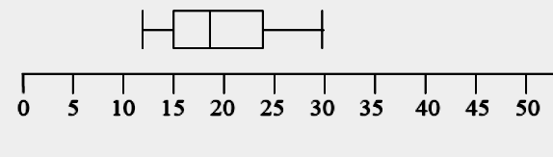
Semi-Interquartile Range

Example 5
For the data set above, work out the Semi Interquartile Range
Solution
Upper quartile = 24 and Lower quartile = 15.5, so SIQR = $\frac{\text{24-15}\text{.}5}{2}=4\text{.}\text{25}$
Cumulative Frequency
Definition: the cumulative frequency is the running total of frequencies.
A cumulative frequency column can be added to a cumulative frequency table. All
you have to do is add all the numbers together.

Example 6
Add a cumulative frequency Solution
column to this table:
Age | Frequency | Cumulative Frequency
12 | 7 | 7
13 | 11 | 18 [7+11]
14 | 0 | 18 [18+0]
15 | 12 | 30 [18+12]

Age | Frequency
12 | 7
13 | 11
14 | 0
15 | 12

Exam tip: If you are asked to find the median and quartiles from a cumulative
frequency table, the best way may be to write the list of data out in full first.
E.g. in the example above write out
12, 12, 12, 12, 12, 12, 12, 13, 13, 13, 13, 13, 13, 13, 13, 13, 13, 13, 15, 15, 15, 15, 15, 15, 15, 15, 15, 15, 15, 15 and then proceed as normal.

Standard Deviation
Definition: the standard deviation of a list of numbers is a measure of how spread out the numbers are from the mean.
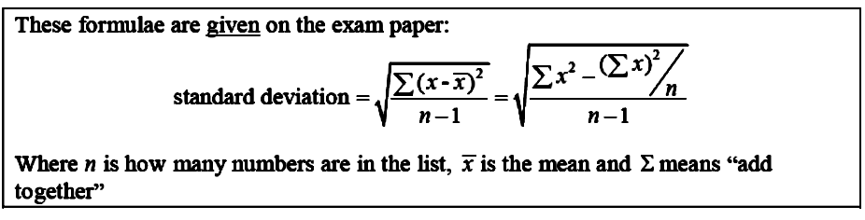
You only need to use one of these formulae. In general, it is more helpful to just
know the method rather than memorising the formula.

Example 6
a) Find the mean of these five numbers: 2, 3, 9, 6, 5
b) Find the standard deviation of the same five numbers
Solution
a) $\frac{2+3+9+6+5}{5}=\frac{\text{25}}{5}=5$so the mean is 5
b) You have a choice of two methods:

Probability
Probability is a measure of how likely an event is:
· If the event is impossible, the probability is 0
· If the event is certain to happen, the probability is 1
· If the event is between certain and uncertain, the probability is given as a fraction.

Example 7 (2007 Exam Question)
 | Wearing blazer | Not wearing blazer
Boys | 40 | 22
Girls | 29 | 9
The table shows the results of
a survey of First Year pupils.
A pupil is picked at random
from this sample, what is the
probability that they are a
girl wearing a blazer?

Solution
In total there are 40 + 29 + 22 + 9=100 pupils.
9 of these were girls wearing a blazer.
So the probability is $\frac{9}{\text{100}}$.
Comparing Statistics
The mean, median and mode are averages. They say whether a list of numbers is
higher or lower on average.

The range, semiinterquartile range and standard deviation are measures of
spread. They say whether a list of numbers is more or less spread out/consistent.

Example 8
The temperature in Aberdeen has a mean of 3°C and a standard
deviation of 5. In London it has a mean of 9°C and a s.d. of 3.
Compare the temperatures in London and Aberdeen.

Solution
You would get NO MARKS (as you are stating the obvious) for:
“Aberdeen has a lower mean”, “London has a higher mean”, “Aberdeen has
a higher standard deviation”, “London has a lower standard deviation”.

You WOULD get marks (as you say what the numbers MEAN) for:
“The temperature in Aberdeen is lower and the temperature is less consistent....”
“The temperature in London is higher and more consistent....” or similar.

3.4.2 Forming a linear model from a given set of data

- Determine the equation of a best-fitting straight line on a scattergraph and use it to estimate y given x
Scatter Graphs and Line of Best Fit
The line of best fit on a scattergraph is a straight line. This means that you can find
the equation of a line of best fit using the method (y = mx + c) shown earlier.
Once you have the equation, you can use the equation to estimate the value of y when
you are told x (or vice versa). At National 5, you have to use the equation to get
any marks (the question will say this). You cannot do it by “looking and guessing”.

Example 2 (2010 Int 2 Exam Question)
A scattergraph shows the taxi fare p pounds plotted against the distance travelled, m miles. A line of best fit has been drawn.
The equation of the line of best fit is p = 2 + 1.5 m .

Use this equation to predict the taxi fare for a journey of 6 miles.

Solution
The journey is 6 miles, so m = 6.
Using the equation,
p = 2 + 1.5 m
p = 2 + 1.5 (6)
p = 2 + 9
= 11 miles

Unit 3

Unit 3 Outcome 5:
Reasoning skills
3.5.1 Interpreting a situation where mathematics can be used and identifying a strategy

Can be attached to a skill of Outcome 3 to require analysis of a situation.
Some questions are straight forward and you have been taught how to do these routinely. We call this knowledge. You have learned how do some new types of questions. Your knowledge toolkit has increased.

Mathematics also involves figuring out how to work out unfamiliar problems. We call this reasoning.
You have to work out how to apply your knowledge toolkit to the given problem. You will have been taught all the relevant knowledge but you have to work out what knowledge is appropriate/pertinent to the question.

This should be a mathematical or real-life context problem in which some analysis is required.
You should be required to choose an appropriate strategy and employ mathematics to the situation.

Examples of context: home economics, health and wellbeing, finance (inflation and interest rates), science (energy consumption in the home or car), technology (manufacturing), modern studies (population, statistics).

3.5.2 Explaining a solution and/or relating it to context
You are required to give meaning to the determined solution in everyday language.
This means that you must show working and explain how you arrive at the solution.

There are clues in the marks.

I mark means 1 argument in the answer.
2 marks means 2 arguments in the answer are looked for.
The more marks the arguments (lines of working) are looked for.

It is silly to write a single line and answer for a 5 mark question!
This completes
the revision
for Unit 3

Index of Key Words for National 5
Algebraic Fractions 14
Adding 16
Dividing 15
Multiplying 14
Subtracting 16
Amplitude 52
Angles and Circles 20
Appreciation 70
Arc 19
Area 19
Circle Sector 19
Box Plot 75
Brackets 8
Expansion (Common/ 8
Changing the Subject 33
Circles 19
Arc Length 19
Sector area 19
Compound Interest 69
Crosssection 22
Cumulative Frequency 77
Depreciation 70
Difference of Two Squares 10
Dot Plots 75
Equations
Linear (in)equations 29
Quadratic 37
with sin, cos and tan 54
Factorising 9
Common Factor 10
Difference of two squares 10
Double Brackets (Trinomial) 11
Fractions (Operations) 73
Fractions in Powers 5
Gradient 17
Graphs of sin, cos and tan 51
Indices 4
Line of Best Fit 82
Median 75
Multiplying Brackets 8
Negative Powers 4
Parabola 36
Axis of symmetry 36
Finding k in y=kx² 35
Percentage 68
find the percentage 68
Period 51
Phase angle 53

Pie Charts 74
Powers
Exam Questions 5
Fractions 4
Negative 4
Rules 3
Probability 80
Pythagoras (and _{S}^{O}_{H C}^{A}_{H T}^{O}_{A})
Circles 42
Converse 43
Long diagonal (3D) 44
Quadratic Equations 37
Factorising 38
Graphically 38
The formula 40
Quadratic Formula 40
Quadratic Functions 37
Graphs 34
y=(x–a)²+b 34

Quartiles 75
Rounding 23
Scatter Graphs 82
Scientific Notation (Standard Form) 6
Sector Area 19
Semi InterquartileRange (SIQR) 76
Significant Figures 5
Similarity 49
Simultaneous Linear Equations 30
Algebraic 30
Graphically 32
Standard Deviation 78
Straight Line 25
Find the equation of a straight line 25
Sketching 26
y=mx + c 25
y–intercept 25

Surds 3
Rationalising the denominator 4
Simplifying 4
Trigonometry 51, 58
Graphs 51
Trigonometric Equations. 54
Trigonometric Identities 55
Area of triangle 59
(Co)sine Rules 60
Bearings and Trigonometry 63
Volumes of Solids 21
(Cylinder/Cone/Sphere/Prism)

ACKNOWLEDGEMENT

Adapted from
D Watkins
Newbattle Community High School Maths Department

