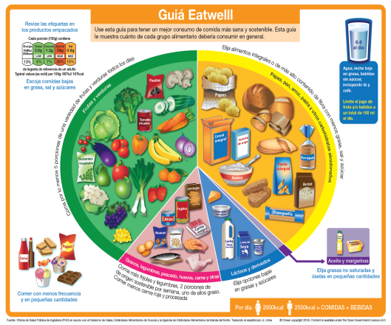
S1 Home Economics Tasks
I hope you are well. Please find attached an Eatwell Guide worksheet for you to complete. I have also a powerpoint to help you complete this.
Once you have done this you will then be able to complete the Daily Food diary which I have also attached. By completing this every day you will be able to evaluate your food choices throughout the day and think of ways of making your diet healthier.
This has been added to SMH and can be returned via SMH or by emailing Mrs Howitt at gw10howittjulie@glow.sch.uk or Miss Bruce at gw10bruceangela@glow.sch.uk

