S1 SOCIAL SUBJECTS
HOME LEARNING
Dear Learner and Parent/Carer
This pack has been created to support you with learning at home. Hopefully, enabling you to keep some element of normality and routine in a time which is, frankly, not at all normal or easy. Everyone has different circumstances and we fully understand this. Please complete work at a pace that suits you and your family. Also, we understand that you have many different subjects sending you work and need to manage your time to complete work for all subjects.
We would recommend completing 1 or 2 tasks per week - some will take longer than others. As you complete a task, you can email it to your teacher or send it through ‘show my homework’. This will allow your teacher to give you feedback before you move onto the next task. You can attach your work as a word document or take a picture of work you have handwritten.
If you have any questions, we are also working from home, and will reply to any emails you send. Our email addresses are listed below:

Mrs Matthewman: gw10matthewmandonna@glow.ea.glasgow.sch.uk
Mrs Tracey: gw17traceylisa@glow.ea.glasgow.sch.uk
Miss McWilliams: gw14mcwilliamsphilip@glow.ea.glasgow.sch.uk
Mrs Glen: mrsglen@glow.ea.glasgow.sch.uk

S1 Geography: Scotland
Resource Pack 2020
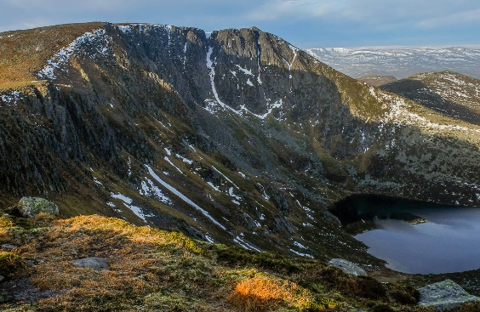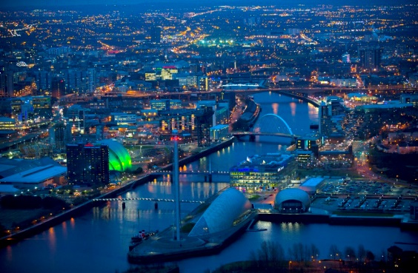

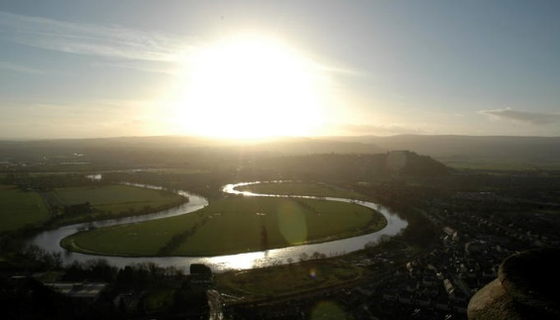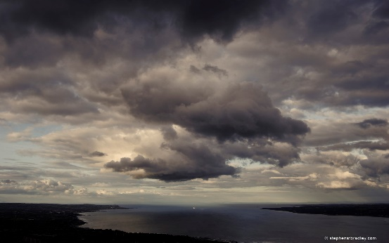

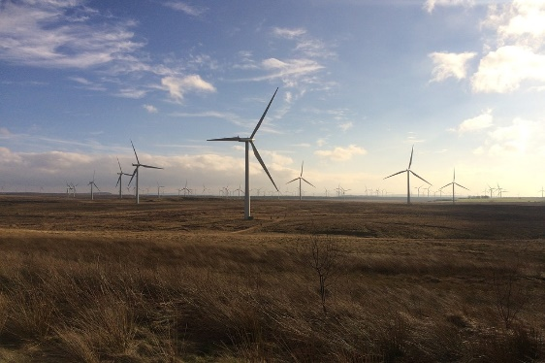
Geography is an education for life and for living.
Geography informs us about:

- The places and communities in which we live and work
- Our natural environments and the pressures they face
- How and why the world is changing, both globally and locally
- The choices that exist in managing our world for the future
- The importance of location in business and decision-making

Contents
- Curriculum Links
- Scotland’s Weather – Weather Diary
- Scotland’s Landscape
- How is Scotland’s Landscape changing?
- Deforestation in Scotland
- Deforestation Poster
- Scotland’s Population
- News Bulletin
- Research Task
- Where do people in Scotland live?
- The Future of Scotland
- Write a letter

Curriculum for Excellence Level 3

Experience and Outcome | Benchmark
I can identify the possible consequences of an environmental issue and make informed suggestions about ways to manage the impact. SOC 3-08a | - Provides a simple explanation of at least three consequences of an environmental issue, and for each suggest how they could be managed.
I can compare the population structure of Scotland with a contrasting country and can express informed views about the future implications for these societies. SOC 4-11c | - Asks and responds to questions about the future implications of population structures for Scotland and a contrasting area.
By comparing settlement and economic activity in two contrasting landscapes. I can reach conclusions about how landscapes influence human activity. I can explain my findings clearly to others. SOC 3-13a | - Provides at least two explanations as to how landscapes influence human activity, using two contrasting areas.
By considering the type of text I am creating, I can independently select ideas and relevant information for different purposes, and organise essential information or ideas and any supporting detail in a logical order. I can use suitable vocabulary to communicate effectively with my audience. LIT 3-26a | - Organises ideas and information in a logical order.  - Uses varied and appropriate vocabulary to make meaning clear and/or to attempt to enhance writing.

Scotland’s Weather
For the next 7 days keep a weather diary.
You should use the following website, https://www.bbc.co.uk/weather/2648579, to get information on temperature and wind speed. For the rest of your weather diary look out the window regularly throughout the day.

Day | Highest Temperature | Lowest temperature | Wind Speed | Description of weather (think about sunshine, rainfall)
1
2
3
4
5
6
7

Scotland’s Landscape
This is Scotland’s Landscape. Next to each picture, write down what you see.
What do you see?
What do you see?
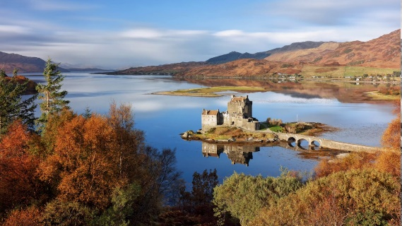
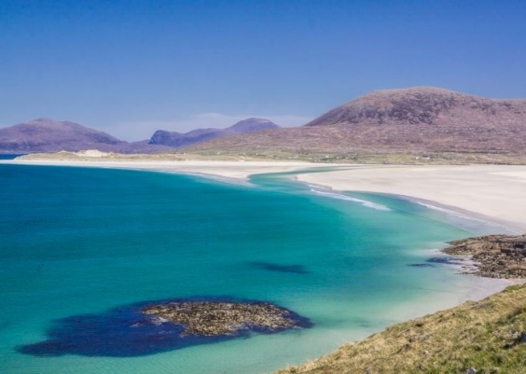
What do you see?
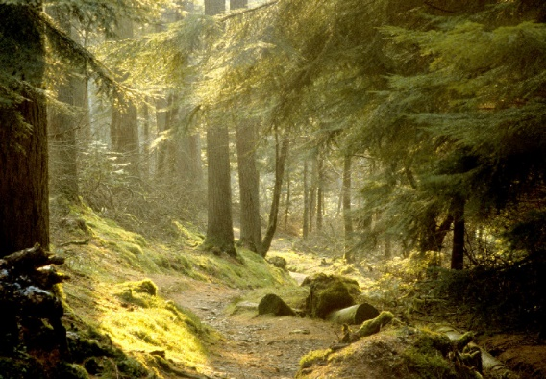
What do you see?
What do you see?
How is Scotland’s Landscape Changing?
Scotland’s landscape is constantly changing. The landscape is being changed by nature, for example rainfall, but it is also being changed by humans.

Task 1 – Watch and Write

Watch the video clip – https://www.bing.com/videos/search?q=what+is+deforestation+for+kids&&view=detail&mid=27211A7B609E4BEBD11427211A7B609E4BEBD114&&FORM=VRDGAR

Write down the definition of deforestation.

Deforestation is the process whereby natural forests____________________________________________________________________________________________________________________________________________________________________________.

Task 2 – Investigate
Using the video clip above and internet research complete the mind map below.

Why are humans cutting down trees?

Deforestation in Scotland
The historic deforestation of Scotland
In Scotland, deforestation has occurred because wood has been sold for money or to make materials we need. Also, deforestation in Scotland has occurred because we need the space to grow food and rear cows for food.
By 1900, only 5% of our land cover remained as forest. During the 20th century, however, trees have been planted which has increased Scotland's land cover to 17%.
Effects of Deforestation
Deforestation can have a negative impact on the environment. The most dramatic impact is a loss of habitat for millions of species. 80% of Earth’s land animals and plants live in forests, and many cannot survive when their homes are destroyed. This can result in species of plants and animals becoming extinct. Deforestation also drives climate change and leads to global warming.
How can we manage this problem?
There are any ways that we can reduce deforestation. One approach in Scotland is to give areas National Park status. This means the area is protected and cutting down trees is not allowed. An example of this is Loch Lomond National Park. We can also work hard to recycle so less paper is needed. In schools and offices, we can work to become paper free and finally we can plant more trees to replace the ones we cut down.
Task 3 - Write
Answer the questions below in full sentences using the information above.
- What percentage of Scotland’s land cover is forests?
- What effects does deforestation have? You must mention three.
- How can we stop/reduce people cutting down trees? You must mention three.
Deforestation Poster
LITERACY CHALLENGE TASK
Can you unscramble the words below?

- RCLYCEE - ________________________
- HITABIT - ________________________
- ENCTXIT - ________________________
- DSTAFORIOTEN - ___________________
Task 4 – Create
Create a poster about deforestation. You have space on the next page for this. Below you can find the assessment criteria for your poster. What do you want to achieve? Gold? Silver?
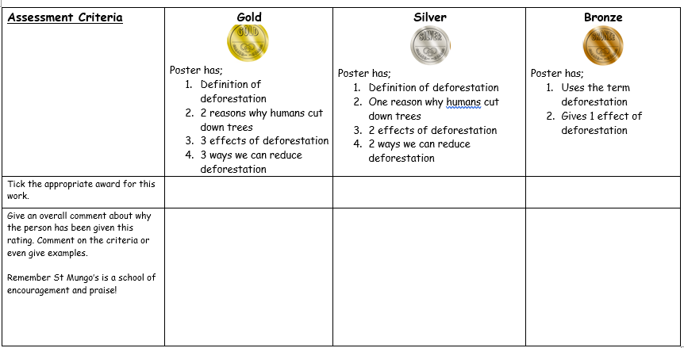

Scotland’s Population
The word population refers to the whole number of people living in a country, city or an area. Scotland’s total population is 5.4 million people.
Scotland has a population which is ageing. This means that there are less babies being born and people are living longer. An ageing population can cause many problems.

Problem 1 - If there are less babies being born; this will mean less people to work when these babies become adults. This will mean less workers to help pay for pensions.

Problem 2 - If there are not enough people working and paying tax the government may need to take more money off the people that are working to support the elderly.

Problem 3 - If there are fewer young people and more elderly people the money the government gets will have to be spent on healthcare, pensions and care homes rather than education.

Problem 4 - If the population is ageing, the government may take steps to increase the number of people available to work. To do this they may increase the pension age which could mean people are working well into their 70s.

Task 5 – Create
You have been asked to inform the public about the problems that our ageing population may bring here in Scotland.
To inform them you have been asked to write a news bulletin. A news bulletin is a short statement summarising the main points on an issue. This is normally presented at the start of the news programme. You can even read this out to family to educate them on the issue.
News Bulletin

Welcome to BBC News at 6 I am, ________________________. Our top story today, Scotland’s First Minister Nicola Sturgeon has discussed the problems that Scotland’s ageing population could lead to. She has said it could cause _______________________________________________________________________________________________________________________________________________________________________________________________________________________________________________________________________________________________________. This is a developing story with more to come when we receive it.

Task 6 – Research
Several countries have an ageing population. Research a country other than Scotland that has an ageing population. Include the following;

- The name of the country
- Two facts about the ageing population in this country (this can be data, concerns about this problem, how the country is trying to overcome this problem)

Name - _____________________________________________________

Fact one - _________________________________________________________________________________________________________________________________________________________________________________

Fact two - _________________________________________________________________________________________________________________________________________________________________________________

Where do people in Scotland live?
With just over 5 million people in Scotland they can live in any part of this country they want to live in. There are 7 cities to choose from and 790 islands to choose from.
Many people want to have lots of things to do and see and therefore choose to live in a city. However, some people want a quiet life with a bigger house and garden, and choose to live in the suburbs.

CITY
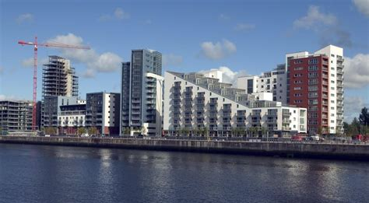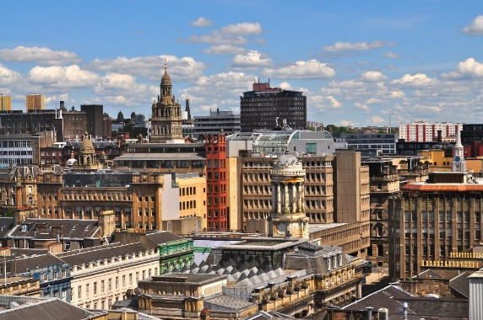

SUBURBS
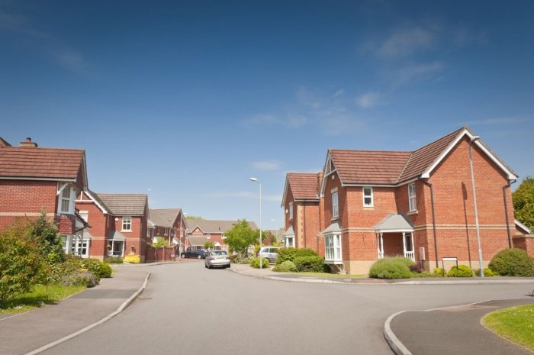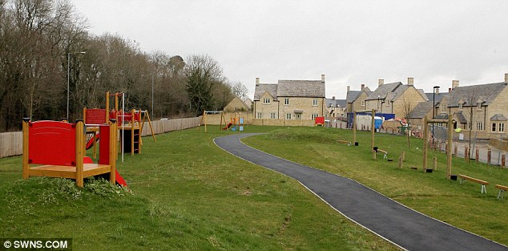

Task 7 – Define
Using the pictures provided on the previous page (and some internet research), create a definition for the following;

- City - ______________________________________________________________________________________________________________

- Suburbs - ______________________________________________________________________________________________________________

Task 8 – Apply
My name is James. I am 26 and I am a lawyer. I live on my own, I do not own a car and I spend a lot of time going out with friends, going to the cinema and travelling abroad when I can.
My name is Peter. I live with my two young children and my wife. I work as a lawyer and my wife is a teacher. I have a car to drive to work and I spend a lot of my free time with my family spending time outside, for example going walks.
- Where should James and Peter live?
James should live in ________________ and Peter should live in ______________.

- Complete the sentences below.

James has chosen to live in the city because_____________________________________________________. Another reason why James has chosen to live in the city is ___________________________________________________________.

Peter has chosen to live in the suburbs because __________________________________________________________. Peter has also chosen to live in the suburbs because __________________________________________________________.

The Future of Scotland
Scotland, as well as the rest of the world, are facing a major global issue. This is called climate change, or otherwise known as Global Warming.
Task 9 – Research - Using the following website, complete the questions below. (https://www.natgeokids.com/uk/discover/geography/general-geography/what-is-climate-change/)
- What is climate change?
_________________________________________________________________________________________________________________________________________________________________________________
- How many degrees Celsius has earth warmed by in the last century?

___________________________________________________________
- Complete the following sentence, filling in the missing words.

The changing climate will actually make our weather more ________________ and ___________________.

- There are 3 causes of climate change. Name the cause and given some description about how it causes climate change.

Cause 1 - ________________
_________________________________________________________________________________________________________________________________________________________________________________

Cause 2 - _______________
_________________________________________________________________________________________________________________________________________________________________________________

Cause 3 - _______________
_________________________________________________________________________________________________________________________________________________________________________________
- Name 4 ways climate change will affect the planet?

- Climate change is affecting wildlife. Name 3 species that are suffering.

- How will farmers in developing countries be affected by climate change?
______________________________________________________________________________________________________________________
- Identify 3 ways that you can help?

Pen Pal Letter
St Mungo’s Academy has received a letter from a girl in Brazil who wants to know all about Scotland. It was decided that S1 Geographers would reply to her because they have been studying Geography in Scotland.
S1 Social Subjects
St Mungo’s Academy
235 Crownpoint Road
Glasgow
G40 2RA
Hi First Year,
My name is Vivian and I live in Brazil. I have never visited Scotland but I really want to know all about it. I hope you don’t mind sharing all that you have learned with me! Can you tell me what the landscape in Scotland looks like? Can you tell me why it looks like that? I bet it is different to the landscape here in Brazil. I know Scotland has lots of mountains but does your country have any other beautiful features? I hear it is not as warm in Scotland as it is down in London, can you tell me why that is? It is always warm here in Brazil so I want to visit a country that is not as warm as my own country. Brazil and Scotland have something in common; people in our countries are cutting down trees. I know why we are doing that here in Brazil but why are trees being cut down in Scotland? What are you all doing to stop or reduce the cutting down of trees? We could learn something from you here in Brazil so any information would be greatly appreciated. Our biggest city, Rio De Janeiro, has a population of 6.45 million people. I know that is way more than the total population of Scotland. Does everyone in Scotland live in cities like Glasgow? If not, where do they live? Here in Brazil we are worried about climate change. I understand that cutting down trees is not helping the planet but I don’t really know much more than that. Can you tell me some information about climate change that you have learned? When I look at pictures online of Scotland, I see big white blades in the countryside. Can you tell me what these are and what you use them for? They look dangerous in the pictures, are these a good thing for your country? I am wondering if Brazil should consider using these as well. I hope one day to be able to visit Scotland but, in the meantime, if you could write a letter to me helping me with all my questions about Scotland, I would really appreciate it. You have such a beautiful and unique country and I want to learn as much as I can about it.
Can’t wait to hear from you, Vivian.

Task 10 – Literacy
Write a letter, responding to Vivian. Remember to answer all of her questions. You can also ask her questions about her country.

__________________________________________________________________________________________________________________________________________________________________________________________________________________________________________________________________________________________________________________________________________________________________________________________________________________________________________________________________________________________________________________________________________________________________________________________________________________________________________________________________________________________________________________________________________________________________________________________________________________________________________________________________________________________________________________________________________________________________________________________________________________________________________________________________________________________________________________________________________________________________________________________________________________________________________________________________________________________________________________________________________________________________________________________________________________________________________________________________________________________________________________________________________________________________________________________________________________________________________________________________________________________________________________________________________________________________________________________________________________________________________________________________________________________________________________________________________________________________________________________________________________________________________________________________________________________________________________________________________________________________________________________________________________________________________________________________________________________________

