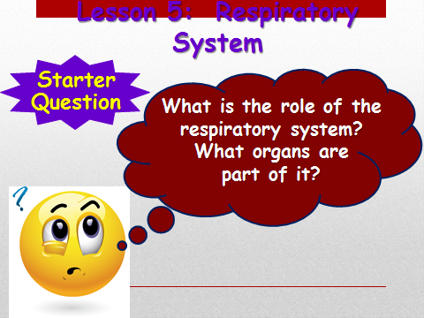

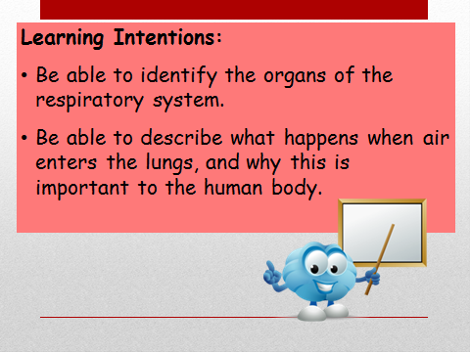  
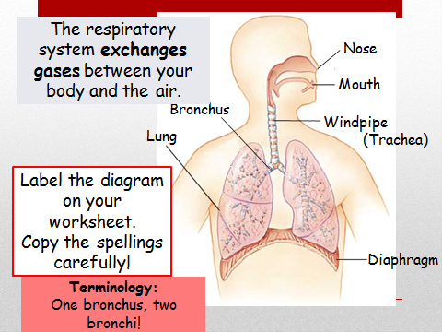

2. Label the diagram of the human breathing system with these words.

lungs diaphragm (di – a- fram) ribs



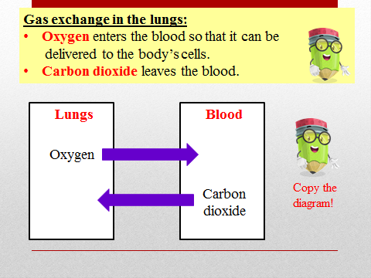

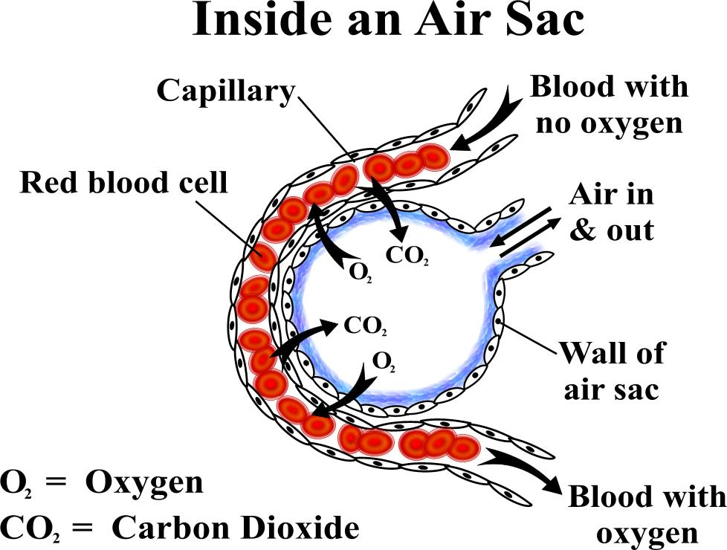

**Note**

**The oxygen that enters the blood is needed for respiration, so without it our cells would die!**

Gas exchange happens in the **alveoli** of the lungs

Try the link below to see a You tube clip gas exchange.

<https://www.youtube.com/watch?v=mZvzl8KH6iI>

There is also a clip on BBC Bitesize for you to look at:

<https://www.bbc.co.uk/bitesize/clips/zt27sbk>

**TASK: Complete table below with part of the lung and its function.**

|  |  |
| --- | --- |
| **Part** | **Function** |
| Nose/Mouth |  |
| Trachea (Windpipe) |  |
| Bronchi |  |
| Alveoli |  |
| Diaphragm |  |

Try to find out the role of the rings of cartilage in the trachea and bronchi

**Complete the summary below you will need to scroll down**

The Respiratory System

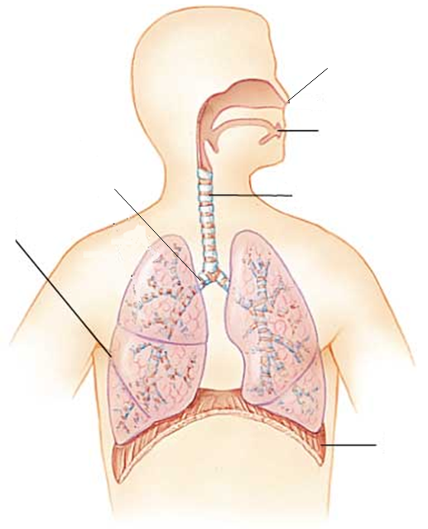

The respiratory system _________ gases between the body and the air.

When we breathe in air enters through the _________ and _________. It the passes down the ____________, into the two ___________ and then into the ___________.

The _________________ is a muscle that helps to control breathing.

**Brainpop clip**

**Go to Brainpop, hopefully you made the family account last week. Follow this path**

Brainpop/science/ cellular life and genetics/ cellular respiration. The clip lasts about 4 minutes