S3 GEOGRAPHY
HOME LEARNING

Dear Learner and Parent/Carer
This pack has been created to support you with learning at home. Hopefully, enabling you to keep some element of normality and routine in a time which is, frankly, not at all normal or easy. Everyone has different circumstances and we fully understand this. Please complete work at a pace that suits you and your family. Also, we understand that you have many different subjects sending you work and need to manage your time to complete work for all subjects.
We would recommend completing at least 3 tasks per week - some will take longer than others. As you complete a task, you can email it to your teacher or send it through ‘show my homework’. This will allow your teacher to give you feedback. You can attach your work as a word document or take a picture of work you have handwritten.
If you have any questions, your teacher is also working from home and will reply to any emails you send.

Miss McWilliams email address:
gw14mcwilliamsphilip@glow.ea.glasgow.sch.uk

- S3 Our City: Glasgow
Revision Pack 2020
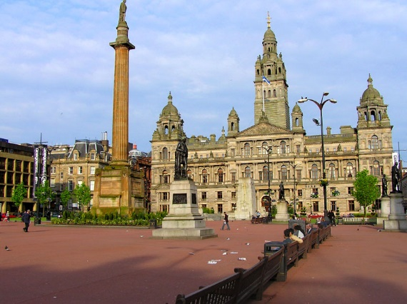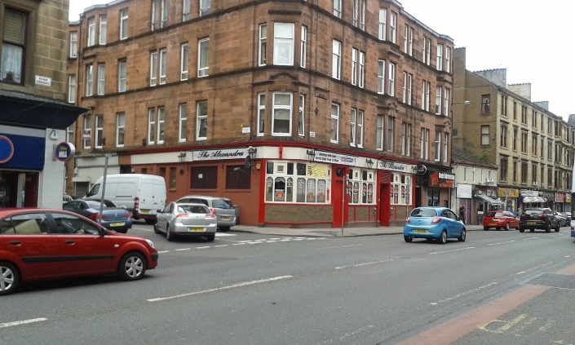
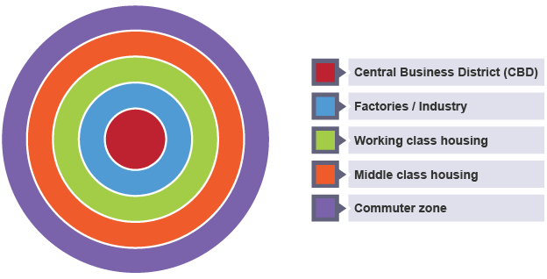
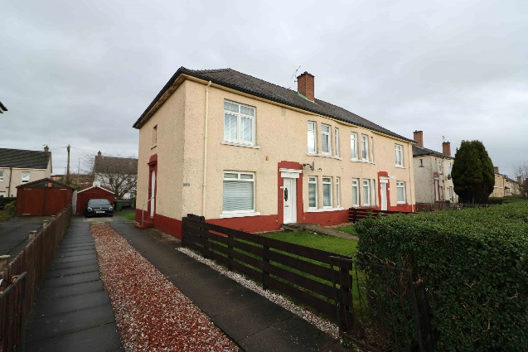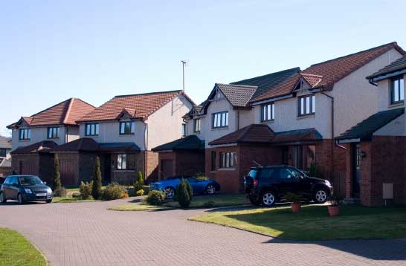

Contents
- Curriculum Links
- Urban Areas
- Concentric zone model
- CBD
- CBD changes
- Inner City
- Inner City Changes
- Suburbs
- Changes to the suburbs
- Create your own town task (app, website, paper)
- SQA Past Papers – Urban, Glasgow

Curriculum for Excellence Level 4

Experience and Outcome | Benchmark
I can explain the development of the main features of an urban area in Scotland or elsewhere and can evaluate the implications for society concerned. SOC 4-10b | - Explains in some detail how any chosen urban area has developed, and evaluates the impact on the society.
I can evaluate and interpret raw and graphical data using a variety of methods, comment on relationships I observe within the data and communicate my findings to others. MNU 4-20a | - Interprets raw and graphical data.  - Uses statistical language, for example, correlations, to describe identified relationships.

Urban Areas
An urban area, or built-up area, is a human settlement with a high population density and lots of buildings. Urban areas are categorized as cities, towns or suburbs.
Example: Manhattan, NYC 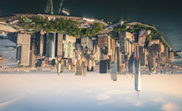

Task 1: Numeracy Skills
Diagram 1: changes to the number of people living in urban rural areas worldwide from 1960 to 2017.
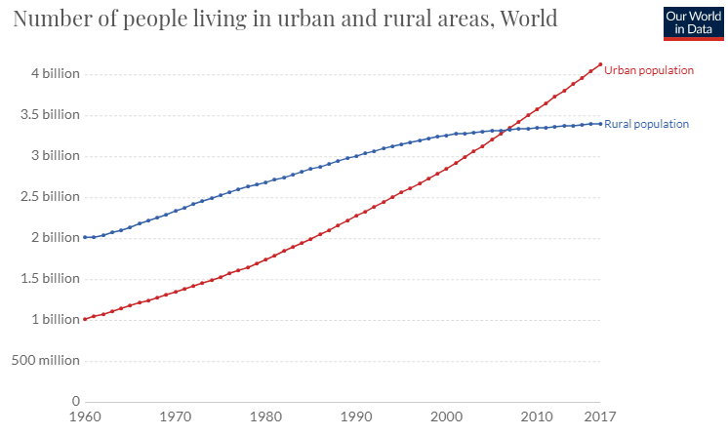
Describe the graph above (3). (Think trend, highest, lowest, number and date)
Description 1 - ______________________________________________________________________________________________________________________
Description 2 - ______________________________________________________________________________________________________________________
Description 3 - ______________________________________________________________________________________________________________________
Task 2 – KU
Use the image provided to identify the reasons why many people choose to live in urban areas.
Image | Reason why people live in urban areas

Concentric Zone Model
Geographers use models to help them understand reality. Land use models tell us where we might expect to find different land uses like high quality housing or industry. They also help to explain the pattern of growth of a city.

This model is based on the idea that land values are highest in the centre of a town or city.

This model is also based on the idea that cities grow outwards, therefore the oldest part of town is found in the centre and the newest part of town is found on the outside.

Task 3 – Watch

https://www.bing.com/videos/search?q=concentric+zone+model&&view=detail&mid=AE90562C261DEF4EB2FDAE90562C261DEF4EB2FD&&FORM=VRDGAR&ru=%2Fvideos%2Fsearch%3Fq%3Dconcentric%2Bzone%2Bmodel%26FORM%3DHDRSC3
CBD
Using your learning in class, identify the CBD from the map below and provide 3 reasons why this is the CBD.
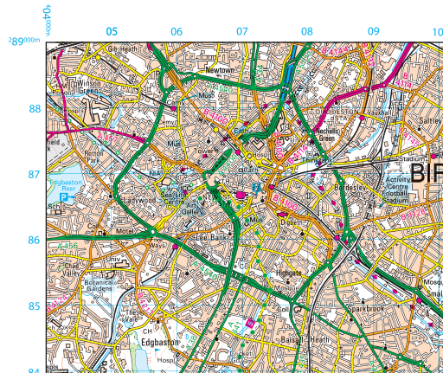
Task 4 – Identify

CBD - __ __ __ __

Reason 1 - ____________________________
Reason 2 - ____________________________
Reason 3 - ____________________________

Characteristics of the CBD
A characteristic is a feature belonging to a place and a characteristic is used to identify the place.
Using the images below, identify the characteristics normally associated with the CBD.
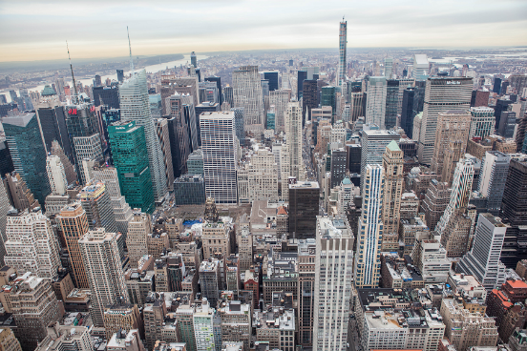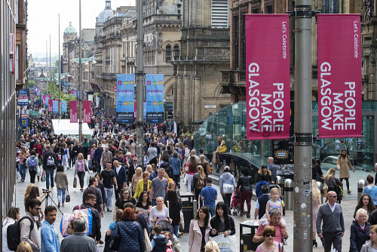
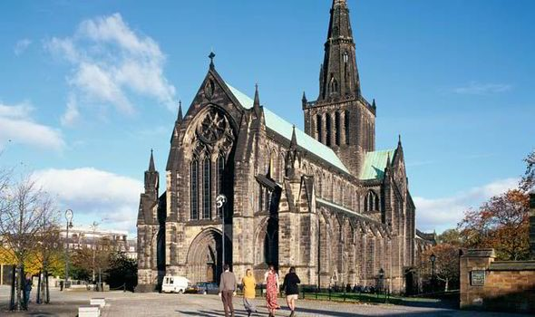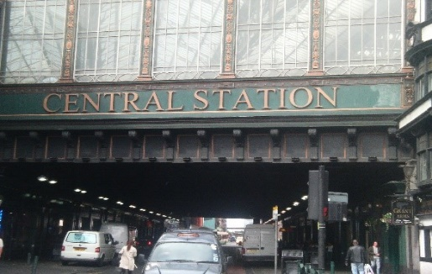
Task 5 – Describe

The CBD of any city will have ________________________________, ______________________________________________________, ___________________________________________________ and _________________________________.
Changes in Glasgow’s CBD
Task 6 – Research - Using the web links below read the information and then identify what has changed in Glasgow’s CBD and give one reason why this change has taken place.
Link 1 - https://www.glasgowtimes.co.uk/news/17562184.glasgow-shops-are-closing-at-a-faster-rate-than-new-ones-are-being-opened/
What has changed? | Why has this change taken place?

Link 2 - https://www.glasgowlive.co.uk/news/glasgow-news/heres-new-bus-gates-been-16847852
What has changed? | Why has this change taken place?

Link 3 - https://www.bbc.co.uk/news/uk-scotland-glasgow-west-51406537
What has changed? | Why has this change taken place?

Inner City
The Inner-City area is the area comprising of both factories and Industry and working-class housing.

Factories and industry were located just outside the CBD because land was _________ to buy here as the CBD is where land value is the highest. The factories historically also needed to be close to the place they planned to sell or ___________ their manufactured goods.

Working in factories was a _______ skilled job which meant low pay. To support workers, working class housing, _________, were built close to factories to ensure people could walk to work as they weren’t in a position to _______ for transport or own a car.

Task 7 – Remember

Using the word bank below, fill in the blanks above.

tenements transport

cheaper pay low
Problems in the Inner City
The Inner-City areas of Glasgow were referred to throughout Europe as “slums.” Many problems occurred in these areas.

One of the biggest reasons for problems in Glasgow’s Inner City areas can be found here - https://www.bing.com/videos/search?q=shipbuilding+industry+glasgow&&view=detail&mid=D4EA54D63CF1D9CBC384D4EA54D63CF1D9CBC384&&FORM=VRDGAR&ru=%2Fvideos%2Fsearch%3Fq%3Dshipbuilding%2Bindustry%2Bglasgow%26FORM%3DHDRSC3.

Task 7 – Research

Watch the video clip and note down the problem.

One of the main reasons for problems in Glasgow’s Inner City was __________________________. This happened because _______________________________________________________.

As a result of the reason discussed above, poverty was rife in the inner-city areas of Glasgow which led to even more problems. Look at the images on the next page.

- 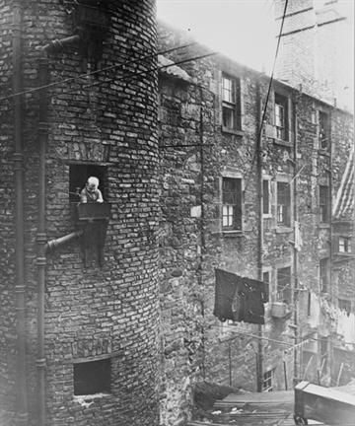 Tenements where dirty on the outside due to the pollution from nearby factories. The pollution also caused health problems.

- 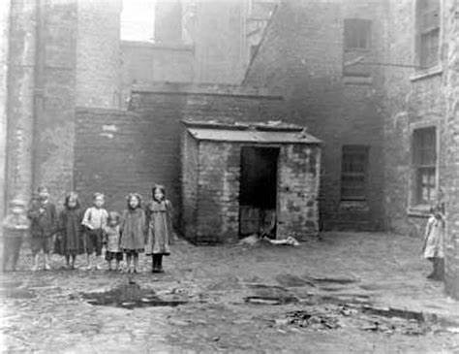 Tenements had no indoor toilets or sewage systems. This caused disease to spread easy and human waste could be found in the street and back yards of tenements.

- 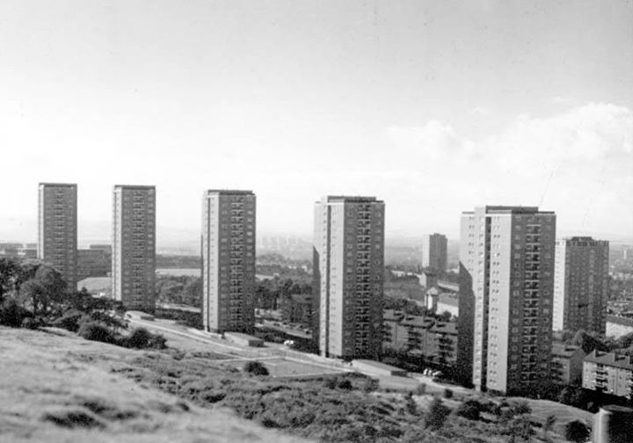 To solve the problem of overcrowding, the council built high rise flats. These flats were built in a hurry and with cheap materials which meant they needed fixed often and suffered dampness.

Task 8 – Create
Create a wordle to showcase your learning about problems in Glasgow’s Inner City. Further research on this topic will ensure you have even more key words for your wordle.

You have created a wordle before in class but there is an example below to help you.

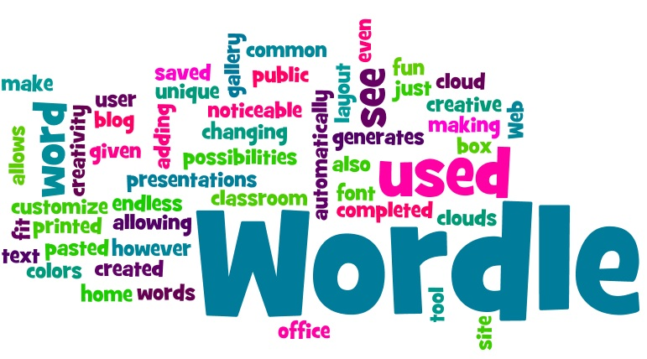

Step by step guide to creating a wordle;

- Choose your main word for your wordle – for this task your main word is problem.
- Select another 3 words that are not as important as the word problem, but are important to the issue you are studying.
- Other words linked to the 3 words you have chosen in step 2 should be noted.
- Words in each step should get smaller with the size of the word representing the importance of the word (for example problem should be the biggest word in your wordle).
- Create your word on word, on paper or use this website http://www.wordle.net/create.

Please send all completed wordle’s to my glow, this can be a word document or a picture taken on your phone – gw14mcwilliamsphilip@glow.sch.uk

Inner City Changes
To solve the many social, economic and environmental problems in Glasgow’s inner city many areas underwent extensive regeneration. One the areas regenerated is now known as the Athletes Village in Dalmarnock.
Task 9 – Remember

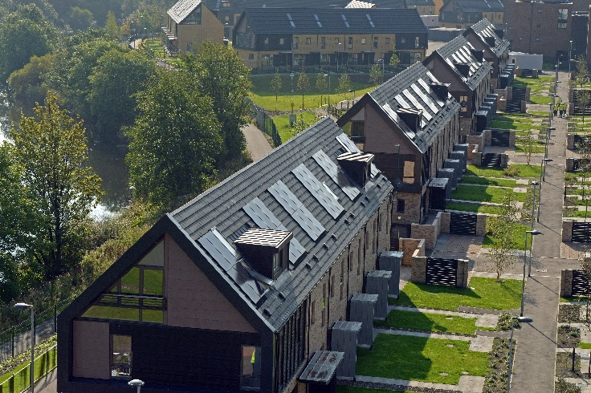
What are these? Why were these houses built with these?

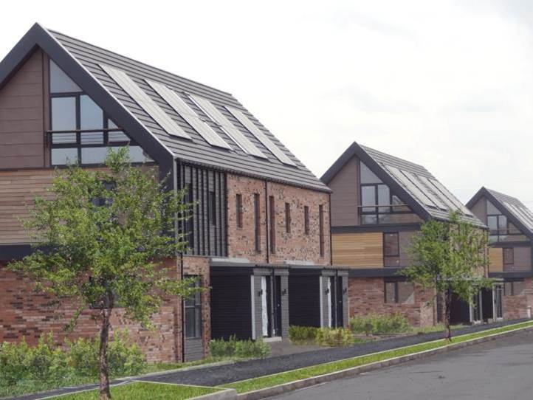
There are lots of trees and grass next to the new houses, why is this?

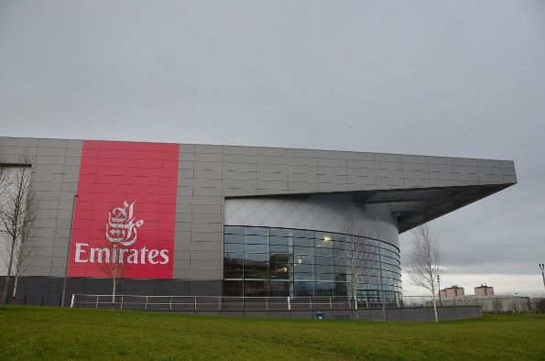
This regeneration programme didn’t just build houses. Why do you think building the emirates arena would help the local area?

Suburbs
The suburbs are the newest part of a town/city. The suburbs are groups of new modern housing built on the outskirts of a town. These areas are found in the commuter zone of the Concentric Zone Model.
Using your learning in class, identify the suburbs from the map below and provide 3 reasons why this is the suburbs.

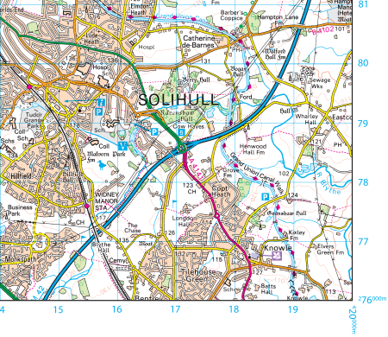

Task 10 – Identify

Suburbs - __ __ __ __

Reason 1 - ____________________________
Reason 2 - ____________________________
Reason 3 - ____________________________

Changes in the Suburbs
On the 18th of March work was set and issued on SMHW regarding changes to the suburbs. This is called urban sprawl. This is where building takes place on the edge of the suburbs, making cities even bigger. Building on the suburbs is both a good and a bad thing.
Trees are removed to make space for buildings.
Shopping centres/retail parks provide amenities and services for people living in new housing estates.
Increased pollution from more cars in the area.

Free parking and being undercover whilst shopping results in less people shopping in the CBD and instead shop in shopping centres on the outskirts of town.
Modern industrial estates provide jobs for people living in new housing estates.

Task 11 – Organise
Decide which statements, noted in the boxes above, represent a positive impact of building in the suburbs or a negative impact of building in the suburbs. Complete the table below.
Positive Impact | Negative Impact
Solutions to Urban Sprawl
It is important that, where possible, we stop/limit urban sprawl. Urban sprawl impacts on the climate and affects wildlife habitats potentially leading to extinction of species.

There are two solutions to Urban sprawl.

- Greenbelt
A Green Belt has been set up. This is a zone around the city in which no development can take place. The land here is protected from humans.
It stops the city growing outwards and prevents problems such as the loss of farmland and wildlife.
Creating a green belt means building cannot take place and if developers want to build, they must seek authority from council/government authorities.
However, due to an increasing population and council budget cuts sometimes developers are given the green light to build on the green belt.

- Brownfield Sites

A brownfield site is a derelict site which is built on again. Glasgow city council has developed on many of these, for example The Athletes Village, Dalmarnock.

By attracting development here (normally in inner city areas) this should reduce developments on the city edge. However, as these areas are closer to the CBD it is more expensive to develop here.

Task 12 – Literacy
Answer the following questions, using in the information above, in full sentences.
- What is the green belt?
- What does the green belt stop?
- Why might the green belt zone not always work?
- What is a brownfield site?
- What brownfield site have you already studied in detail in class?
- Why might developers wish not to build on brownfield sites?
Applying my Learning
Imagine you are a councillor and you decide whether planning applications are granted. You know that you should not allow new developments on the Green Belt. You know the problems that urban sprawl brings. But you also need to do what is best for local people, the people who voted for you.

Three applications have been received to build an area of the city’s Green Belt.

Task 13 – Apply

- Application for a New Business Park
Please allow this development at the edge of Glasgow. It will bring many benefits to the city:
- It will bring 550 jobs, mostly well-paid
- It will be built in an area of high unemployment
- The Buildings will not produce any air, noise or water pollution
- Two new roads will be built to reduce traffic on existing local roads.

- Application for a new Retail Park
Please allow this development at the edge of Glasgow. It will bring many benefits to the city:
- It will bring 230 jobs which will be given to local people in order to reduce poverty levels in this part of the city.
- People will have more to spend so other businesses will prosper
- We shall only build on poor-quality farmland
- It will be landscaped to look attractive.

- Application for a New Housing Estate

Please allow this development at the edge of Glasgow. It will
- Provide 178 new homes
- 260 workers will be needed to build the houses
- Houses for all income groups
- A new lake development and wildlife will be encouraged
- A new leisure centre with cheap entry for local people.

Read the three applications detailed above and decide whether any should go ahead. Give reasons for your choice (this should include pros and cons).

______________________________________________________________________________________________________________________________________________________________________________________________________________________________________________________________________________________________________________________________________________________________________________________________________________________________________________________________________________________________________________________________________________________________________________________________________________________________________________________________________________________________________________________________________________________________________________________________________________________________________________________________________________________________________________________________________________________________________________________________________________________________________________________________________________________________________
Create your own Town
You have now studied the concentric zone model in great detail and should have a sound understanding of how cities grow and why they are laid out the way they are.

We have also explored how the city of Glasgow is changing and why these changes are having to take place.

Now it is your turn to create your own town.

This task can be completed both electronically or on paper.

Success Criteria;

- Your city must follow the layout of the concentric zone model.
- Your city must have a CBD, inner city, middle class housing and a commuter zone.
- When creating your city, you need to think about land values, building shape and size, housing type, transport, shopping, changes in this zone, climate change strategies etc.
- Your city can reflect a real city, like Glasgow, or you can make up your own city.

Diagram 1: Concentric Zone Model
Website - http://citycreator.com/
APP - Citytopia
SQA Past Papers

National qualifications are just around the corner for you; therefore, it would be appropriate for you to engage in past paper practice after you have completed part 1 of your learning pack.

We have been working towards completing these types of exam question for many months now. If you need any help or support email me on gw14mcwilliamsphilip@glow.sch.uk.

Question 8 and question 10 - https://www.sqa.org.uk/pastpapers/papers/papers/2019/N5_Geography_all_2019.pdf
Question 10 –
https://www.sqa.org.uk/pastpapers/papers/papers/2018/N5_Geography_all_2018.pdf
Question 5 and question 6 –
https://www.sqa.org.uk/pastpapers/papers/papers/2017/N5_Geography_all_2017.pdf
Question 6 - https://www.sqa.org.uk/pastpapers/papers/papers/2015/N5_Geography_all_2015.pdf

Command Words
Describe - Say what you see. Give detail of what it is. You do not explain here.
Explain - State why or how, or note impact. Use connectives;
Top Connectives
- Because…
- This means…
- As a result…
- This could…
- Therefore…

- Urban Areas in Other Places
Revision Pack 2020

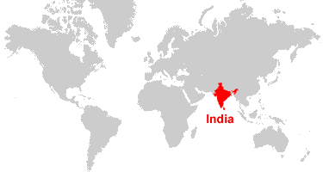

Contents
- Curriculum Links
- Mumbai, India
- Housing Problems in Mumbai
- Shanty towns
- Shanty Town case Study: Dharavi, Mumbai
- Literacy Task

Curriculum for Excellence Level 4

Experience and Outcome | Benchmark
I can explain the development of the main features of an urban area in Scotland or elsewhere and can evaluate the implications for society concerned. SOC 4-10b | - Explains in some detail how any chosen urban area has developed, and evaluates the impact on the society.
I can evaluate and interpret raw and graphical data using a variety of methods, comment on relationships I observe within the data and communicate my findings to others. MNU 4-20a | - Interprets raw and graphical data.  - Uses statistical language, for example, correlations, to describe identified relationships.
As appropriate to my purpose and type of text, I can punctuate and structure different types of sentences with sufficient accuracy, and arrange these to make meaning clear, showing straightforward relationships between paragraphs. LIT 4-22a | - Applies a range of strategies and resources to ensure accuracy of spelling including unfamiliar or specialist vocabulary.  - Uses a variety of punctuation, including more complex punctuation, to convey meaning and enhance writing, for example, inverted commas, colons, semi-colons, parentheses, dashes and ellipses. Punctuation is varied and accurate.  - Writes grammatically accurate sentences.  - Uses a variety of sentence structures to clarify meaning and enhance writing, for example, simple and complex sentences, lists, repetition and/or minor sentences.  - Structures writing effectively using a variety of linking phrases and topic sentences to signpost a clear structure, line of thought or argument.  - Writes in a fluent and legible way.  - Reviews and edits writing independently to ensure clarity of meaning, technical accuracy and to improve content, language and/or structure.
I can use notes and other types of writing to generate and develop ideas, retain and recall information, explore problems, make decisions, or create original text. | - Uses notes and/or other sources to generate ideas, inform thinking and support the creation of new texts.  - Selects relevant ideas and information including essential detail or evidence. • Organises essential ideas and information to convey a structured line of thought.
As I listen or watch, I can make notes and organise these to develop thinking, help retain and recall information, explore issues and create new texts, using my own words as appropriate. LIT 4-05a | - Uses notes to create new texts that show understanding of the issue/subject and draw on information from more than one source.

Urban Areas in Other Places
Urban environments do not just exist in the developed world. Urban environments exist in the developing world too, although in many ways these environments are very different to cities like Glasgow.

Case Study: Mumbai, India
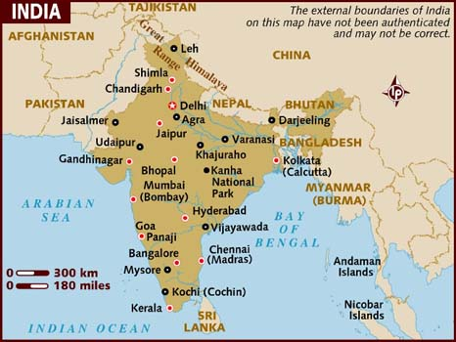
Mumbai (which used to be called Bombay) is the largest city in India. It is a city of many contrasts which is typical of a city in a developing country. It has the glamour of the film industry and designer shops but it is also one of the most crowded areas in the world with a population of over 20 million. It has acute and widespread poverty, the biggest slums in the whole of Asia and a large criminal underworld.
Site
Mumbai’s original site was an island off the West coast of India. It grew as a fishing and trading port and as a small industrial centre and spread onto 6 more islands. The wetlands between these islands have now been reclaimed to form one island, Bombay Island.
Early Growth
Mumbai started to grow when railways were built and factories began to appear. The railways connected the cotton growing areas which led to the building of cotton spinning and weaving mills.
Growth since Independence
India gained independence from Britain in 1947. Mumbai’s manufacturing industries expanded but its service industries developed even faster. The financial services industry grew with a lot more banks, finance houses and insurance companies setting up.
Meanwhile, the film industry, which began 100 years ago, also grew rapidly. Today Mumbai has the biggest film industry in the world which turns out more films per year than does Hollywood.
In the 1990s multinational companies such as IBM, BA and Prudential began moving their call centres here because wage rates were lower than most developed countries (90% lower).
The workforce is also highly educated – many graduates are attracted to call centres as the wages are twice as high as those earned by teachers.
As industry expanded Mumbai was able to improve its road, port and airport. It could also afford to build new schools, universities and hospitals. With more wealthy people entertainment also increased and many shopping malls were built.
In the countryside life did not improve. It became increasingly difficult for people to make a living. An increasing number headed for Mumbai – the obvious choice of centre for rural immigrants.
Mumbai Today
Mumbai is the industrial powerhouse of India.
- Its ports handle 40% of India’s trade by sea
- Its airport handles 60% of India’s trade by air.
- It provides 10% of all factory jobs in India.
- Its factories make 25% of all the goods that are made in India.
- Its people pay 33% of income tax.
Land Uses
As Mumbai grew the original site was taken over by businesses and this became the CBD. As the city has continued to grow the CBD has expanded westwards and southwards. The main land uses of the CBD are similar to any other – government buildings, hotels, shops, offices etc.
The CBD also contains some old industrial areas on the eastern side of the island. The remaining old industry is found next to the CBD and still in south Mumbai. Many of these old factories have now closed, especially the cotton mills.
Further out in the suburbs are newer industrial areas and technology parks and at the city edge to the east is Navi Mumbai (New Bombay). This has been built in the last 40 years and includes Mumbai’s new port, many other new industries, as well as shopping centres and homes for over 1 million people.
Housing is all over Mumbai – including the CBD – it is the biggest land use.

Task
- Describe the site of Mumbai.
- Choose one of the main industries in Mumbai. Give 2 reasons why it set up here.
- Do you think Mumbai has grown mainly because of its employment opportunities, or because of the lack of employment opportunities within the countryside? Give reasons for your answer.
- Describe how Mumbai has grown outwards over the years.
- In what ways is Mumbai’s CBD similar to Glasgow’s CBD?

Housing Problems in Mumbai
There are many reasons why housing problems in Mumbai exist.
- Population Size
Firstly, there is more than 20 million people living in this one city. Scotland’s total population is just over 5 million (the population of Mumbai is therefore 4 times more than our country put together).
Diagram 1: Population of Mumbai 1901 to 2011
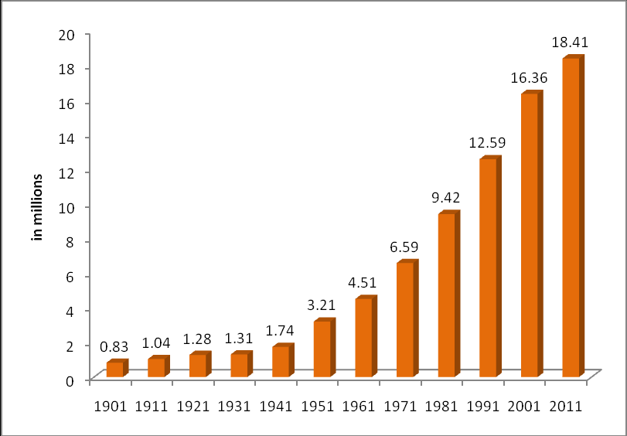
Task 1: Numeracy Skills
Describe the graph above (3). (Think trend, highest, lowest, number and date)
Description 1 - ______________________________________________________________________________________________________________________
Description 2 - ______________________________________________________________________________________________________________________
Description 3 - ______________________________________________________________________________________________________________________
- Migration
Migration is when people move from one area to another. In India many people are leaving the countryside and moving to the city. This has resulted in an increase in the number of people living in Mumbai.
People are being pushed out of the countryside; these are called “push factors.”
- Unemployment
- Food shortages due to drought
- Lack of education
- Poor healthcare

However, many people are attracted to live in cities; these are called “pull factors.”

Think back to our learning in class, note down 3 reasons why people would want to move to a city;

1.
2.
3.

Housing Problems in Mumbai
Due to the mass movement of people into the city of Mumbai the government struggle to provide enough housing. This means that people build their own homes in any area they can find space.
When many people build like this, they create a new urban area, within a city, called a “shanty town.”
Pictures of shanty towns that can be found all over the developing world.
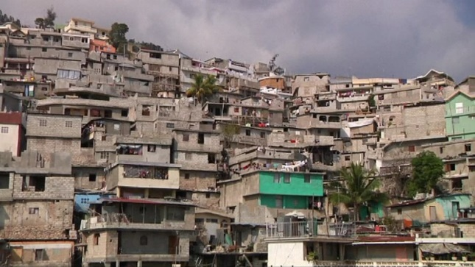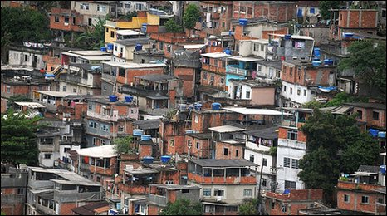
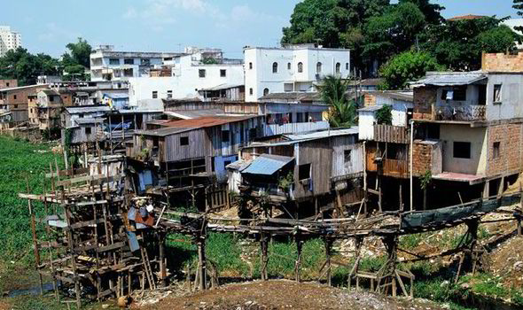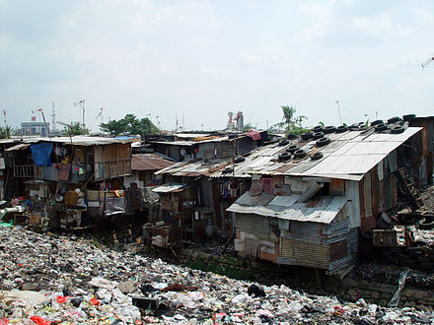
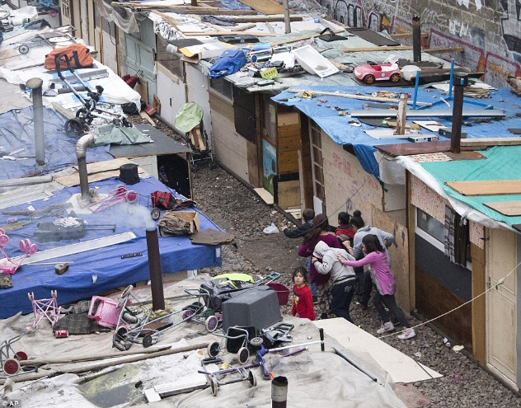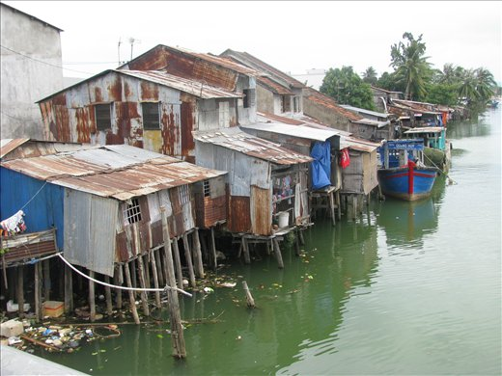

Shanty Town Features

Although Shanty Towns are very different, they have some similarities no matter where they are in the world.

- Houses may have brick walls and tin roofs – some are still made from scrap materials.
- Houses are small and overcrowded
- No legal electricity.
- Water may be accessed from a standpipe (on for a couple of hours/day) – no water access in home
- There may be basic community toilets that are shared by many people.
- Roads are not paved or signposted.
- No refuse collection.
- No emergency services.
- Few schools.
- High crime, suicide, drug use and disease.

Task 2 – Create
On the next page, using the information above, draw your own shanty house and make sure you label the shanty house.

Things to consider;
- What is your shanty house made of?
- How many people live here?
- How many floors does your shanty house have?
- Does your shanty house have windows/doors?
- Is it clean outside your shanty house or is it surrounded by rubbish?

My Shanty House

Shanty Town Case Study: Dharavi, Mumbai
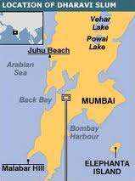
Dharavi is the most famous shanty town in Mumbai because it featured in the film Slumdog Millionaire. This movie can be watched at home as part of your learning.
Location
- It is near the centre of Mumbai.
- Occupies a small area of 175 hectares (less than 1 square mile).
Growth
Dharavi was once a fishing village but the land around it was drained in the 1800s – this allowed more people to settle here. The people who settled here were mainly migrants from other parts of India – potters, leather tanners and embroidery workers.
Dharavi has continued to attract people from the countryside who want to have a higher standard of living in the city or who have been forced to leave their farms. It grew very quickly towards the end of the 20th Century when people were moving here at a rate of 200/day.
Features
- Land use - mainly housing, factories and shops. One million people live in the area, there are 15,000 one room factories and hundreds of shops.
- Ownership – the local government own the land but the residents do not pay them rent, which makes them illegal squatters. They do pay rent but it is to a local landlord who looks after their area of Dharavi.
- Building materials – the newest part is around the edge where flimsy housing is built by recent arrivals using scrap material – wood, cloth and corrugated, iron. Amaze of passageways leads into the centre of the slum where the oldest and most solid buildings are found – they are made of brick and concrete.
- Houses – most began as one room but have been added to over the years. The average size is 3x3 metres and the average extended family size is between 6 and 10 people.
- Water – available from standpipes for a couple of hours/day.
- Toilets – there is only one for approximately 500 people. Many people will often use shallow rivers as a toilet.
- Electricity – most houses have electricity although the supply is illegal and often irregular.
- Employment – 80% of people work in the workshops and small factories.
Problems
- Living conditions are unsanitary and unhealthy – the pipes that bring the water in are often cracked and sewage seeps in. 3000 people per day attend hospital with diarrhoea and diseases such as typhoid.
- People often work in dangerous conditions with toxic substances. As a result, disease spreads very rapidly and life expectancy is only 50 years.
- Lack of basic services – apart from having no toilets and safe water there is also no refuse collection. There are many rats and flies which spread disease.
- There are few schools and hospitals – most people are forced to use private schools and health centres. People have to pay for these which mean literacy rates are very low and so is life expectancy.
- No taxes are paid (because no one pays to rent the land they own and many people work in the informal economy). As a result, Mumbai has less money to spend improving the city.
- The area has a poor image which discourages tourists from visiting.

Benefits of Dharavi
Although Dharavi has many problems, it is not all bad…
- It provides cheap, affordable housing – rents in Dharavi can be as little as £3/month, so even the poorest can live here.
- It provides a lot of employment. There are thousands of workshops and factories which pay low wages but together give employment to most of the residents. Many skilled people work here e.g. metalsmiths, garment workers which allows them to pass their skills onto others.
- It brings the city a lot of money. Some of Dharavi’s goods are exported all over the world –the total of everything made here is £300 million/annum. Much of this money is spent in Mumbai.
- Very low crime rate. Although the area is overcrowded and many homes do not have doors let alone locks the crime rate is lower here than in the rest of the city.
- It is very sociable. There are communal areas where people can sit and chat whilst completing daily chores such as washing and repairing clothes.
- People are very enterprising – they pass on these attitudes to the next generation.

Task 3
- Describe the location of Dharavi.
- Describe the types of jobs available in Dharavi.
- Life expectancy is 15 years lower in Dharavi than the rest of India. Explain why.
- Explain why literacy rates are also very low.
- Provide 3 reasons why Dharavi is a benefit to the people living here?

Literacy Task – Essay
Part 1 - Research
Watch the documentary Kevin McCloud “Slumming it.” This is a documentary focused on Dharavi over two episodes.
Episode 1 – https://www.bing.com/videos/search?q=kevin+mccloud+slumming+it&view=detail&mid=0E9AF1558EFA46F4BB4B0E9AF1558EFA46F4BB4B&FORM=VIRE
Episode 2 - https://www.bing.com/videos/search?q=kevin+mccloud+slumming+it&view=detail&mid=07B6C284ABCD16F4590F07B6C284ABCD16F4590F&FORM=VIRE

When watching the documentary take notes under the following headings, this will help you with writing your essay;

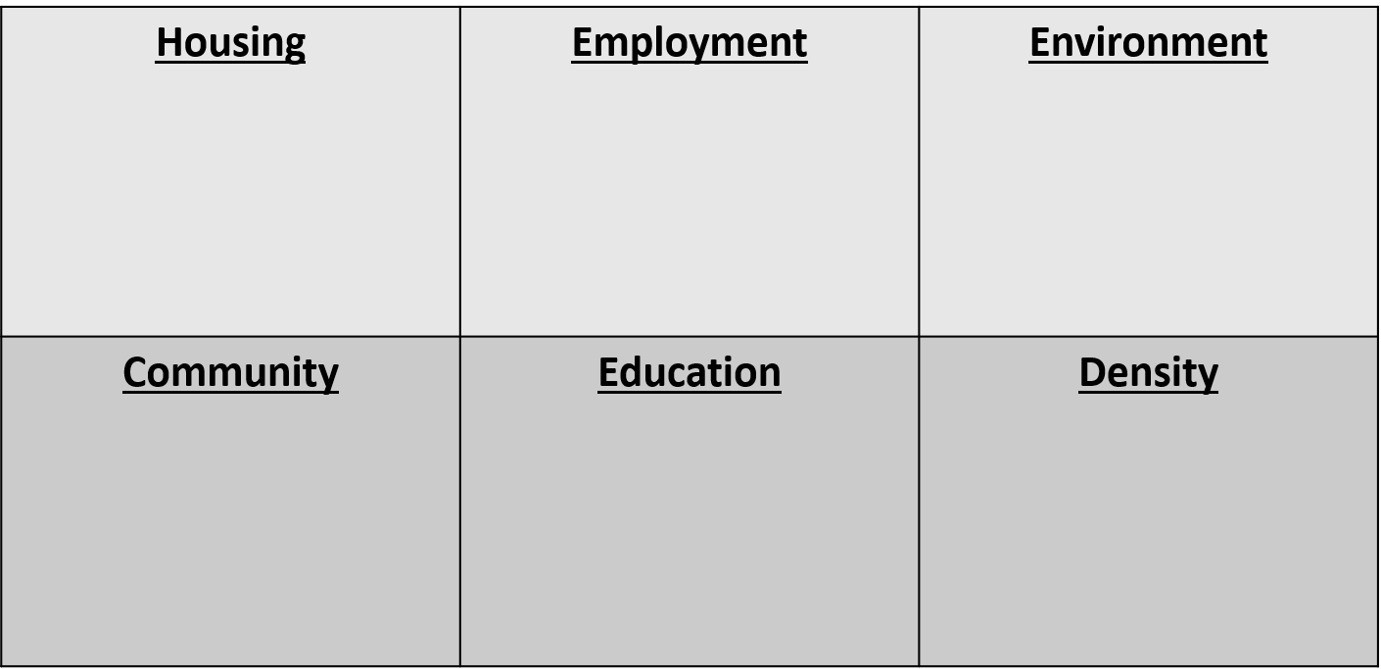

Literacy Task – Essay
Part 2 – Write your Essay
Essay Question - “Discuss the living conditions experienced by residents of Dharavi, Mumbai.”

Essay Success Criteria
Introduction – What is Dharavi? Introduce the living conditions and lives of those who live in Dharavi than you will discuss in your report.
Paragraph 1 – Housing
Describe the housing in Dharavi, be factual and use information to exemplify the points you make. Include analysis – how does this housing affect their way of life?
Paragraph 2 – Environment
Describe what the environment is like in Dharavi. Remember the environment is the area around them. Can you explain the impact this environment could have on the people who live there?
Paragraph 3 – Employment
Describe what type of jobs people do in Dharavi. Include analysis – is employment in Dharavi better than Glasgow? What about the work ethic of the residents in the shanty town? Can you compare this to Glasgow?
Paragraph 4 – Community
In Dharavi, what is their sense of community like? Remember community is the term given to the interaction of people with others around them. Can we learn anything from this in our city?
Paragraph 5 - Changes
Describe how Dharavi may change in the future. Consider how housing will change. What will the impact of this be? Are the people of Dharavi happy about this?
Conclusion – Sum up your comments in the essay. Is Dharavi all bad, or can we learn a thing or two from how they choose to live?

