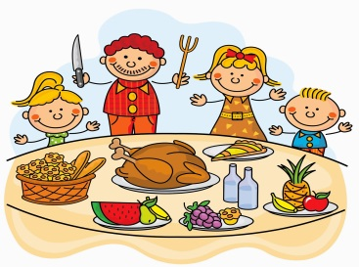
S3 Home Economics Homework Tasks
As we would have been working on Feeding the Family and Food Choices, I have attached a worksheet for you to complete. I have also attached a power point which you should look at first as this will help you do the worksheet. As always your or can be returned to me via SMH or emailed to gw10howittjulie@glow.sch.uk
Hopefully you are still helping out in the kitchen at home to keep up your practical skills.

