My diet

- List the food and drink you had yesterday.
Breakfast | Lunch | Dinner | Snack/Drinks

- How does it compare to The Eatwell guide?
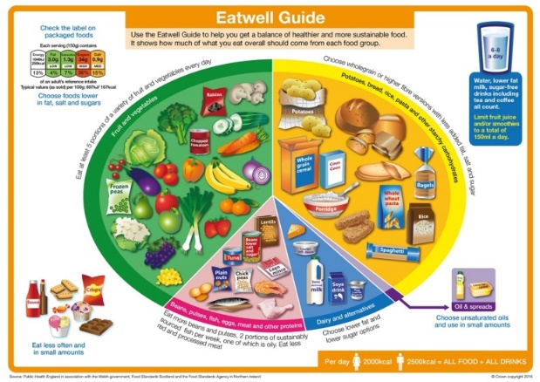
Comments:

- What types of starchy carbohydrate did you have?

- How many portions of fruit and vegetables did you have?

- My diet

- What is good about your diet?

- What needs improving?

- How can you make these changes?

